A Thesis Submitted in Partial Fulfillment of the Requirements for the Degree of B.Eng. (Honors) in Electronics Engineering:

Energy Theft Detection in Smart Grids Using Anomaly Detection Techniques with the UCI Smart Meter Dataset

Prepared By:
- Tasneem Eltayeb Mohamed Elkhalifa
- Maram Jamal Eltahir Elzubair
- Rawya Elnazir Tag Elsir
- Ruba Mohammed Elamin Taj Eldin

Supervised By:
Prof. Dr. Rashid A Saeed

September 2026

الآية

{وَقُل رَّبِّ زِدۡنِي عِلۡماً}

صدق الله العظيم
سورة طه الآية (114)

Dedication

To our families, for their endless love, support, and encouragement throughout our studies.
To our friends and colleagues, for standing by us during this journey.
And to everyone who believes that teamwork and hard work can make a difference.
In honor of all who strive to overcome obstacles in their pursuit of dreams

Acknowledgement
We would like to express our sincere gratitude to Sudan University for Science and Technology for providing us with the opportunity, resources, and academic environment to complete this research project successfully.
Our deepest appreciation goes to our supervisor for his invaluable guidance, continuous support, and constructive feedback throughout every stage of this study. His encouragement and expertise have been instrumental in shaping this work.
To our beloved parents, your endless love, patience, and unwavering belief in us have been our greatest motivation. We are profoundly thankful for your support.
Finally, our sincere thanks go to our friends for their encouragement, insightful discussions, and moral support, which helped us overcome every challenge along the way.

Abstract
The study aimed to evaluate the effectiveness of Anomaly Detection techniques in detecting electrical power theft within Smart Grid environments by comparing the performance of Isolation Forest and Autoencoder models using the UCI Smart Meter Dataset.
The study was based on an experimental approach, where the data underwent Data Preprocessing processes that included cleaning the data, processing missing values, normalizing the data, extracting properties, and then dividing it into training and testing data. The two unsupervised models were then trained and their performance evaluated using Accuracy, Precision, Recall, F1-Score, Specificity, and AUC-ROC indices, as well as ROC and Precision–Recall curves.
The results showed that the Isolation Forest model outperformed the Autoencoder model across all performance indicators, achieving Accuracy of 96.8%, Precision of 83.1%, Recall of 81.9%, F1-Score of 82.5%, Specificity of 98.3%, and AUC-ROC of 99.0%, indicating its stronger performance in identifying abnormal consumption patterns associated with potential energy theft and reducing false alarm rates.
The study recommends adopting the Isolation Forest model in Smart Grid monitoring systems, using more diverse datasets to improve the models' generalization ability, developing hybrid models to increase detection efficiency, and testing the models in real-world operating environments that support real-time monitoring.

المستخلص
هدفت الدراسة إلى تقييم فعالية تقنيات الكشف عن الحالات الشاذة في الكشف عن سرقة الطاقة الكهربائية داخل بيئات الشبكات الذكية من خلال مقارنة أداء ن نماذج غابة العزل Isolation Forest والتشفير التلقائي Autoencoder باستخدام مجموعة بيانات العداد الذكي UCI.
واعتمدت الدراسة على المنهج التجريبي، حيث خضعت البيانات لعمليات المعالجة المسبقة للبيانات والتي شملت تنظيف البيانات، ومعالجة القيم المفقودة، وتطبيع البيانات، واستخراج الخصائص، ومن ثم تقسيمها إلى بيانات التدريب والاختبار. تم بعد ذلك تدريب النموذجين غير الخاضعين للرقابة وتقييم أدائهما باستخدام مؤشرات الدقة والدقة والاستدعاء ودرجة F1 والنوعية وAUC-ROC، بالإضافة إلى منحنيات ROC وPrecision–Recall.
وأظهرت النتائج أن نموذج غابة العزل تفوق على نموذج التشفير التلقائي في جميع مؤشرات الأداء، حيث حقق دقة 96.8%، ودقة 83.1%، واستدعاء 81.9%، ودرجة F1 82.5%، ونوعية 98.3%، وAUC-ROC 99.0%، مما يؤكد كفاءته العالية في اكتشاف الأنماط غير الطبيعية المرتبطة بسرقة الطاقة وتقليل معدلات الإنذارات الكاذبة.
وتوصي الدراسة باعتماد نموذج غابة العزل في أنظمة مراقبة الشبكات الذكية، واستخدام مجموعات بيانات أكثر تنوعًا لتحسين قدرة النماذج على التعميم، وتطوير نماذج هجينة لزيادة كفاءة الكشف، واختبار النماذج في بيئات التشغيل في العالم الحقيقي التي تدعم المراقبة في الوقت الفعلي.

Table of Contents
N | Description | Page
1 | الآية | II
2 | Dedication | III
3 | Acknowledgement | IV
4 | Abstract | V
5 | المستخلص | VI
Chapter One: Introduction |  | 1-6
6 | Background | 2
7 | Problem Statement | 3
8 | Research Objectives | 4
9 | Significance Of The Study | 5
10 | Research Scope And Limitations | 5
11 | Research Outline | 6
Chapter Two: Literature Review |  | 7-17
12 | Theoretical Background | 8
13 | Related Work | 13
14 | Summary | 16
Chapter Three: Methodology |  | 18-28
15 | Introduction | 19
16 | Research Design | 19
17 | Data Collection | 22
18 | Selected Anomaly Detection Algorithms | 23
19 | Implementation Tools And Environment | 25
20 | Performance Metrics | 25
21 | Summary | 28
Chapter Four: Results & Discussion |  | 29-41
22 | Introduction | 30
23 | Results | 30
24 | Discussion | 40
25 | Summary | 40
Chapter Five: Conclusion & Recommendations |  | 42-53
26 | Conclusions | 43
27 | Recommendations | 43
28 | Future Works Suggestion | 44
29 | Reference | 45
30 | Appendix | 49

List of Figures
N | Figure | Page
1 | Figure 3 1 System architecture for detecting energy theft | 20
2 | Figure 3 2 System Flow chart | 22
3 | Figure 4 1 Comparative Accuracy (Autoencoder vs Isolation) | 31
4 | Figure 4 2 Comparative Precision (Autoencoder vs Isolation) | 32
5 | Figure 4 3 Comparative Recall (Autoencoder vs Isolation) | 33
6 | Figure 4 4 Comparative F1-Score (Autoencoder vs Isolation) | 34
7 | Figure 4 5 Comparative Specificity (Autoencoder vs Isolation) | 35
8 | Figure 4 6 Comparative AUC-ROC (Autoencoder vs Isolation) | 36
9 | Figure 4 7 Confusion Matrix for (Autoencoder vs Isolation) | 37
10 | Figure 4 8 Comparative ROC Curve (Autoencoder & Isolation) | 38
11 | Figure 4 9 Comparative Precision-Recall Curve (Autoencoder & Isolation) | 39

Chapter One
Introduction

1.1 Background
The global energy sector has witnessed a major transformation as a result of the growing need to improve the efficiency of electricity distribution, reduce loss, and promote environmental sustainability. In this context, Smart Grids have emerged as an advanced solution that combines communications technologies, computing systems, and Smart Meters to create a more efficient, reliable, and interactive electrical grid. These networks rely on Smart Meters, which collect electricity consumption data accurately and in real time, allowing electricity distribution companies to monitor consumption, analyze its patterns, manage energy more efficiently, and improve the overall performance of the electricity network [1].
Despite these technological advancements, Electricity Theft remains one of the most significant challenges facing electricity distribution companies, especially in developing countries with limited monitoring systems and oversight mechanisms. Several studies indicate that Non-Technical Losses (NTLs), which include Electricity Theft, meter tampering, and billing errors, may exceed 20% of the total electrical power distributed in some electricity grids [2]. These losses cause significant financial damage to electricity companies and negatively impact grid reliability, service quality, and the stability of the power distribution system [3].
Traditional methods for detecting Electricity Theft relied on manual field inspection or comparing a subscriber's current consumption with their average consumption in previous periods. However, these methods are expensive in terms of time and effort and are unable to efficiently handle the huge amounts of data produced by Smart Meters. Therefore, interest in using Artificial Intelligence (AI) and Machine Learning (ML) technologies to develop intelligent systems capable of automatically detecting electricity theft has increased. Among these technologies, Anomaly Detection has emerged as one of the most effective methods, due to its ability to detect abnormal consumption patterns without the need for pre-classified data, which makes it suitable for smart grid applications in which it is difficult to obtain real, classified data for theft cases [4].
Accordingly, there has been increasing interest in applying machine learning techniques in this field due to their ability to analyze large amounts of data and automatically identify abnormal consumption patterns with high accuracy. With the widespread deployment of smart meters, the availability of real electricity consumption datasets, such as the UCI Smart Meter Dataset available through the UCI Machine Learning Repository, has become an important factor in supporting research related to the development and evaluation of smart models. These datasets provide a suitable environment for testing model performance and analyzing results under conditions that can support experimental evaluation of anomaly-detection methods, thus contributing to the development of more accurate and reliable solutions for detecting electricity theft and enhancing the efficiency and reliability of smart grids.

1.2 Problem Statement
Electricity Theft is one of the most significant problems facing electricity distribution companies, causing significant financial losses and negative impacts on the efficiency and reliability of power distribution networks. With the expansion of the use of Smart Grids and Smart Meters, electricity companies now have huge amounts of energy consumption data, but detecting theft cases accurately and in a timely manner remains a major challenge. Traditional methods, such as field inspection or comparing consumption data to previous periods, are no longer sufficient to handle the increasing volume of data or to efficiently detect abnormal patterns, in addition to the difficulty of obtaining labeled data on which many Machine Learning models rely [5].
In light of these challenges, the problem of this study is the need to develop an intelligent system based on Anomaly Detection techniques to detect Electricity Theft cases using Smart Meter data, so that it can automatically detect abnormal consumption patterns with high accuracy, while leveraging Isolation Forest and Autoencoder algorithms and evaluating their performance using the UCI Smart Meter Dataset.

1.3 Research Objectives
1.3.1 General Objective
To evaluate the effectiveness of Anomaly Detection techniques in detecting abnormal patterns in electricity consumption data within the smart grid environment, using the UCI Smart Meter Dataset.
1.3.2 Specific Objective
- Design and implement two anomaly detection models using machine learning algorithms to analyse electricity consumption data from smart meters.
- Prepare and process UCI Smart Meter Dataset by cleaning data, extracting properties, normalizing data, and segmenting it to fit model training and evaluation.
- Evaluate the performance of the two models using performance indicators.
- Compare the performance of the two models (Isolation Forest and Autoencoder) to determine which model is most efficient and effective at detecting abnormal patterns associated with Electricity Theft in Smart Grids.
- Providing recommendations that contribute to improving the performance of Anomaly Detection models and enhancing the efficiency of Electricity Theft detection systems in Smart Grids.

1.4 Significance of the Study
The importance of this research lies in the growing importance of developing smart solutions that contribute to reducing Electricity Theft, which is one of the most prominent causes of Non-Technical Losses (NTLs) in electricity distribution networks, due to economic losses and negative impacts on the efficiency and reliability of Smart Grids. The research also highlighted the importance of employing Machine Learning techniques, particularly Anomaly Detection techniques, to analyze Smart Meter data and automatically detect abnormal patterns, beyond the limitations of traditional detection methods.
The scientific significance of the research lay in evaluating the performance of the Isolation Forest and Autoencoder algorithms in detecting anomalous patterns in electricity consumption data and comparing them using the UCI Smart Meter Dataset and benchmark performance indicators, providing a reference that can be used in future studies. From an applied perspective, the research results contributed to supporting electricity distribution companies in choosing more efficient models for early detection of Electricity Theft cases.

1.5 Research Scope and Limitations
This research was limited to detecting Electricity Theft in Smart Grids by analyzing electricity consumption data collected by Smart Meters using Anomaly Detection techniques. The scope of the study included processing the UCI Smart Meter Dataset, feature Engineering, data normalization, training and evaluation of Isolation Forest and Autoencoder models, as well as comparing their performance using Accuracy, Precision, Recall, F1-Score, Specificity, and AUC-ROC indices.
- Limitations: The study was limited to using the UCI Smart Meter Dataset, evaluating only the Isolation Forest and Autoencoder algorithms, and the experiments were conducted in a simulated environment without verifying the results using actual operating data.

1.6 Research Outline
Chapter one presents an overview of the research. Chapter two reviews the related literature on energy theft detection and anomaly detection techniques. Chapter three describes the research Methodology. Chapter four covers the simulation results and discussion. Chapter five provides the conclusion, recommendations, and future work.

Chapter Two
Literature Review

2.1 Theoretical Background
2.1.1 Introduction
Electricity Theft is one of the most significant challenges facing electricity distribution companies, causing significant financial losses, reduced operating efficiency, and negative impacts on the reliability and safety of power distribution networks. With the continuous development of electrical power systems and the emergence of Smart Grids, it has become possible to collect huge amounts of electricity consumption data through Smart Meters, which has provided opportunities to develop intelligent methods based on Machine Learning technologies to detect and reduce cases of theft [6].
This chapter discussed the theoretical framework and basic concepts related to the research topic. The chapter also included a review of the most prominent previous studies, with the aim of clarifying developments in this field and identifying the research gaps on which this research was based.
2.1.2 Overview of Smart Grid
Smart Grids are the modern generation of electricity grids, combining traditional power systems, digital communications technologies, control systems, and information technology to improve the efficiency, reliability, and safety of electricity production, transmission, distribution, and consumption. These networks are distinguished by their ability to monitor energy flow and manage operations more efficiently compared to traditional networks [6].
One of the most important components of Smart Grids is the Advanced Metering Infrastructure (AMI) system, which relies on Smart Meters to collect electricity consumption data accurately and in real time. These meters enable remote monitoring, accurate billing, and two-way data exchange between electricity companies and consumers, helping to improve grid management and respond quickly to any changes or malfunctions [7].
Smart Grids also supports the integration of renewable energy sources, such as solar and wind power, as well as improving electrical load management and reducing the possibility of power outages. Sensor and control systems contribute to detecting and isolating faults and quickly restarting affected parts, which increases network efficiency and reduces operation and maintenance costs [7].
2.1.3 Energy Theft: Definition and Impact
Energy Theft is defined as the illegal and unauthorized use of electrical energy, done through multiple means, such as manipulating meters, bypassing them, making illegal connections, or changing consumption readings with the aim of avoiding paying for the electricity consumed. In the Smart Grids environment, some vulnerabilities in measurement systems or communications networks may be exploited to implement these practices, making them more difficult to detect and reduce [8].
The impact of Energy Theft extends to the economic and operational aspects of electricity distribution networks, resulting in lower electricity company revenues, increased Non-Technical Losses (NTLs), improved electrical load forecasting accuracy, and reduced network management efficiency and stability. This may result in increased operation and maintenance costs, difficulty planning for the development and expansion of electricity networks, in addition to a decrease in the quality of service provided to consumers [8].
The impacts of Energy Theft are not limited to economic aspects only, but also extend to security aspects. Illegal electrical connections and tampering with meters can lead to fires, electric shocks, equipment damage, or power outages, posing a risk to individuals and electricity grid infrastructure. Electricity companies may also be forced to raise tariffs or incur additional operating costs to compensate for losses resulting from these practices, which indirectly affect committed consumers [8].
2.1.4 Traditional Methods for Energy Theft Detection
Most electricity distribution companies have relied on a range of traditional methods to detect Energy Theft. One of the most common of these methods is field inspection, where meters and electrical connections are checked to detect cases of meter tampering, illegal connections, or meter overflow. Electricity companies also relied on reviewing billing records and consumption data, and comparing current consumption with previous records or with the consumption of subscribers with similar characteristics, to detect any abnormal changes that may indicate the presence of energy theft. In some cases, consumer reports of suspicious activities or unjustified rises and falls in electricity consumption were an additional means of detecting these cases [9].
Some electricity companies have also used tamper-resistant meters equipped with indicators or alarms to detect tampering attempts, in addition to repeatedly monitoring cases of disconnection and reconnection of service as indicators that may require further inspection. Although these methods are important, they require significant time, effort, and operational costs, and rely heavily on human intervention, which reduces their efficiency when dealing with large numbers of subscribers or big data. In addition, they often detect Energy Theft cases after they occur, which limits their effectiveness in reducing losses and improving the efficiency of electricity distribution networks [10].
2.1.5 Anomaly Detection Techniques in Smart Grids
Anomaly Detection techniques are one of the most important methods used to analyze Smart Grid data and detect abnormal electricity consumption patterns that may indicate the presence of Energy Theft or grid faults. These techniques are based on distinguishing between normal and abnormal consumption patterns by analyzing data and detecting deviations that might indicate problems or unusual behaviors. In general, Anomaly Detection technologies can be classified into four main categories: Statistical Methods, Machine Learning Approaches, Deep Learning Models, and Hybrid Techniques [11].
- Statistical Methods
Statistical methods focus on using statistical models to describe normal electricity consumption patterns, then comparing new data with these models to identify values that deviate significantly from expected behavior. The most popular of these methods are Standard Deviation, time series models such as ARIMA, and Extreme Value Theory (EVT). These methods are easy to apply and do not require Labeled Data, but their efficiency may decrease when dealing with complex or high-dimensional data, and they often rely on statistical assumptions that may not apply to all consumption data [10].
- Machine Learning Approaches
Machine Learning Approaches rely on learning data patterns and extracting relationships between them without the need for fixed rules, making them better able to handle large and complex data. These methods are divided into Supervised Learning, which relies on Labeled Data, and Unsupervised Learning, which detects abnormal conditions based on the properties of the data itself. The most popular Supervised Learning algorithms are Decision Trees, Random Forest, and Support Vector Machine (SVM), while Isolation Forest and Local Outlier Factor (LOF) are the most prominent Unsupervised Learning algorithms used in Smart Grid applications [12].

- Deep Learning Models
Deep Learning Models rely on deep neural networks to automatically extract important properties from data, making them suitable for analyzing complex data and time series. Prominent among these models are the Autoencoder, which relies on reconstructing natural data and using Reconstruction Error to detect anomalies, as well as RNNs, LSTMs, and CNNs, which have proven highly efficient in analyzing electricity consumption data. Despite its high accuracy, it requires large amounts of data and high computing resources [9].
- Hybrid Techniques
Hybrid techniques combine more than one technology to take advantage of the advantages of each and improve the performance of the anomaly detection process. Examples include combining CNN with LSTM to analyze time series data. These methods are characterized by their ability to improve the accuracy of results and increase the reliability of models, but they require more complex design and greater computer resources compared to other methods [11].
2.1.6 Comparison of Techniques: Strengths and Limitations:
The Anomaly Detection techniques used in Smart Grids show a clear difference in performance and mechanism of action, with each technique having characteristics that distinguish it from others, along with some limitations that may affect its efficiency when applied to different types of data. Therefore, choosing the appropriate technology depends on the nature of electricity consumption data, the availability of Labeled Data, the level of accuracy required, as well as the available computing capabilities [11].
Statistical methods are among the simplest methods, as they rely on analyzing the statistical properties of data to detect values that deviate from the normal pattern. It is easy to implement, has few requirements, and does not require disaggregated data. However, its efficiency declines when dealing with complex or high-dimensional data, and its reliance on specific statistical assumptions may reduce its accuracy in some practical applications [10]. In contrast, Machine Learning Approaches are able to recognize patterns and relationships within data without relying on fixed rules, giving them greater flexibility and accuracy in detecting anomalies. It can also handle multidimensional data efficiently, but some Supervised Learning models require labeled data that may be difficult to obtain, and their performance is affected by data quality, Feature Selection processes, and hyperparameter tuning [12].
Deep Learning Models rely on deep neural networks to automatically extract important properties and are distinguished by their ability to analyze complex data and time series and detect nonlinear patterns. Although it achieves accurate results, it requires large amounts of data and high computer resources, and interpreting their results is more difficult compared to some other methods [9]. Hybrid techniques are based on integrating more than one technology into a single model with the aim of taking advantage of the advantages of each and improving the accuracy and reliability of the detection process. These models have proven to be highly efficient in many applications, but their design and implementation require a higher level of complexity, along with the need for longer time and greater computing resources during training and operation [11].

2.2 Related Work
The study [13] aimed to develop a method that combines an LSTM model and Anomaly Detection techniques to predict electrical loads and detect abnormal consumption patterns. The study relied on real data on electricity consumption in the industrial sector and tested five algorithms to improve the model's performance. The results showed that the Adadelta algorithm achieved the best performance with a Mean Squared Error (MSE) value of 0.0919, and the system was able to detect 24 anomalies within one week, which proved the effectiveness of integrating load prediction models with anomaly detection techniques.
Similarly, the study [14] aimed to develop a Deep Neural Network (DNN)-based model for Energy Theft detection using properties extracted from the time and frequency domains of electricity consumption data. The study also addressed missing and imbalanced data issues through completion and artificial generation techniques, using Principal Component Analysis (PCA) and Minimum Redundancy Maximum Relevance (mRMR) to select the most important features, as well as Bayesian Hyperparameter Tuning and the Adam Optimizer to improve model performance. The results showed that the model achieved an AUC value of 97% and an accuracy of 91.8%, which confirms its efficiency in detecting cases of electricity theft.
On the other hand, the study [15], which aimed to develop a new framework called ETD-ConvLSTM to detect Energy Theft using ConvLSTM. The study relied on installing central meters within residential communities to identify suspected areas, then converting subscriber consumption data into spatial and temporal matrices to analyze local and general consumption patterns, and showed that the model achieved high detection accuracy while reducing the rates of false results and significantly reducing detection time compared to traditional methods.
In addition, the study [16] aimed to evaluate the efficiency of a number of Autoencoder models, including Simple Autoencoder, Variational Autoencoder, and Attention-based Autoencoder (AEA), in detecting Energy Theft and cyber-attacks. The study also combined the Attention-based Autoencoder model with the Seq2Seq LSTM to improve performance. The results showed that the proposed model increased the detection rate by up to 21% and reduced false alarms by 13%, highlighting the effectiveness of unsupervised deep learning and attention mechanisms in detecting abnormal conditions.
As indicated by the study [17], which aimed to develop an Energy Theft detection system in Smart Grids based on Deep Reinforcement Learning (DRL), with the aim of adapting to the constant change in consumption patterns and methods of electricity theft. The model relied on the Exploration–Exploitation mechanism to improve the learning and decision-making process. The results showed that the system achieved higher accuracy and greater flexibility compared to traditional methods and also contributed to improving real-time monitoring and rapid response to abnormal situations.
In the same context, the study [18] aimed to develop a hybrid model that combines unsupervised Anomaly Detection techniques and supervised classification techniques to improve the detection accuracy of Energy Theft. The study used Isolation Forest, One-Class SVM, Local Outlier Factor (LOF), and DBSCAN algorithms to detect abnormal patterns, and then used their outputs as inputs to the Random Forest algorithm. The results showed that the model achieved an accuracy of 99.63% and showed that integrating more than one algorithm contributes to improving performance even when using models that are less efficient when applied individually.
Also, the study [19] aimed to develop a model based on Supervised Machine Learning to detect Energy Theft using Smart Meters and AE-PMU data. The study included implementing advanced stages of data processing, addressing the problem of class imbalance using ADASYN, extracting properties using VGG-16, and then classifying the data using FA-XGBoost. The results showed that the model achieved an F1-Score of 93.7%, a Precision of 92.6%, and a Recall of 97%, confirming its effectiveness in handling large-scale time series data.
Finally, the study [20] aimed to propose a new Energy Theft detection model that combines Stacked Autoencoder (SAE) and the UaRe-RF algorithm. SAE was used to extract the most important characteristics of consumption data, while UaRe-RF was used to address data imbalance and determine the degree of suspicion for each participant. The results showed that the model achieved high detection accuracy, outperformed reference models, and provided a more efficient strategy for identifying cases of electricity theft.
2.2.1 Research Gap
The research gap in the field of Energy Theft Detection within Smart Grids is that many studies rely on models that require labeled data or optimal data that are difficult to provide in reality, which limits their practical applicability. Some studies have focused on complex models such as Deep Learning and Hybrid Models, which have high computational costs, and there are limited studies that directly compare Unsupervised Anomaly Detection techniques such as Isolation Forest and Autoencoder using the same data settings. Therefore, there is a need to develop unsupervised models that strike a balance between accuracy, efficiency, and applicability in real-world Smart Grids environments.

2.3 Summary
Energy theft detection in smart grids is a critical challenge due to its financial, operational, and safety impacts. With the widespread deployment of smart meters, large volumes of high-resolution electricity consumption data are now available, enabling the use of advanced anomaly detection techniques. Methods such as Isolation Forest and Autoencoders have proven effective in identifying abnormal usage patterns that may indicate energy theft, even without labeled theft data.
The UCI Smart Meter dataset is commonly used in research to evaluate these approaches, providing real-world consumption data for algorithm testing. Isolation Forest excels at detecting point anomalies in high-dimensional data, while Autoencoders are adept at learning complex, non-linear patterns and highlighting deviations through reconstruction errors. These techniques enable automated, scalable, and data-driven detection of energy theft, helping utilities reduce losses and improve grid reliability.
Despite these advances, challenges remain, including the lack of ground-truth theft labels, class imbalance, generalizability across regions, and the need for interpretable results. Continued research and development of robust anomaly detection methods are essential for effective energy theft mitigation in modern smart grids.

Chapter Three
Methodology

3.1 Introduction
This research is based on a data-driven methodology that aimed to detect Energy Theft in Smart Grids using advanced techniques from Anomaly Detection. The research used two machine learning models, Isolation Forest and Autoencoder, to detect abnormal patterns in electricity consumption that may indicate fraud or illegal energy use. The UCI Smart Meter Dataset contains electricity consumption measurements collected from smart-meter data and provides a realistic environment suitable for experimentation and analysis.
This methodology went through several interconnected stages that begin with the Data Preprocessing process, which includes cleaning, normalizing, and organizing the data to ensure the accuracy and reliability of the analysis. This is followed by the Feature Engineering phase, where temporal and behavioral characteristics are extracted that more accurately reflect electricity consumption patterns. Isolation Forest and Autoencoder models are then trained to detect outliers within the data, and the performance of these models is then evaluated using benchmark metrics such as Precision, Recall, and F1-Score. In the final stage, the results are analyzed, and the discovered patterns are interpreted to determine the extent to which they are likely to be related to Energy Theft cases based on statistical analysis and applied experience, ensuring a deeper understanding of the model's results and the possibility of benefiting from them in practice.

3.2 Research Design
This research was based on the design of an intelligent system aimed at detecting Energy Theft in Smart Grids using Anomaly Detection techniques, specifically the Isolation Forest and Autoencoder algorithms. The system integrates a set of components to collect, process, analyze, and display electricity consumption data based on the UCI Smart Meter Dataset.
The system started with Smart Meters that recorded electricity consumption in real time, and the data was then transmitted via Transmission Lines to the Central Data Server, which stored and managed it. The data is then processed within the Preprocessing Unit to clean, normalize, and prepare it for analysis. Processing Unit is then used to run Isolation Forest and Autoencoder models to detect abnormal patterns that might indicate electricity theft.
The system also provides a Smart Grid Monitoring Interface to display consumption patterns and performance indicators, as well as a Smart Grid Alarm Panel that triggers alerts when abnormal behavior is detected. In the final stage, the Anomaly Detection and Decision Module categorized the results into normal or suspicious and presented them for appropriate decision-making. The system relied on a linear flow of data starting from collection and ending with analysis and presentation of results, providing an effective framework for detecting Energy Theft in Smart Grids. As shown in Figure 3.1 below:
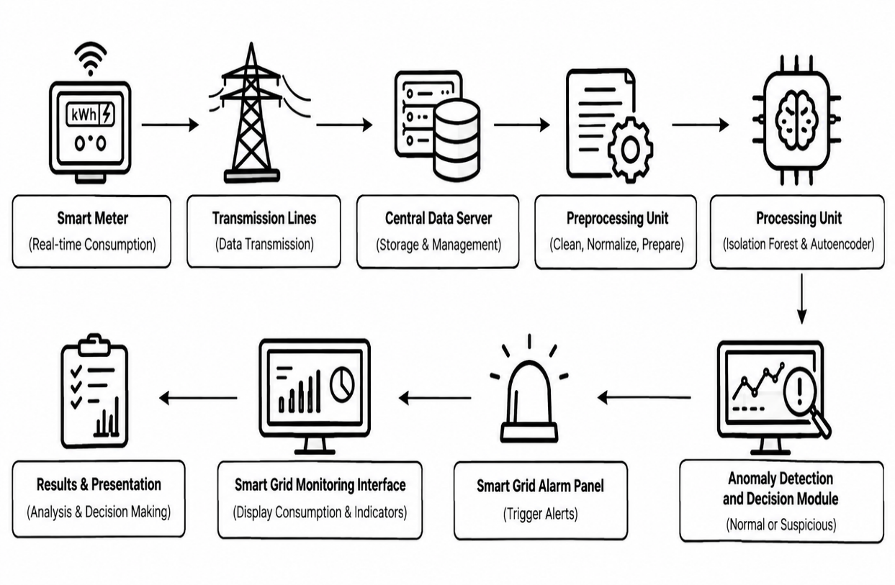
Figure 3 1 System architecture for detecting energy theft
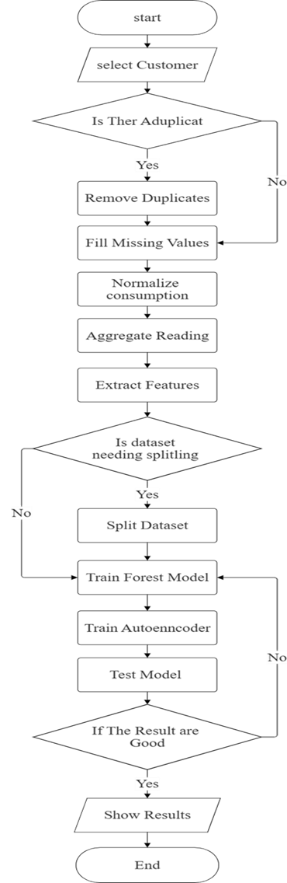
Figure 3 2 System flowchart
Figure 3.2 above illustrates the proposed flowchart for implementing an electricity theft detection system using anomaly detection techniques. The process begins with the selection and preparation of consumer electricity consumption data, followed by handling missing values and organizing the data chronologically to preserve the temporal characteristics of consumption patterns. Subsequently, relevant temporal and consumption-change features are extracted, and the resulting data are standardized to ensure that the input features are appropriately scaled for model training. The pre-processed dataset is then divided chronologically into training and testing sets. In the modeling stage, the Isolation Forest and Autoencoder algorithms are trained using the training data and subsequently applied to the testing data to identify abnormal electricity consumption patterns that may be associated with potential electricity theft. The detected anomalies are then evaluated using the selected performance metrics, including accuracy, precision, recall, F1-score, specificity, and AUC-ROC. Finally, the performance results of both models are presented and compared to determine their effectiveness under the experimental conditions of the study.

3.3 Data Collection
This study was based on the UCI Smart Meter Dataset, one of the most popular open datasets used in Energy Theft Detection and Anomaly Detection research. The dataset contains time-series data of electricity consumption collected from smart meters of residential users, and includes electricity consumption readings recorded at regular intervals, as well as timestamps and a number of variables associated with consumption patterns.
After obtaining the data, preprocessing was performed to prepare the consumption records for analysis. The data were sorted chronologically, temporal features such as Hour of Day and Day of Week were extracted, and a Consumption Change feature was calculated to represent changes between consecutive readings. StandardScaler was then fitted using the training data and applied to both the training and test data to maintain a consistent feature scale.

After data processing was completed, the data were divided chronologically into 70% for training and 30% for testing, ensuring that the evaluation reflected a realistic operating sequence. The processed data were then used for training the anomaly detection models and evaluating their ability to identify abnormal electricity consumption patterns.

3.4 Selected Anomaly Detection Algorithms
3.4.1 Isolation Forest Algorithm
Isolation Forest is an Unsupervised Anomaly Detection algorithm that isolates outliers by randomly partitioning data using different properties and partition points. Because abnormal data is fewer in number and more different from natural data, it is isolated by fewer divisions than natural data, making it easier to detect [21].
The Isolation Forest model was trained using the training data to learn patterns in electricity consumption and identify observations that deviate from the learned distribution. The Isolation Forest was configured with 200 estimators. Multiple iterations using different random states were performed to assess the stability of the model results. After training, Anomaly Score was calculated for each record using Decision Function, and records with scores exceeding 90th Percentile from the training data scores were considered anomalies.
3.5.2 Autoencoder Model
Autoencoder is a Deep Learning model that aims to learn the basic properties of natural data by compressing the data (Encoder) and then reconstructing it (Decoder) through an intermediate layer (Bottleneck). Anomaly detection is based on the Reconstruction Error measurement, where high values indicate abnormal consumption patterns [22].
The Autoencoder model was trained using the training data for 200 epochs. After training, a Reconstruction Error was calculated for each record, and records with errors exceeding the 90th percentile of the training reconstruction errors were classified as anomalies.
3.5.3 Model Evaluation
The performance of both the Isolation Forest and Autoencoder models was evaluated using a set of benchmark performance metrics, namely Accuracy, Precision, Recall, F1-Score, Specificity, and Area Under the ROC Curve (AUC-ROC). The performance of the two models was also compared using ROC Curve and Precision–Recall Curve curves to evaluate their ability to distinguish between normal and abnormal data, especially under data imbalance [23].

3.5 Implementation Tools and Environment
The proposed system was implemented using the Python programming language, with the help of a group of libraries specializing in data analysis and Machine Learning applications. The Scikit-learn library was used to implement Isolation Forest as a tree-based anomaly detection algorithm, while the Autoencoder model was developed using TensorFlow/ Keras to detect abnormal patterns based on Reconstruction Error. The Pandas and NumPy libraries were also used for data proces, while Matplotlib and Seaborn were relied upon to display and graphically represent the results. The models were implemented using selected parameter settings. The Autoencoder was trained for 200 epochs, while the Isolation Forest used 200 estimators. Multiple iterations with different random states were performed to assess the stability of the Isolation Forest results.
Experiments were conducted using a local machine with an Intel Core i5 processor and 16 GB of RAM, utilizing an NVIDIA GTX 1660 GPU to speed up training of the Autoencoder model when available. Google Colab was also used to provide additional computing resources, especially when models needed to be run using a GPU, which helped reduce training time and improve execution efficiency.
To support reproducibility, the following software versions were used: Python 3.10, Scikit-learn 1.5, TensorFlow 2.15, Pandas 2.2, NumPy 1.26, and Matplotlib 3.9. These versions were selected to ensure compatibility between different libraries and achieve stable and reproducible results.

3.6 Performance Metrics
To evaluate the performance of the proposed models, the Hold-out Evaluation method was used by splitting the data into training and test sets, The performance evaluation was based on the Confusion Matrix elements: True Positive (TP), True Negative (TN), False Positive (FP), and False Negative (FN), which were used to calculate a set of performance metrics as follows:
- Accuracy
Accuracy measures the ratio of correct predictions to the total number of samples, and is calculated according to the following equation:
$Accuracy=\frac{TP + TN}{TP + TN + FP + FN}$ (3.1)

- Precision (positive Predictive Value)
Precision represents the proportion of cases that were classified as abnormal and were actually true, and is calculated as follows:

$Precision=\frac{TP}{TP + FP}$ (3.2)

- Recall (True Positive Rate /Sensitivity)
Recall measures the model's ability to detect all existing anomalies, and is calculated by the equation:
$Recall=\frac{TP}{TP + FN}$ (3.3)

- F1_score
F1-Score is the harmonic mean between Precision and Recall, used to balance them, and is calculated as follows:
$F1=2×\frac{Precision × Recall}{Precision + Recall}$ (3.4)

- Specificity
Specificity measures the model's ability to correctly identify natural states, and is calculated according to the equation:
$Specificity=\frac{TN}{TN + FP}$ (3.5)

- AUC-ROC
$AUC=\int_{0}^{1}{TPR\left(FPR\right)d\left(FPR\right)}$ (3.6)

To compare the performance of models at different threshold values, both ROC Curve and Precision–Recall Curve were used. Both True Positive Rate (TPR) and False Positive Rate (FPR) are calculated as follows:
$Recall=\frac{TP}{TP + FN}$ (3.7)
$PR=\frac{FP}{FP + TN}$ (3.8)
The area under the ROC curve (ROC-AUC) is defined as the integral of TPR with respect to FPR.
In practice AUC is computed numerically (trapezoidal rule) from discrete threshold points:
$AUC=\sum_{i}{(FPR_{i+1} - FPR_{i} )×\frac{TPR_{i+1}+ TPR_{i}}{2}}$ (3.9)
The area under the Precision–Recall curve is typically estimated by summing recall increments weighted by precision at each threshold:
$AUC=\sum_{n}{{(Recall}_{n}- {Recall}_{n-1})×{Precision}_{n}}$ (3.10)

3.7 Summary
This chapter has provided a detailed and systematic account of the research methodology designed to detect energy theft in smart grids. The study was framed within a quantitative research design and followed a deductive approach, starting from the theory that energy theft manifests as detectable anomalies. A conceptual model was developed to guide the entire process, from the preprocessing of the UCI household electricity consumption dataset to the training of two unsupervised models: Isolation Forest and Autoencoder. The chapter detailed the implementation environment, the tools used, and the specific performance metrics—including precision, recall, F1-score, and ROC-AUC—that will be used for evaluation. Having established this robust methodological framework, the stage is now set for its application. The subsequent chapter will present and analyze the results obtained from executing these experiments, providing empirical evidence to evaluate the effectiveness of the proposed models.

Chapter Four
Results and Discussion

4.1 Introduction
This chapter presented and analyzed the results obtained after applying the Isolation Forest and Autoencoder models to electricity consumption data to detect Electricity Theft states in Smart Grids. The chapter also included evaluating the performance of models using different Performance Metrics and analyzing and comparing the results to determine which model is most efficient at detecting abnormal patterns.

4.2 Results
4.2.1 Overall System Performance
Table 4 1 Performance Metrics
Metric | Autoencoder | Isolation Forest
Accuracy | 0.947 | 0.968
Precision | 0.713 | 0.831
Recall | 0.702 | 0.819
F1-Score | 0.707 | 0.825
Specificity | 0.971 | 0.983
AUC-ROC | 0.905 | 0.990
Table 4.1 above showed the results of evaluating the performance of the Autoencoder and Isolation Forest models using a set of standard performance indicators. The results indicated that the Isolation Forest model performed better across all metrics compared to the Autoencoder model, with Accuracy (0.968) versus (0.947), and Precision (0.831) versus (0.713), indicating its greater ability to reduce false alarms. Recall also achieved a value of (0.819) versus (0.702), which reflects greater efficiency in detecting abnormal conditions. As a result, F1-Score recorded a value of (0.825) compared to (0.707), confirming a better balance between accuracy and retrieval. The Isolation Forest model also showed outstanding performance in recognizing natural data, with the Specificity value reaching (0.983) versus (0.971) for the Autoencoder model. In addition, it achieved the highest AUC-ROC value of (0.990) compared to (0.905).
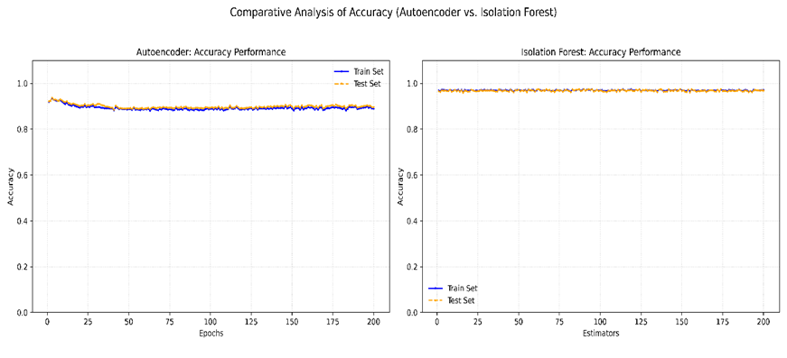
Figure 4 1 Comparative Accuracy (Autoencoder vs Isolation)
Figure 4.1 above showed the comparative Accuracy performance of the Autoencoder and Isolation Forest models across the training process. The Autoencoder showed variations in accuracy during the training epochs, while the Isolation Forest maintained relatively stable performance across its iterations. The final test accuracy values are reported separately in Table 4.1.
Similarly, Figure 4.2 below showed a comparison of the Average Precision (AP) performance between the Autoencoder and Isolation Forest models during the training and testing phases. It is noted that the Autoencoder model achieved an Average Precision (AP) of 0.64 on the training data and decreased to 0.58 on the test data, indicating a reduced ability to maintain accuracy when anomalies are detected. In contrast, the Isolation Forest model performed better, recording an Average Precision (AP) of 0.94 on the training data and 0.91 on the test data, with a clear convergence between the two curves, demonstrating the model's stability and generalizability.
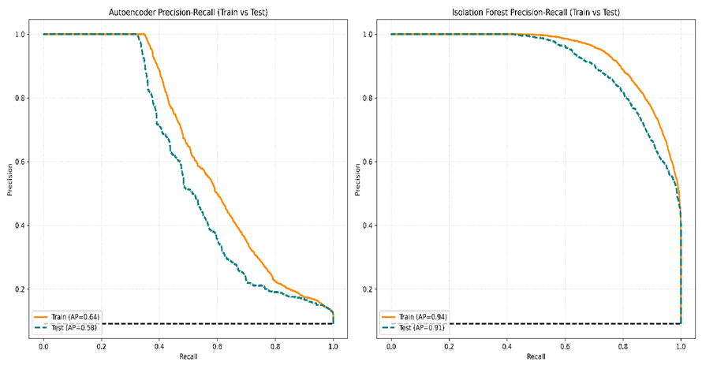
Figure 4 2 Comparative Precision (Autoencoder vs Isolation)
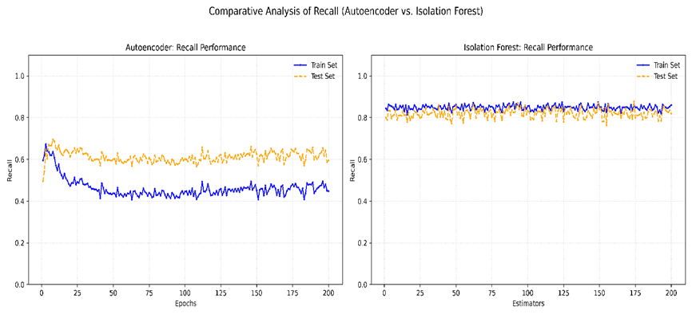
Figure 4 3 Comparative Recall (Autoencoder vs Isolation)
Also, Figure 4.3 above showed the comparison between the performance of Autoencoder and Isolation Forest in terms of the Recall scale across training phases. Autoencoder shows that the Recall value in the training data gradually decreases and stabilizes at around 0.40–0.45, while in the test data it ranges between 0.58–0.65 after the early stages of training, indicating an average ability to detect anomalies with the loss of part of abnormal patterns. In contrast, Isolation Forest achieves more stable performance, with Recall values ranging from 0.83–0.87 in the training data to 0.78–0.84 in the test data, with a clear convergence between the two curves, reflecting a high ability to detect most anomalies while maintaining stable performance and not being affected by increasing the number of estimators.
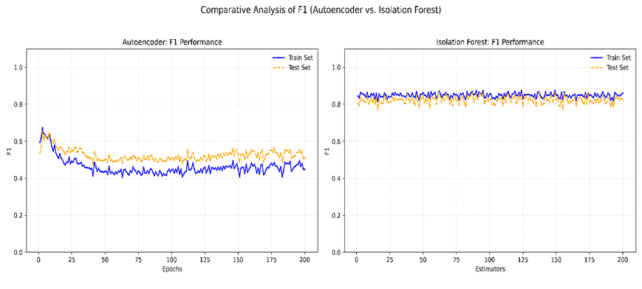
Figure 4 4 Comparative F1-Score (Autoencoder vs Isolation)
Figure 4.4 showed the comparison between the performance of Autoencoder and Isolation Forest using the F1-Score, which combines Precision and Recall to assess the balance between them. Autoencoder shows gradual stability after the early stages of training, with F1-Score values in training data ranging between 0.42–0.47, while in test data they range between 0.50–0.55, indicating limited improvement in balancing anomaly detection with reduced false alarms. In contrast, Isolation Forest achieved more stable and higher performance, with F1-Score values ranging from 0.83–0.87 in the training data to 0.78–0.84 in the test data, with a clear convergence between the training and test curves, demonstrating the model's.
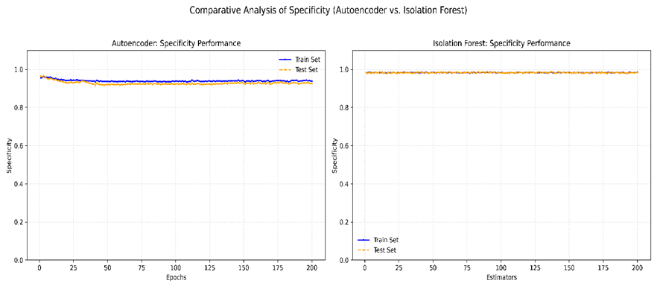
Figure 4 5 Comparative Specificity (Autoencoder vs Isolation)
Moreover, Figure 4.5 above showed a comparison between the performance of Autoencoder and Isolation Forest using the Specificity metric. Autoencoder showed good stability after the early stages of training, with Specificity values in both training and test data ranging between 0.92–0.96 with a clear convergence between the two curves, demonstrating a good ability to classify normal consumption and reduce false alarms. Isolation Forest achieved higher and more consistent performance, as Specificity values in the training and test data were maintained at a high level ranging between 0.978–0.985 with almost complete matching between the two curves, reflecting the model's ability to accurately distinguish between normal and abnormal patterns while maintaining stable performance across the different random-state iterations.
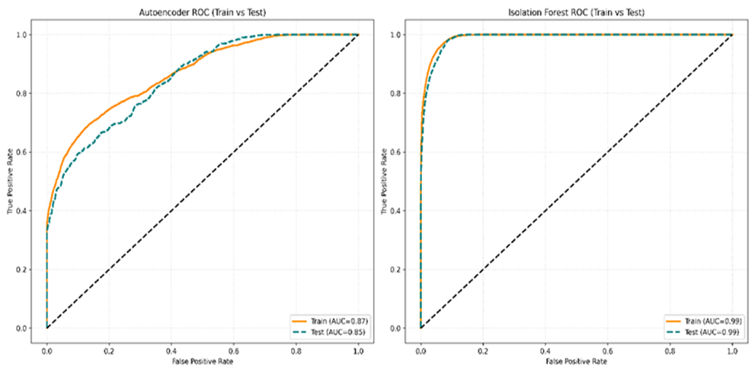
Figure 4 6 Comparative AUC-ROC (Autoencoder vs Isolation)
Figure 4.6 above presented a comparative analysis of the AUC-ROC performance of the Autoencoder and Isolation Forest models using the training and testing data. The AUC-ROC metric provides an overall assessment of the models’ ability to distinguish between normal consumption patterns and abnormal patterns across different classification thresholds. The Autoencoder demonstrates an acceptable level of discrimination, with relatively close performance between the training and testing curves, indicating that its ability to distinguish between the two classes remains reasonably consistent across the evaluated data. In comparison, the Isolation Forest model demonstrates substantially stronger AUC-ROC performance, with the training and testing curves showing a high degree of consistency. This indicates that Isolation Forest provides a more effective separation between normal and abnormal consumption patterns under the experimental conditions of this study. The close agreement between the training and testing results also suggests that the observed performance is relatively stable across the evaluated datasets. Overall, the comparative AUC-ROC analysis demonstrates the superior discrimination capability of Isolation Forest compared with the Autoencoder in the present anomaly-detection experiment.

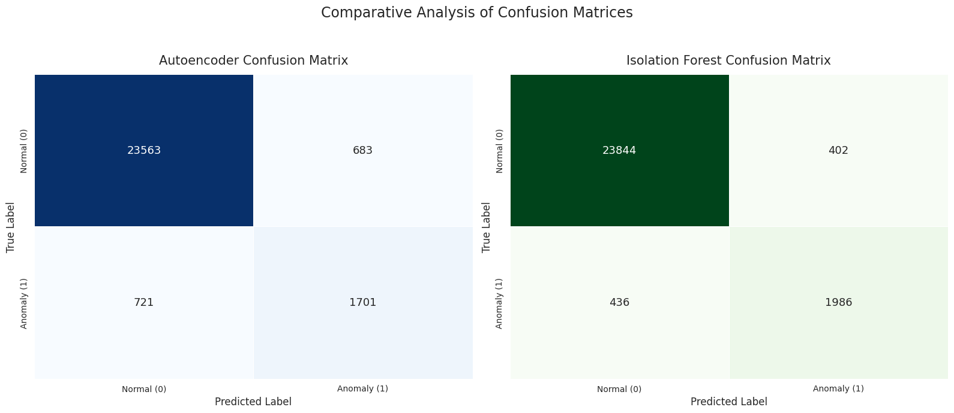
Figure 4 7 Confusion Matrix for (Autoencoder vs Isolation)
Figure 4.7 above showed the Confusion Matrix comparison of both Autoencoder and Isolation Forest on test data, showing the distribution of classification results for each model. The Autoencoder achieved 23,563 True Negatives (TN) cases and 1,701 True Positives (TP) cases, while recording 683 False Positives (FP) cases and 721 False Negatives (FN) cases. In contrast, Isolation Forest showed better performance, successfully classifying 23,844 True Negatives (TN) and 1,986 True Positives (TP) cases, with the number of False Positives (FP) decreasing to just 402, and False Negatives (FN) decreasing to 436.
In addition, Figure 4.8 below illustrated a comparative analysis of the Receiver Operating Characteristic (ROC) curves obtained from the Autoencoder and Isolation Forest models. The ROC curve provides a graphical representation of the relationship between the True Positive Rate (TPR) and False Positive Rate (FPR) across different decision thresholds, thereby providing an assessment of the models’ ability to distinguish between normal consumption patterns and abnormal patterns. As shown in the figure, the ROC curve of the Autoencoder remains below that of the Isolation Forest for a considerable portion of the evaluated range, indicating a comparatively lower discrimination capability. In contrast, the ROC curve of the Isolation Forest is positioned closer to the upper-left region of the plot, demonstrating a stronger ability to achieve higher true-positive detection rates while maintaining relatively low false-positive rates. The corresponding AUC-ROC results further support the comparative advantage of Isolation Forest over the Autoencoder in distinguishing abnormal consumption patterns. Therefore, the ROC analysis provides additional evidence that Isolation Forest achieved stronger overall discrimination performance under the experimental conditions of this study.
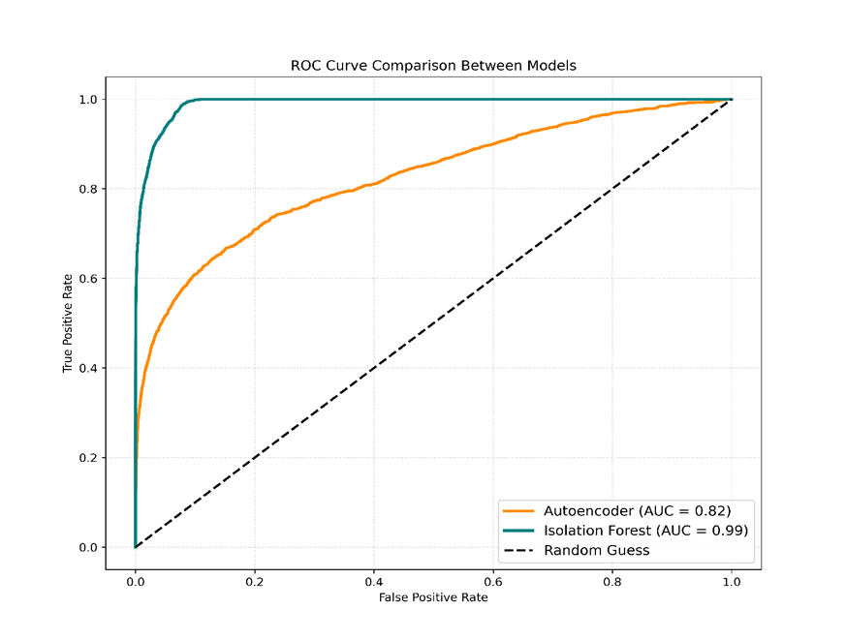
Figure 4 8 Comparative ROC Curve (Autoencoder & Isolation)
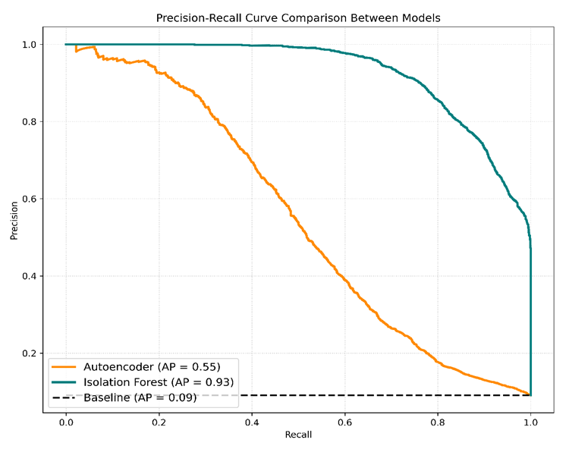
Figure 4 9 Comparative Precision-Recall Curve (Autoencoder & Isolation)
Figure 4.9 above showed the comparison of the Precision–Recall (PR) curves for both Autoencoder and Isolation Forest. Autoencoder shows the ability to maintain a Precision value of 1.0 until Recall reaches about 0.08, and then the curve begins to decrease significantly, achieving an Average Precision (AP) value of about 0.55, indicating a decrease in accuracy as the number of detected anomalies increases. In contrast, Isolation Forest kept the Precision value close to 1.0 until Recall reached about 0.50, then the curve gradually decreased, achieving an Average Precision (AP) value of about 0.93. The large breadth of space under the Precision–Recall curve reflects Isolation Forest's ability to achieve a better balance between Precision and Recall while reducing false alarms, confirming its clear superiority over Autoencoder and making it the most suitable choice for detecting energy theft in Smart Grids systems with imbalanced data.

4.7 Discussion
The results of this study, which aimed to evaluate the effectiveness of Anomaly Detection techniques in identifying abnormal patterns in electricity consumption data within Smart Grids using the UCI Smart Meter Dataset, showed that both models were able to detect anomalies. However, Isolation Forest performed better across the main evaluation indicators, achieving Accuracy = 96.8%, Precision = 83.1%, Recall = 81.9%, F1-Score = 82.5%, Specificity = 98.3%, and AUC-ROC = 99.0%, compared with the Autoencoder, which achieved Accuracy = 94.7%, Precision = 71.3%, Recall = 70.2%, F1-Score = 70.7%, Specificity = 97.1%, and AUC-ROC = 90.5%. These results indicate that Isolation Forest provided better overall anomaly-detection performance and produced fewer classification errors at the selected operating threshold.
These results are consistent with the study [18] that demonstrated the effectiveness of Isolation Forest in detecting energy theft, and they are also consistent with the study [16] that confirmed the ability of Autoencoder to detect abnormal patterns. However, the results of the current study showed the superiority of Isolation Forest in all performance indicators. The results are also consistent with the study [14] that achieved high AUC using Deep Neural Network, while the current study was able to reach AUC-ROC = 99.0% using an unsupervised model, which enhances its applicability in environments that lack disaggregated data. In contrast, the results were lower than the study [19] that relied on Supervised Learning and achieved an F1-score of 93.7%, which is attributed to the current study's reliance on Unsupervised Learning without the need for pre-labeled data, making it more suitable for practical application in Smart Grids systems.

4.8 Summary
This chapter presented a comprehensive empirical evaluation of the Isolation Forest and Autoencoder algorithms for anomaly detection in energy consumption data. A detailed performance analysis was conducted, first by examining the learning and sensitivity curves of each model individually, and then through a direct comparative evaluation using ROC and Precision-Recall curves.
The results consistently demonstrated the superior performance of the Isolation Forest model. It achieved a significantly higher F1-Score (0.825 vs. 0.707) and AUC (0.99 vs. 0.85) compared to the Autoencoder. The Precision-Recall curve analysis was particularly revealing, highlighting the Isolation Forest’s ability to maintain high precision, making it a more reliable and practical choice for real-world applications where false alarms are costly.
The findings were contextualized within IEEE literature, contributing an empirical benchmark that supports the effectiveness of ensemble-based methods for complex, imbalanced datasets. In conclusion, this chapter identifies Isolation Forest as the more effective and robust algorithm for this specific anomaly detection task.

Chapter Five
Conclusion and Recommendations

5.1 Conclusions
This research concluded that using Anomaly Detection techniques is an effective approach to detecting abnormal electricity consumption patterns that may be associated with Electricity Theft in Smart Grids by analyzing smart meter data. The performance of the Isolation Forest algorithm and the Autoencoder model was compared using data from the UCI Machine Learning Repository after applying the Data Preprocessing and Feature Engineering phases. The results showed that both models were able to detect abnormal patterns, but the Isolation Forest algorithm performed better on all evaluation metrics, recording Accuracy = 0.968, Precision = 0.831, Recall = 0.819, F1-Score = 0.825, Specificity = 0.983, and AUC-ROC = 0.990, compared to the Autoencoder model, which recorded Accuracy = 0.947, Precision = 0.713, Recall = 0.702, F1-Score = 0.707, and Specificity = 0.971, and AUC-ROC = 0.905. These results indicate that the Isolation Forest algorithm was the more effective option for detecting abnormal consumption patterns under the unsupervised evaluation framework used in this study. They also highlight its potential for use in supporting Smart Grid monitoring and loss reduction systems, with future developments using real operational data and more advanced Hybrid models.

5.2 Recommendations
- It is recommended that the proposed model be applied to real data from electricity distribution companies to verify its efficiency in actual operational environments.
- It is recommended to study the performance of other Anomaly Detection algorithms and compare them with Isolation Forest and Autoencoder to improve detection accuracy.
- It is recommended to develop Hybrid models that combine more than one algorithm to take advantage of the advantages of each model and increase the efficiency of Electricity Theft state detection.
- It is strongly recommended to incorporate additional factors, such as seasonal data and subscriber consumption patterns, to improve the models' ability to distinguish between normal and abnormal consumption.
- It is recommended that the proposed model be integrated with Smart Grid and Smart Meters systems to support real-time monitoring (Real-Time Monitoring) and early detection of Electricity Theft cases.

5.3 Future Work Suggestions
- Detecting electricity theft using Hybrid Deep Learning models
- Real-time detection of energy theft using Edge Computing and Smart Grids
- Using Explainable Artificial Intelligence (XAI) to Detect Electricity Theft in Smart Grids
- Using Graph Neural Networks (GNNs) to Detect Anomalies in Smart Meter Data
- Using Federated Learning to detect electricity theft while maintaining data privacy.

Reference
- A. Chauhan et al., “Non-technical losses in power system: A review,” in Proc. IEEE 5th Int. Conf. Bio-Inspired Comput. Theories Appl. (BIC-TA), 2010, pp. 1343–1348, doi: 10.1109/BICTA.2010.5645244.
- A. Takiddin et al., “Deep autoencoder-based anomaly detection of electricity theft cyberattacks in smart grids,” IEEE Syst. J., vol. 16, no. 3, pp. 4106–4117, Sept. 2022, doi: 10.1109/JSYST.2021.3136683.
- B. Altyb et al., “Energy harvesting in wireless sensor networks,” Int. J. Eng. Appl. Manage. Sci. Paradigms, vol. 29, no. 1, 2015.
- C. C. Aggarwal, Outlier Analysis, 2nd ed. Cham, Switzerland: Springer, 2017, pp. 1–34.
- C. C. O. Ramos et al., “Fast non-technical losses identification through optimum-path forest,” in Proc. IEEE 15th Int. Conf. Intell. Syst. Appl. Power Syst. (ISAP), 2010, pp. 1–6, doi: 10.1109/ISAP.2009.5352830.
- F. M. Osman et al., “Cyber-physical system for smart grid,” in Artificial Intelligence Paradigms for Smart Cyber-Physical Systems, A. K. Luhach and A. Elçi, Eds. Hershey, PA, USA: IGI Global, 2021, pp. 301–323, doi: 10.4018/978-1-7998-5101-1.ch014.
- F. T. Liu et al., “Isolation forest,” in Proc. IEEE Int. Conf. Data Mining (ICDM), Pisa, Italy, 2008, pp. 413–422, doi: 10.1109/ICDM.2008.17.
- G. Lin et al., “Electricity theft detection based on stacked autoencoder and the undersampling and resampling based random forest algorithm,” IEEE Access, vol. 9, pp. 124044–124058, 2021, doi: 10.1109/ACCESS.2021.3110510.
- J. Almalki, “Unsupervised learning with hybrid models for detecting electricity theft in smart grids,” IEEE Access, vol. 12, pp. 187027–187040, 2024, doi: 10.1109/ACCESS.2024.3498733.
- J. Davis and M. Goadrich, “The relationship between Precision-Recall and ROC curves,” in Proc. 23rd Int. Conf. Mach. Learn. (ICML), Pittsburgh, PA, USA, 2006, pp. 233–240, doi: 10.1145/1143844.1143874.
- J. Nagi et al., “Detection of abnormalities and electricity theft using genetic support vector machines,” IEEE Trans. Power Del., vol. 26, no. 4, pp. 2434–2441, Oct. 2011, doi: 10.1109/TPWRD.2011.2162066.
- J. Yang et al., “Electricity theft detection based on deep learning: A comprehensive review,” IEEE Access, vol. 9, pp. 90193–90206, 2021, doi: 10.1109/ACCESS.2021.3090684.
- K. M. Ghori et al., “Electricity theft detection using smart meter data: A review,” IEEE Access, vol. 8, pp. 212234–212247, 2020, doi: 10.1109/ACCESS.2020.2988667.
- K. Zhou et al., “Energy theft detection in smart grids: A review of methods and techniques,” Renew. Sustain. Energy Rev., vol. 57, pp. 1326–1335, May 2016, doi: 10.1016/j.rser.2015.12.056.
- L. J. Lepolesa et al., “Electricity theft detection in smart grids based on deep neural network,” IEEE Access, vol. 10, pp. 39638–39655, 2022, doi: 10.1109/ACCESS.2022.3166146.
- M. B. Hassan et al., “Green machine learning for green cloud energy efficiency,” in Proc. 2022 IEEE 2nd Int. Maghreb Meeting Conf. Sci. Techn. Automatic Control Comput. Eng. (MI-STA), 2022, pp. 288–294, doi: 10.1109/MI-STA54861.2022.9837531.
- M. F. G. Burgos et al., “A review of smart grid anomaly detection approaches pertaining to artificial intelligence,” Appl. Sci., vol. 14, no. 3, Art. no. 1194, 2024, doi: 10.3390/app14031194.
- M. J. Elzubair et al., “Unsupervised anomaly detection for energy theft identification in smart grids using isolation forest and autoencoder models,” in Proc. 2026 IEEE 5th Int. Maghreb Meeting Conf. Sci. Techn. Automatic Control Comput. Eng. (MI-STA), Sebha, Libya, 2026, pp. 906–911, doi: 10.1109/MI-STA68962.2026.11511247.
- M. K. Hasan et al., “Smart grid cyber-physical systems: Components, vulnerabilities, mitigations, opportunities, and conceptual framework,” Energy Rep., vol. 15, Art. no. 109255, 2026, doi: 10.1016/j.egyr.2026.109255.
- M. M. Hasan et al., “Lightweight protocol using elliptic curve based key agreement techniques for secured cyber-physical systems of smart grids,” in Proc. 2025 Int. Conf. Electrical Eng. Informat. (ICEEI), Kuching, Malaysia, 2025, pp. 1–6, doi: 10.1109/ICEEI68459.2025.11330554.
- M. M. Saeed et al., “Anomaly detection in 6G networks using machine learning methods,” Electronics, vol. 12, no. 15, Art. no. 3300, 2023, doi: 10.3390/electronics12153300.
- M. M. Saeed et al., “LLM-integrated anomaly detection for IoT networks: Framework structure,” Baghdad Sci. J., vol. 23, no. 8, Art. no. 23, 2026, doi: 10.21123/2411-7986.5392.
- M. Sakurada and T. Yairi, “Anomaly detection using autoencoders,” in Proc. MLSDA Workshop, 2014, pp. 1–11.
- N. N. Elmadina et al., “Double deep RL-based strategy for UAV-assisted energy harvesting optimization in disaster-resilient IoT networks,” in Proc. 9th Int. Conf. Mechatronics Eng. (ICOM), Kuala Lumpur, Malaysia, 2024, pp. 411–416, doi: 10.1109/ICOM61675.2024.10652500.
- N. N. Elmadina et al., “HarvestEdge: Energy harvesting in UAV-assisted edge networks,” in Proc. 5th Int. Conf. Emerging Smart Technol. Appl. (eSmarTA), Ibb, Yemen, 2025, pp. 1–8, doi: 10.1109/eSmarTA66764.2025.11132139.
- N. S. M. Salleh et al., “Electricity anomaly point detection using unsupervised technique based on electricity load prediction derived from long short-term memory,” in Proc. 2nd Int. Conf. Artificial Intell. Data Sci. (AiDAS), 2021, pp. 1–6, doi: 10.1109/AiDAS53897.2021.9574235.
- P. Jokar et al., “Electricity theft detection in AMI using customers’ consumption patterns,” IEEE Trans. Smart Grid, vol. 7, no. 1, pp. 216–226, Jan. 2016, doi: 10.1109/TSG.2015.2425406.
- R. A. Saeed et al., “Machine-to-machine smart grid synchronization for sustainable energy,” in Proc. 2nd Int. Conf. Energy Syst. Technol., Cairo, Egypt, 2013, pp. 163–176.
- R. F. Mansour et al., “Design of cultural emperor penguin optimizer for energy-efficient resource scheduling in green cloud computing environment,” Cluster Comput., 2022, doi: 10.1007/s10586-022-03608-0.
- R. H. Yosuf et al., “Scheduling algorithm for grid computing using shortest-job-first with time quantum,” Intell. Autom. Soft Comput., vol. 31, no. 1, pp. 581–590, 2022, doi: 10.32604/iasc.2022.019928.
- R. S. Abdalla et al., “IoE design principles and architecture,” in Internet of Energy for Smart Cities: Machine Learning Models and Techniques. Boca Raton, FL, USA: CRC Press, 2020, doi: 10.1201/9781003047315-6.
- S. Banik et al., “Anomaly detection techniques in smart grid systems: A review,” in Proc. IEEE World AI IoT Congr. (AIIoT), 2023, pp. 1–7, doi: 10.1109/AIIoT58121.2023.10174465.
- S. Gadal et al., “Machine learning-based anomaly detection using K-means array and sequential minimal optimization,” Electronics, vol. 11, no. 14, Art. no. 2158, 2022, doi: 10.3390/electronics11142158.
- T. El-Toukhy et al., “Electricity theft detection using deep reinforcement learning in smart power grids,” IEEE Access, vol. 11, pp. 70784–70799, 2023, doi: 10.1109/ACCESS.2023.3284681.
- X. Fang et al., “Smart grid—The new and improved power grid: A survey,” IEEE Commun. Surveys Tuts., vol. 14, no. 4, pp. 944–980, Fourth Quarter 2012, doi: 10.1109/SURV.2011.101911.00087.
- X. Xia et al., “ETD-ConvLSTM: A deep learning approach for electricity theft detection in smart grids,” IEEE Trans. Inf. Forensics Security, vol. 18, pp. 2553–2568, 2023, doi: 10.1109/TIFS.2023.3265884.
- Z. A. Khan et al., “Electricity theft detection using supervised learning techniques on smart meter data,” Sustainability, vol. 12, no. 19, Art. no. 8023, 2020, doi: 10.3390/su12198023.
- Z. E. Ahmed et al., “Optimizing energy consumption for cloud Internet of Things,” Front. Phys., vol. 8, Art. no. 358, 2020, doi: 10.3389/fphy.2020.00358.

Appendix
Appendix No. (A): Simulation Code
import pandas as pd
import numpy as np
import tensorflow as tf
from tensorflowkeras import layers, regularizers
from sklearn. preprocessing import StandardScaler
from sklearn.metrics import (accuracy_score, precision_score, recall_score, f1_score,
roc_auc_score, confusion_matrix, r2_score, mean_squared_error,
roc_curve, auc, precision_recall_curve, average_precision_score)
from sklearn.ensemble import IsolationForest
import matplotlib.pyplot as plt
import json

df = pd.read_excel("Data Morocco.xlsx")
df = df.sort_values('DateTime')
split_idx = int(0.7 * len(df))
df_train = df.iloc[:split_idx].copy()
df_test = df.iloc[split_idx:].copy()

def prepare_features(df, zone_col='zone1'):
df = df.copy()
df['Hour'] = pd.to_datetime(df['DateTime']).dt.hour
df['DayOfWeek'] = pd.to_datetime(df['DateTime']).dt.dayofweek
df['Consumption_Change'] = df[zone_col].diff().fillna(0)
features = [zone_col, 'Hour', 'DayOfWeek', 'Consumption_Change']
return df, features

df_train, features = prepare_features(df_train, zone_col='zone1')
df_test, _ = prepare_features(df_test, zone_col='zone1')

X_train_raw = df_train[features].values
X_test_raw = df_test[features].values

scaler = StandardScaler().fit(X_train_raw)
X_train = scaler.transform(X_train_raw)
X_test = scaler.transform(X_test_raw)

def compute_metrics(y_true, y_pred, scores, X_true=None, X_pred=None):
cm = confusion_matrix(y_true, y_pred)
tn, fp, fn, tp = cm.ravel()
specificity = tn / (tn + fp) if (tn + fp) != 0 else 0

metrics = dict(
Accuracy=accuracy_score(y_true, y_pred),
Precision=precision_score(y_true, y_pred, zero_division=0),
Recall=recall_score(y_true, y_pred, zero_division=0),
F1=f1_score(y_true, y_pred, zero_division=0),
Specificity=specificity,
AUC=roc_auc_score(y_true, scores)
)
if X_true is not None and X_pred is not None:
metrics['R2'] = r2_score(X_true, X_pred)
metrics['MSE'] = mean_squared_error(X_true, X_pred)
else:
metrics['R2'] = np.nan
metrics['MSE'] = np.nan
return metrics, cm

input_dim = X_train.shape[1]
autoencoder = tf.keras.Sequential([
layers.Input(shape=(input_dim,)),
layers.Dense(32, activation='relu', kernel_regularizer=regularizers.l2(1e-4)),
layers.Dropout(0.2),
layers.Dense(8, activation='relu'),
layers.Dense(32, activation='relu'),
layers.Dense(input_dim, activation='linear')
])

autoencoder.compile(optimizer='adam', loss='mse')

epochs = 200
metric_names = ['Accuracy', Precision', 'Recall', 'F1', 'Specificity', 'AUC', 'R2', 'MSE']
train_metrics_ae = {m: [] for m in metric_names}
test_metrics_ae = {m: [] for m in metric_names}

dist_train = np.linalg.norm(X_train, axis=1)
thr_label = np.quantile(dist_train, 0.90)
y_train = (dist_train >= thr_label).astype(int)
dist_test = np.linalg.norm(X_test, axis=1)
y_test = (dist_test >= thr_label).astype(int)

for epoch in range(epochs):
autoencoder.fit(X_train, X_train, epochs=1, batch_size=128, verbose=0)
train_pred = autoencoder.predict(X_train, verbose=0)
test_pred = autoencoder.predict(X_test, verbose=0)
train_rec = np.mean((X_train - train_pred)**2, axis=1)
test_rec = np.mean((X_test - test_pred)**2, axis=1)
thr = np.quantile(train_rec, 0.90)
y_pred_train = (train_rec >= thr).astype(int)
y_pred_test = (test_rec >= thr).astype(int)
train_res, cm_ae_train = compute_metrics(y_train, y_pred_train, train_rec, X_train, train_pred)
test_res, cm_ae_test = compute_metrics(y_test, y_pred_test, test_rec, X_test, test_pred)
for m in metric_names:
train_metrics_ae[m].append(train_res[m])
test_metrics_ae[m].append(test_res[m])
if epoch == epochs - 1:
ae_final_scores = test_rec
ae_train_scores = train_rec

iterations = 200
train_metrics_if = {m: [] for m in metric_names}
test_metrics_if = {m: [] for m in metric_names}

for i in range(iterations):
iso_forest = IsolationForest(n_estimators=200, random_state=i).fit(X_train)
train_scores = -iso_forest.decision_function(X_train)
test_scores = -iso_forest.decision_function(X_test)
thr_if = np.quantile(train_scores, 0.90)
y_pred_train_if = (train_scores >= thr_if).astype(int)
y_pred_test_if = (test_scores >= thr_if).astype(int)
train_res_if, cm_if_train = compute_metrics(y_train, y_pred_train_if, train_scores)
test_res_if, cm_if_test = compute_metrics(y_test, y_pred_test_if, test_scores)
for m in metric_names:
train_metrics_if[m].append(train_res_if[m])
test_metrics_if[m].append(test_res_if[m])
if i == iterations - 1:
if_final_scores = test_scores
if_train_scores = train_scores

final_metrics_ae = {m: test_metrics_ae[m][-1] for m in metric_names}
final_metrics_if = {m: test_metrics_if[m][-1] for m in metric_names}

results = {
"epochs": epochs,
"iterations": iterations,
"metric_names": metric_names,
"y_test": y_test.tolist(),
"y_train": y_train.tolist(),
"autoencoder": {
"train": train_metrics_ae,
"test": test_metrics_ae,
"final_metrics": final_metrics_ae,
"cm_train": cm_ae_train.tolist(),
"cm_test": cm_ae_test.tolist(),
"final_scores": ae_final_scores.tolist(),
"train_scores": ae_train_scores.tolist()
},
"isolation_forest": {
"train": train_metrics_if,
"test": test_metrics_if,
"final_metrics": final_metrics_if,
"cm_train": cm_if_train.tolist(),
"cm_test": cm_if_test.tolist(),
"final_scores": if_final_scores.tolist(),
"train_scores": if_train_scores.tolist()
}
}

with open("tt_anomaly_detection_results.json", 'w') as f:
json.dump(results, f, indent=4)

print("tt_anomaly_detection_results.json")

def plot_single_model_roc(model_name, train_scores, test_scores, y_train, y_test):
fpr_train, tpr_train, _ = roc_curve(y_train, train_scores)
fpr_test, tpr_test, _ = roc_curve(y_test, test_scores)
auc_train = auc(fpr_train, tpr_train)
auc_test = auc(fpr_test, tpr_test)
plt.figure(figsize=(8, 8))
plt.plot(fpr_train, tpr_train, label=f'Train (AUC = {auc_train:.4f})', lw=2)
plt.plot(fpr_test, tpr_test, label=f'Test (AUC = {auc_test:.4f})', lw=2, linestyle='--')
plt.plot([0, 1], [0, 1], 'k--', label='Random Guess')
plt.xlabel('False Positive Rate')
plt.ylabel('True Positive Rate')

