Sudan University for Sciences and Technology
College of Graduate Studies

Estimation of the Relation between the Female Height
with Kidney Length Using Ultrasonography
تحديد العلاقة بين طول الإناث وطول الكليتين بإستخدام التصوير بالموجات فوق الصوتية

A thesis Submitted for Partial Fulfillment for the Requirement of M.Sc. Degree in Medical Diagnostic Ultrasound

By:
Siham Mohammed Abd Allah

Supervisor:
Dr. Asma Ibrahim Ahmed

2017

الآية

قال تعالى:
بسم الله الرحمن الرحيم

(وفي أنفسكم أفلا تبصرون )

الذاريات (21)

Dedication

I would like to dedicate my thesis to:
My parents whom always support and encourage me to go forward by their prayers.
To my lovely husband Wagdi who always gives me what all I need and makes my life easier and happier
My brothers whom love me, support, and help me.
My dear sister Suhair whom goes with me step by step in this long road.
My colleagues and every person who helped me.

Acknowledgment

I would like to thank firstly God for enabling me to complete this thesis.
I would like to specially thank Dr. Asma Ibrahim Ahmedthe supervisor of my thesis.
I am particularly gratefully to ultrasound department staff at Alhasahesa hospital.
Thanks also to every person who helped me.
Thanks finally to God who gave me the energy to finish my work

Abstract
This was descriptive cross-sectional study which conducted in Alhasahesa . teaching hospital Aljazeera state . Sudan to assess the relationship between the heights of female individual and the renal length using ultrasonography.
This study was carried out during the period from October 2016 to January 2017.
The data was collected from fifty women, their ages were between (14 and 45) years old, analyzed by SPSS (statistical package for social science).
The study showed the maximum height of female was (175 cm) 2% and the minimum of the height was (152 cm) 2% the most frequent height was (160 cm) 30%. The study showed the maximum age of female was (45 years) 2% and the minimum of the age was (14 years) 2% the most frequent age group was (36-45) 36%. Generally the Rt kidney was shorter than the Lt Kidney. The Rt kidney length was proportionally increased with the height of female according to Person’s test in strength about (0.44).
The Lt Kidney was also proportionally increased with the height of female but less than the Rt kidney by using the same test the strength about (0.24). The study recommended more research studies should be done about the relation of other parameters such as weight, occupations, and races with renal length by using large sample size.
The RT kidney length was proportionally increased with the age of female according to Person’s test in strength about (0.29).
The Lt Kidney was also proportionally increased with the age of female but less than the Rt kidney by using the same test the strength about (0.25). The study recommended more research studies should be done about the relation of other parameters such as weight, occupations, and races with renal length by using large sample size.

مستخلص الدراسة
في طب المجاري البولية يعتبر قياس الكلية مؤشراً مهما في عملية التشخيص ،يمكن أخذ مقاسات الكلية باستخدام العديد من وسائل التصوير الحديثة مثل الموجات الصوتية الأشعة المقطعية ،والرنين المغناطيسي .
قياس طول الكلية لمعرفة المدى الطبيعي له يمثل أداة أساسية مساعدة للتشخيص والتدخل المبكرين، إختلال نمو الكلية وأمراض الكلى تترافق معها تغيرات في قياسات الكلى وللتقييم العملي في التطبيقات السريرية يستخدم طول الكلية كمقياس أساسي لأنه يعطي نتائج مؤكدة كم أنه سهل الإجراء، درست في هذا البحث العلاقة ما بين طول الكلية وإثنين من المقاييس وهما أرتفاع الفرد ،والعمر وركزت في بحثي على الإناث لأجد العلاقة ما بين طول الأنثى وعمرها وطول كليتيها، هذه دراسة مقطعية وصفية أجريت في مستشفى الحصاحيصا التعليمي، لتقويم العلاقة بين إرتفاع وعمرالأنثى وطول كليتيها بإستخدام الموجات فوق الصوتية أُجريت هذه الدراسة في الفترة من أكتوبر 2016 وحتى يناير2017 تم جمع البيانات من 50 إمرأة تتراوح أعمارهن بين 14-45 سنة. وتم تصنيفها وتحليلها بإستعمال الحزمة الإحصائية للعلوم الإجتماعية
توصلت الدراسة إلى أن أقل إرتفاع للإناث هو152سم بنسبة (2%) وأعلى إرتفاع للإناث هو 175 بنسبة (2%) ،كما أن الإرتفاع الأكثرتكراراً هو 160 بنسبة 30%.توصلت الدراسة أيضاً إلى أن أدنى الأعمار 14 سنة بنسبة 2% وأعلاها 45 سنة بنسبة 2% والفئة العمرية 36-45 سنة تشكل نسبة 36%.
عموما وجد أن الكلية اليمنى أقصر من الكلية اليسرى.
وفقاً لمقياس بيرسون للارتباط وجد أن طول الكلية اليمنى واليسرى يتناسب طردياً مع زيادة طول المرأة الإرتباط بالطول في الكلية اليمنى أقوى بقوة تصل إلى 0.44 الإرتباط بالطول في الكلية اليسرى أقل قوة 0.24 وفقاً لنفس المقياس . وفقاً لمقياس بيرسون للارتباط وجد أن طول الكلية اليمنى واليسرى يتناسب طردياً مع زيادة عمر المرأة ،الإرتباط بالعمر في الكلية اليمنى أقوى بقوة تصل إلى 0.29 ،الإرتباط بالعمر في الكلية اليسرى أقل قوة 0.25 وفقاً لنفس المقياس أوصت الدراسة بمزيد من الدراسات لتحديد العلاقة بين مقاييس أخرى مثل الوزن ،المهنة ،والجنس بطول الكليتين بإستخدام عينة أكبر.

Table of Contents
الآية I
Dedication II
Acknowledgment III
Abstract IV
مستخلص الدراسة V
List of tables VIII
List of figures IX
List of abbreviations: X
CHAPTER ONE 1
1.1 Introduction 1
1.2 Problem of the study 2
1.3 Objectives 2
1.3.1 General Objectives: 2
1.3.2 Specific objective: 2
CHAPTER TWO 3
Literature review and theoretical background 3
2.1 Anatomy of kidneys 3
2-2 Physiology 4
2-3 Female Height 6
2-4 Renal length 6
2-5 Normal Renal Measurements 7
2-6 Renal ultrasound 7
2-7 Technique 9
CHAPTER THREE 15
Material and Methodology 15
3- Methodology:- 15
3-1 Study design:- 15
3-2 Area of the study:- 15
3-3 Duration of the study:- 15
3-4 Study population:- 15
3-5 Sample size:- 15
3-6 Study variables:- 15
3-7 Equipment for data collection:- 15
3-8 Tools of data collection:- 15
3-9 scanning technique:- 15
3-10 Data analysis:- 16
3-11 Data presentation:- 16
3-12 Data storage:- 16
3-13 Ethical considerations:- 16
Chapter Four 17
Results 17
CHAPTER FIVE 22
DISCUSSION, CONCLUSION AND RECOMMENDATION 23
5.1 Discussion: 23
5-2 Conclusion:- 24
5-3 Recommendations Error! Bookmark not defined.
References: 26

List of tables
Table No | Table title | Page
(4-1) | Frequency distribution according to age
(4-2) | Frequency distribution according to age
(4-3) | Frequency distribution according to female height in cms
(4-4) | Frequency distribution according to Rt kidney length in mms
(4-5) | Frequency distribution according Lt kidney length in mms
(4-6) | The correlation between female height and Rt kidney
(4-7) | Correlation between the female height and Lt kidney
(4-8) | Correlation between the female age and the Rt kidney
(4-9) | correlation between the female age and the Lt kidney

List of figures
Figure No | Title | Page
(2-1) | Anatomy of kidneys
(2-2) | A normal kidney with true maximum length of 11 cm (A) Shown to have an apparent length of 8.6 cm due to inaccurate orientation (B).
(4-1) | Frequency distribution according to age
(4-2) | Frequency distribution according to height
(4-3) | Frequency distribution according to Rt kidney length in mm

List of abbreviations:
CT | Computed Tomography.
cm | Centimeter.
ESRD | End stage renal disease.
IVC | Inferior vena cava.
KBR | Kidney body ratio.
Lt | left .
m | Meter.
mm | Millimeter.
MRI | Magnetic Resonance Image.
RT | Right.
SD | Standard deviation
USG | Ultrasonography.

CHAPTER ONE
Introduction

CHAPTER ONE

1.1 Introduction
The kidneys in the fresh state are reddish-brown. They are situated posteriorly behind the peritoneum on each side of the vertebral column and are surrounded by adipose tissue. Superiorly they are level with the upper border of the twelfth thoracic vertebra, inferiorly with the third lumbar vertebra. The right is usually slightly inferior to the left, probably reflecting its relationship to the liver. The left is a little longer and narrower than the right and lies nearer the median plane. The long axis of each kidney is directed inferolaterally and the transverse axis posteromedially. Hence the anterior and posterior aspects usually described are in fact anterolateral and posteromedial. The transpyloric plane passes through the superior part of the right renal hilum and the inferior part of the left. (Grays 2008)
Kidney plays an important role in our body such as excretes metabolic wastes, maintaining the equilibrium between fluid and electrolyte, control of blood pressure, erythropoiesis etc. Loss of kidney mass and kidney function alters the length and size of kidney. Many diseases adversely affect the kidney leading to its enlargement and reduction. Renal dimensions are also greatly affected by age, gender and body mass index.
The methods of assessment of changes in the dimensions of visceral organs by using clinical methods are difficult and unreliable and there may occur subjective errors. Thus now-a-days, there are several newer techniques like x-rays, USG, CT, and MRI etc. to detect renal pathology. Thus measurement of renal length and to establish its normal range serves as a baseline tool for early diagnosis and intervention (IOSR Journal of Dental and Medical Sciences 2016).
Systemic diseases like diabetes mellitus and hypertension rising globally and are the leading cause of end stage renal disease (ESRD).
Multiple renal diseases like nephrolithiasis, hydronephrosis, chronic renal diseases, and renal tumors along with end stage renal disease alters renal dimensions leading to changes in the size and shape of kidney. Thus estimation of renal size is a vital criteria in the diagnosis, treatment and evaluation of renal disease. Renal size estimation most commonly includes renal length, renal volume and cortical thickness. For everyday practice, renal length measurements are more reliable because of its easy reproducibility. Renal dimensions measurement is widely carried out by ultrasonography (USG) because of its accessibility, non-invasive and easy reproducibility. ( . Paul L, Talhar S, Sontakke B, Shende M, Waghmare J (2016)

1.2 Problem of the study
Kidney length may increase by many disease but also may increase proportionally with height unless we knew this fact it may lead to misdiagnosis .

1.3 Objectives

1.3.1 General Objectives:
To estimate the relation between the length of kidneys and the female height and .

1.3.2 Specific objective:
• To find whether there is a relationship between the height and age of the female and the length of kidneys.

CHAPTER TWO
Literature review and theoretical background

CHAPTER TWO

Literature review and theoretical background

2.1 Anatomy of kidneys
The kidneys lie in the retroperitoneal fat on either side of the vertebral column with the left kidney usually lying at a slightly higher level than the right. They are a little flattened in transverse section and oval in the longitudinal plane resulting in an ellipsoidal shape. They are positioned with their long axes diverging inferiorly so that the lower poles are more lateral and anterior than the upper poles. The longer axis of the transverse plane is also angled at about 45° so that the hilum of each kidney lies more anteriorly than the lateral border. (Paul L. Allan 2011)
The psoas muscles are related to the medial aspects of both kidneys. On the right side the right lobe of the liver covers the lateral aspect and much of the anterior surface of the kidney; the hepatic flexure of the colon and the duodenum are also related to the anterior surface. Medially the hilum of the right kidney lies adjacent to the inferior vena cava (IVC) with the right adrenal gland above its upper pole. On the left side the spleen lies adjacent to the lateral aspect of the upper pole and the left adrenal gland lies superiorly and anteromedially. Inferiorly the splenic flexure of the colon lies anterolaterally and the tail of the pancreas extends over the middle portion of the anterior surface. Medially the hilum of the left kidney is related to the abdominal aorta. The length of the normal adult kidney is usually given as 10–12 cm but there is a wider range of 7–14 cm in patients with normal renal function. (Paul L. Allan 2011)
The kidney is surrounded by a fibrous capsule which demarcates it from the surrounding perirenal fat. The cortex forms the outer part of the renal parenchyma surrounding the medulla, which is made up of the renal pyramids arranged around the renal sinus. Projections of the cortex extend down to the renal sinus between the pyramids; these are called septa (or columns) of Bertin. (Paul L. Allan 2011)
The renal sinus contains the collecting system together with the major arteries and veins; these structures are surrounded by fat which fills the renal sinus. The tips of the pyramids project into the calyces of the collecting system, and the calyces join up to form the renal pelvis. The renal sinus opens on the medial aspect of the kidney; most of the renal pelvis is usually within the renal sinus but it can project outside the kidney to some extent, producing an extrarenal pelvis. (Paul L. Allan 2011)

Figure (2.1) Anatomy of kidneys (Carol M. Rumack 2011)

2-2 Physiology
The kidneys are organs specialized to filter the blood. As such, they make an important contribution to the removal of metabolic waste products as well as to maintenance of fluid and electrolyte balance. Specific functions of the kidneys include:
- Regulation of extracellular fluid volume.
- Regulation of inorganic electrolyte concentration in extracellular fluid.
- Regulation of the osmolarity of extracellular fluid.
- Removal of metabolic waste products.
- Excretion of foreign compounds.
- Maintenance of acid-base balance.
- Hormone and enzyme production.
The regulation of extracellular fluid volume, in particular, plasma volume, is important in the long-term regulation of blood pressure. An increase in plasma volume leads to an increase in blood pressure and a decrease in plasma volume leads to a decrease in blood pressure. Plasma volume is regulated primarily by altering the excretion of sodium in the urine. Other inorganic electrolytes regulated by the kidneys include chloride, potassium, calcium, magnesium, sulfate, and phosphate. (LAURIE KELLY 2005)
The kidneys also regulate the osmolarity of extracellular fluid, in particular plasma osmolarity. The maintenance of plasma osmolarity close to 290 mOsm prevents any unwanted movement of fluid into or out of the body’s cells. An increase in plasma osmolarity causes water to leave the cells, leading to cellular dehydration; a decrease in plasma osmolarity causes water to enter the cells, leading to cellular swelling and possibly lysis. Plasma osmolarity is regulated primarily by altering the excretion of water in the urine. (LAURIE KELLY 2005)
As the major excretory organs in the body, the kidneys are responsible for the removal of many metabolic waste products.
These include urea and uric acid, which are nitrogenous waste products of amino acid and nucleic acid metabolism, respectively; creatinine, a breakdown product of muscle metabolism; and urobilinogen, a metabolite of hemoglobin that gives urine its yellow color.
Foreign compounds excreted by the kidneys include drugs (e.g. penicillin, no steroidal anti-inflammatory drugs); food additives (e.g., saccharin, benzoate); pesticides; and other exogenous nonnutritive materials that have entered the body. If allowed to accumulate, these substances become quite toxic. (LAURIE KELLY 2005)
Along with the respiratory system, the renal system maintains acid-base balance by altering the excretion of hydrogen and bicarbonate ions in the urine. When the extracellular fluid becomes acidic and pH decreases, the kidneys excrete H+ ions and conserve HCO 3– ions. Conversely, when the extracellular fluid becomes alkaline and pH increases, the kidneys conserve H+ ions and excrete HCO3– ions. Normally, the pH of arterial blood is 7.4.
Although the kidneys are not considered endocrine glands per se, they are involved in hormone production. Erythropoietin is a peptide hormone that stimulates red blood cell production in bone marrow. Its primary source is the kidneys. Erythropoietin is secreted in response to renal hypoxia.
Chronic renal disease may impair the secretion of erythropoietin, leading to development of anemia. The kidneys also produce enzymes. (LAURIE KELLY 2005)
The enzyme renin is part of the renin–angiotensin–aldosterone system. As will be discussed, these substances play an important role in the regulation of plasma volume and therefore blood pressure.
Other renal enzymes are needed for the conversion of vitamin D into its active form, 1, 25-dihydroxyvitamin D3, which is involved with calcium balance. (LAURIE KELLY 2005)

2-3 Female Height
Female height defined as the distance between the female head and her feet. It measured in centimeters or inches in standing position using meter tape or any other tool of measuring height.

2-4 Renal length
It is the longest craniocaudal length (Paul L. Allan 2011)
A renal length outside the normal range may be an indication of a pathological process and measurements should therefore form part of the protocol of renal scanning. The maximum renal length can often only be obtained from a section which includes rib shadowing. A subcostal section, which foreshortens the kidney, often underestimates the length and it is more accurate to measure a coronal or posterior longitudinal section. (Jane A. Bates 2004)

2-5 Normal Renal Measurements
In adult the size of the kidneys is affected by age, sex (greater in men than in women), and body size; furthermore, the left kidney is slightly larger than the right in most individuals.( Devin Deen.2005).
The normal renal length in females ranges from 9.5 to 12.1 cm and in males from 10.1 to 12.6 cm.2 Therefore, the normal adult kidney should measure 9-13 cm in length,1 2.5 to 3.5 cm3,4 in thickness and 4 to 5 cm in width3,4.These are good average measurements for exam purposes.
Body habitus and age should be considered since a single measurement could misrepresent the patient’s condition (Devin Deen.2005).
Renal length
< 1 year old: 4.98 + 0.155 x age (month)
> 1 year old: 6.79 + 0.22 x age (years)
Adulthood: Right kidney: 10.74 ± 1.35 (SD), left
kidney: 11.10 ± 1.15 (SD).( Anil T. Ahuja.2014)

2-6 Renal ultrasound
The kidneys should be assessed in the transverse and coronal plane. Optimal patient positioning varies; supine and lateral decubitus positions often suffice, although oblique and occasionally prone positioning may be necessary (e.g., obese patients). Usually, a combination of subcostal and intercostal approaches is required to evaluate the kidneys fully; the upper pole of the left kidney may be particularly difficult to image without a combination of approaches. (Paul L. Allan 2011)
Having the patient take in a deep breath will move the liver and spleen distally, which may create a better window to enhance visualization of the kidneys. (Paul L. Allan 2011)
A subcostal or intercostal transducer approach may be used for visualization of the upper and lower poles of the kidneys.
To measure the overall length the longest craniocaudal length is found by rotating the probe around its vertical axis. Care must be taken to measure the longest length as it is easy to obtain a false, low measurement due to the ellipsoidal shape of the kidney. (Paul L. Allan 2011)
(Fig.2.2).
If a measurement is to be recorded it is important that this is the longest length, especially if serial measurements are likely to be made. (Paul L. Allan 2011)
The most efficient way to examine the kidneys is to use the liver as a window to image the right kidney or through the spleen for the left kidney.
he patient should be in a supine and/or decubitus position.
Several alternative scanning windows can be used to image the kidney.
These include the right posterior oblique, right lateral decubitus, and left lateral decubitus views.( Paul L. Allan 2011)
Renal length can be measured easily and quickly in most patients and provides a reasonable estimate of overall renal size, but care should be taken in attributing significance to differences between measurements of less than 10–12 mm.( Paul L. Allan 2011)
A more accurate estimate of the size of the kidneys is sometimes necessary and in these cases an assessment of the renal volume can be made. (Paul L. Allan 2011)

(A) (B)
Figure (2.2): A normal kidney with true maximum length of 11 cm (A)
Shown to have an apparent length of 8.6 cm due to inaccurate orientation (B).(Paul L. Allan 2011)

2-7 Technique
The most efficient way to examine the kidneys is to use the liver as a window to image the right kidney or through the spleen for the left kidney. The patient should be in a supine and/or decubitus position. Several alternative scanning windows can be used to image the kidney. These include the right posterior oblique, right lateral decubitus, and left lateral decubitus views. Having the patient take in a deep breath will move the liver and spleen distally, which may create a better window to enhance visualization of the kidneys. (Paul L. Allan 2011)
A subcostal or intercostal transducer approach may be used for visualization of the upper and lower poles of the kidneys.
Ultrasound examinations are performed to assess overall renal architecture, examine or detect intrarenal and extrarenal masses, document hydrone-phrosis, detect calculi, examine renal vasculature, and determine renal size and echogenicity (Sandra L.2012)

Patient preparation:
Patient should be hydrated, unless contraindicated.
Transducer selection:
2.5 to 4 MHz curvilinear.
Patient position:
Supine or decubitus.
Images and observations should include the following:
The right kidney should be demonstrated in a supine or slightly decubitus position. The liver should be used as the acoustic window.
The left kidney should be surveyed with the patient in a right lateral decubitus position. The spleen should be used as the acoustic window.
The renal cortex and medulla should be well delineated.
Longitudinal scans should be made through the midline and lateral and medial borders. Measurement of the long axis should be made from upper
to lower poles.
Transverse scans should be made through the upper pole, middle section at the level of the renal pelvis, and lower pole. (Sandra L.2012)

2-8 Previous Studies:
A Hekmatia et al (2004) estimated sonographic measurements of absolute and relative renal length in healthy 400 Isfahani adult volunteers. Data included in the study was height, age, sex and sonographic renal length. Mean height for men and women was 171±6 cm and 159±5 cm respectively. Longest longitudinal diameter of kidney was considered as renal length. The mean renal length (absolute length) for left and right kidney was 111±9.8 mm and 109±8.4mm, respectively. Relative renal length for each kidney was considered as Kidney body-height ratio (KBR) = Absolute renal length (in millimeters)/Subjects body height (in centimeters). KBR (kidney body-height ratio) was considered a good index for estimating renal length. They found that mean KBR for left kidney was significantly higher than that for the right kidney. They concluded that there was a positive correlation between absolute renal length and subject’s height which was significant.
An ultrasonographical study was conducted by Arooj A et al (2011) on 100 adult normal Malaysian populations to estimate the relationship between renal dimensions with anthropometric measurements. Renal dimensions included renal length as the maximal longitudinal distance in sagittal view, width as the perpendicular distance to the longitudinal length and thickness as maximum length in cross section. Ultrasonographic images were taken in two postures, in supine and lateral decubitus position in respective side after holding breath for a while. Mean left renal length for male was 10.04±0.88 cm and right renal length was 9.67±0.77 cm. In case of female, the mean left renal length was 9.8±1.03 cm and right renal length was 9.7±0.84 cm. The average height of the study group was 163.34±9.13cm. This study revealed that height of the patient was directly proportional to renal length, width and thickness. To establish relationship between renal length and height, 514 adult patients without any renal disease underwent oblique coronal 8-slice CT scan to measure renal length. Anthropometric measurements like height, weight and age, gender and race were recorded. For each patient, the average kidney size (kidney length) was considered between right and left kidney and it ranged from 80-134mm. The average body habitus constant for male and female were 61.0 and 57.7 respectively. By regression analysis it was observed that 0.39868 units increase in kidney size (kidney length) was strongly associated with a unit increase in patient’s height. A strong significant correlation was established between the anthropometric data like height and weight of the patient along with kidney size (kidney length) by the following formula: Kidney size (mm) = 49.18109+0.2065×weight (kg) +0.27360× height (cm). He also commented that a bigger body height would have a larger blood volume to flow in kidneys and thus make it larger. Hammad L.F et al (2012) established relationship between anthropometric measurements and renal dimensions in young Saudi population of age group 19-28 years without any known clinical disease. All participants underwent ultrasonography examination in empty bladder, so that an increase in renal length caused by oral hydration can be avoided. Renal length was taken as the longest longitudinal diameter and renal width, thickness and cortical thickness were measured in longest absolute term. The mean renal length for right and left side was 10.32 cm and 10.77 cm respectively. The mean height for male and female was 1.72m and 1.57m respectively. Renal volume was measured by using ellipsoid formula: renal volume= length×width×thickness×0.5. Pearson correlation test was used to examine the relationship of renal dimensions with anthropometric measurements. They observed that both kidney lengths in young Saudi population were smaller than the same aged European population. They explained by giving reason that mean height of the young Saudi population was lower than the European population. Relationship between renal length and height was established by Abdullah MB et al (2014) by carrying out a study on normal adult Sudanese using MRI disc summation method. 98 subjects aged 20-45 years underwent MRI for indications other than renal disease. Renal length was calculated as -Renal length= number of slices (in which kidney appeared) x slice thickness (cm). Correlation value (0.007) showed the linear relationship between the height and right kidney length and similar findings were also observed in relation to left kidney with height, where correlation coefficient was significant (0.000) in Scatter plot diagram. The mean renal length was10.18±0.46 cm for right kidney and 10.67±0.47 cm for left kidney. Following equations were derived from their study for easy reference in clinical practice: Left kidney length= 0.038x height+3.940. Right kidney length= 0.028x height + 5.202. They also commented a significant relationship between renal length and height of the patient. Monographic values of mean renal dimensions were compared with mean height in 477 patients aged 18-80 years without any renal disease, in Kuwait. Renal dimensions included the longest longitudinal diameter as renal length and the interval between the outer border of the renal cortex and the outer border of the medullary pyramid as renal cortical thickness. The mean renal length of the right kidney was 10.68±1.4cm and the left kidney was 10.71±1.0cm. Mean height of the male was 172±6.5cm and a female was 158±6.5cm. The Pearson correlation coefficient was used to assay the significance of linear association among different variables. They did not find any relationship between patient’s height and renal length. A study was carried out with aim of correlating renal length with the height of an individual among 77 healthy participants. Renal length was measured using ultrasonography as the maximum bipolar dimension in longitudinal plane after fasting for 6 hours prior to the test, in order to reduce bowel gas, and height was measured in meters (m). The average renal length for right side was 10.15 cm and for left side was 10.33 cm. It was observed by the authors that renal length did not correlate with patient’s height .While right renal parenchymal thickness showed strong positive relationship with height of patient but it failed to establish such relation on left side.
Most of the studies showed that normal renal dimensions vary according to patient’s body habitus, height of an individual. This variation can be represented by a normograms and thus it enlightens the clinicians for easy reference in urological and nephrological practices. Thus the knowledge of normal renal dimensions enables them for easy comparison in situations where renal diseases come into questions.

CHAPTER THREE
Material and Methodology

CHAPTER THREE

Material and Methodology

3- Methodology:-

3-1 Study design:-
Descriptive cross – sectional study

3-2 Area of the study:-
The study was done in Alhasahesa teaching hospital.

3-3 Duration of the study:-
The study was carried out from 20/10/2016 until 20/1/2016.

3-4 Study population:-
The study was involved all female in group of age 14-45 years old.

3-5 Sample size:-
Fifty women.

3-6 Study variables:-
Female height, Rt kidney length, Lt kidney length.

3-7 Equipment for data collection:-
The machines used in this study were:
Toshiba power vison6600 (mobile 2004) (Trans abdominal curvilinear probe (3.5-5MHz)
Sonoscape (A5) (mobile) Trans abdominal curvilinear probe 3.5-5 MHz
-In addition to meter tape (EAGLE Power tape) to measure the female height.

3-8 Tools of data collection:-
The data was collected by data collection sheets and ultrasound.

3-9 scanning technique:-
The females were consented and lied in supine position. A coupling gel was applied to ensure good acoustic contact between the transducer and skin and allow optimum transmission of the sound beam.

3-10 Data analysis:-
The data was analyzed by statistical package for social sciences (SPSS).

3-11 Data presentation:-
The results were picked up with different tables and figures.

3-12 Data storage:-
Data was stored in personal computer and patient data sheet.

3-13 Ethical considerations:-
No patient identification and individual details will be publish

Chapter Four
Results

Chapter Four

Results
Table (4-1) the mean and standard deviation of the variables used in the study
Descriptive Statistics
 | Number of cases | Minimum | Maximum | Mean | SD
Age in years | 50 | 14 | 45 | 31.06 | 8.761
Height in cm | 50 | 145 | 175 | 162.14 | 6.990
Rt kidney length in mm | 50 | 83 | 116 | 99.46 | 7.476
Lt kidney length in mm | 50 | 86 | 130 | 100.66 | 8.518
 | 50

Table (4-2): Frequency distribution according to the age
Age |  | Frequency | Percent | Valid Percent | Cumulative Percent
Less than | 15 | 1 | 2.0 | 2.0 | 2.0
Less than | 15-25 | 16 | 32.0 | 32.0 | 34.0
Less than | 26-35 | 15 | 30.0 | 30.0 | 64.0
Less than | 36-45 | 18 | 36.0 | 36.0 | 100.0
Less than | Total | 50 | 100.0 | 100.0

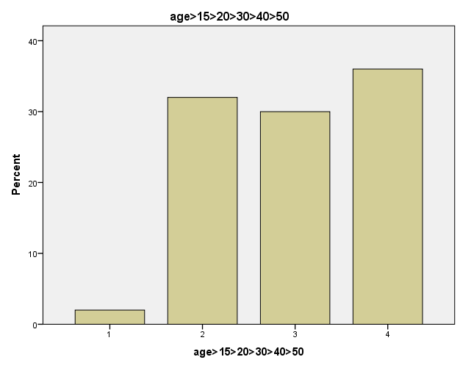

Fig (4-1) Frequency distribution according to the age

Table (4-3): Frequency distribution according to height in cm.
Height in cm |  | Frequency | Percent | Valid Percent | Cumulative Percent
 | Less tan154(1) | 9 | 18.0 | 18.0 | 18.0
 | 154-159(2) | 5 | 10.0 | 10.0 | 28.0
 | 160-164(3) | 15 | 30.0 | 30.0 | 58.0
 | 165-169(4) | 9 | 18.0 | 18.0 | 76.0
 | 170-174(5) | 11 | 22.0 | 22.0 | 98.0
 | 175-179(6) | 1 | 2.0 | 2.0 | 100.0
 | Total | 50 | 100.0 | 100.0

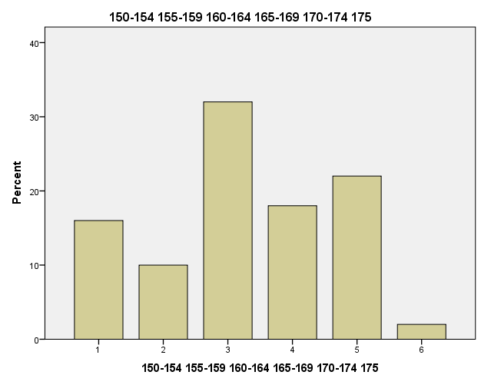

Fig (4-2) Frequency distribution according to height in cm.

Table (4-4): Frequency distribution according to Rt kidney length in mm.
Rt kidney length in mm |  | Frequency | Percent | Valid Percent | Cumulative Percent
 | 80-84 | 1 | 2.0 | 2.0 | 2.0
 | 85-89 | 1 | 2.0 | 2.0 | 4.0
 | 90-94 | 10 | 20.0 | 20.0 | 24.0
 | 95-99 | 13 | 26.0 | 26.0 | 50.0
 | 100-104 | 14 | 28.0 | 28.0 | 78.0
 | 105-109 | 3 | 6.0 | 6.0 | 84.0
 | 110-114 | 6 | 12.0 | 12.0 | 96.0
 | 115-119 | 2 | 4.0 | 4.0 | 100.0
 | Total | 50 | 100.0 | 100.0

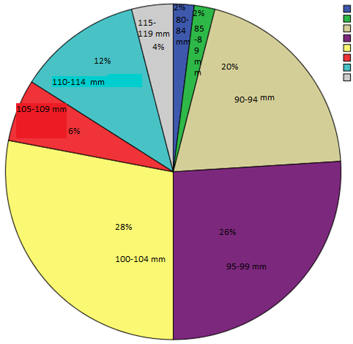

Fig(4-3) Frequency distribution according to Rt kidney length in mm.

Table (4-5): Frequency distribution according to Lt Kidney length in mm.
Lt kidney length in mm |  | Frequency | Percent | Valid Percent | Cumulative Percent
 | 85-89 | 3 | 6.0 | 6.0 | 6.0
 | 90-94 | 6 | 12.0 | 12.0 | 18.0
 | 95-99 | 16 | 32.0 | 32.0 | 50.0
 | 100-104 | 10 | 20.0 | 20.0 | 70.0
 | 105-109 | 7 | 14.0 | 14.0 | 84.0
 | 114-110 | 4 | 8.0 | 8.0 | 92.0
 | 115-119  120-124  125-130 | 3  0  1 | 6.0  0  2 | 6.0  0  2 | 98.0  98.0  100.0
 | Total | 50 | 100.0 | 100.0 | 100.0

Table (4-6) Correlation between the female height and the Rt kidney
 |  | Female height | Rt Kidney
female height | Pearson Correlation | 1 | .436(**)
female height | Sig. (2-tailed) |  | .002
female height | N | 50 | 50
Rt Kidney length | Pearson Correlation | .436(**) | 1
Rt Kidney length | Sig. (2-tailed) | .002
Rt Kidney length | N | 50 | 50

Table (4-7) correlation between the female height and the Lt Kidney
 |  | Female height | Lt kidney
Female height | Pearson Correlation | 1 | .234
Female height | Sig. (2-tailed) |  | .102
Female height | N | 50 | 50
Lt kidney length | Pearson Correlation | .234 | 1
Lt kidney length | Sig. (2-tailed) | .102
Lt kidney length | N | 50 | 50

Table(4-8) correlation between the female age and the Rt kidney
 |  | Female height | Rt Kidney
Female age | Pearson Correlation | 1 | .436(**)
Female age | Sig. (2-tailed) |  | .002
Female age | N | 50 | 50
Rt kidney | Pearson Correlation | 286* | 1
Rt kidney | Sig. (2-tailed) | .002
Rt kidney | N | 50 | 50

CHAPTER FIVE

DISCUSSION, CONCLUSION AND RECOMMENDATION

CHAPTER FIVE

DISCUSSION, CONCLUSION AND RECOMMENDATION

5.1 Discussion:
This is a cross-sectional study aimed to assess the relationship between female height and kidneys length. 50 female were enrolled in the study, their age ranging from 14 to 45 years; presented at Alhasahesa hospital.
According to the descriptive statistics the mean of age is 31year, the mean height is 162, the mean of Rt kidney length is 99 mm, and the mean of Lt Kidney length is 101 mm.
Distribution of female according to the age groups , age group between 15-25 were 32%, between 26-35 were 30%, and between 36-45 were 36% that is mean the age groups are approximately equals.
Distribution of female according to height in cms, height group between 160 cms and 164cms were 30% and this the group of the mean height.
Distribution of Rt kidney length in mms, length groups 95-99 and 100-104 were 26% and 28% respectively may be due to using small sample size. Distribution of Lt Kidney length in mms, length groups 95-99 and 100-104 were 32% and 20% respectively may be due to using small sample size. According to correlation between the height of female and the Rt kidney length the P-value (0.002) is less than (0.05) that means there is a significant correlation.
According to correlation between height of female and Lt Kidney length the P-value (0.097) is greater than (0.05) that means no significant correlation, may be due to using small sample size.
According to correlation between the female age and the Rt kidney length P-value (0.044) is less than (0.05) that means there is a significant correlation. According to correlation between female age and Lt Kidney length the P-value (0.085) is greater than (0.05) that means no significant correlation, may be due to using small sample size.

5-2 Conclusion:-
Ultrasound was the most reliable and easiest imaging modality that can use to measure the renal length. The study showed that the Rt and Lt Kidney length is proportionally increased with height. And this relation is stronger in Rt kidney than the Lt Kidney.
The study also showed that the Rt and Lt Kidney length is proportionally increased with age. And this relation is stronger in Rt kidney than the Lt Kidney.

5-3 Recommendations
Further studies should be done about the relation of other parameters such as weight; occupation; and races with renal length by using large sample size.
More research studies should be done about the comparison of male and female kidneys size.
Make routine measurements of kidney length for all patients to evaluate general renal condition.

References:
- Susan Standring . Gray’s Anatomy. 39th Edition. Elsevier Inc. 2008
- Carol M. Rumack, Stephaine. R. Wilson, J. Williamcharboneau, Deborah Levine. Diagnostic ultrasound. 4th edition (volume one) .Elsevier Inc.; Philadelphia: 2011.Pach
- IOSR Journal of Dental and Medical Sciences (IOSR-JDMS) e-ISSN: 2279-0853, p-ISSN: 2279-0861.Volume 15, Issue 4 Ver. III (Apr. 2016), PP 19-23 www.iosrjournals.org
- Paul L, Talhar S, Sontakke B, Shende M, Waghmare J (2016) Relation between Renal Length and Renal Volume with Patient’s BMI: A Critical Appraisal. Anat Physiol 6: 246. doi:10.4172/2161-0940.1000246
- LAURIE KELLY. Essentials of Human Physiology for Pharmacy. Taylor & Francis e-Library. New York. 2005
- Sandra L. Hagen-Ansert. Textbook of diagnostic ultrasound. 7th edition.vol.1. Mosby; USA: 2001.
- Paul L. Allan, Grant M. Baxter, Michael J. Weston. Clinical Ultrasound. 3rd Edition. Volume I. Elsevier Limited. Printed in China .2011
- Jane A. Bates. Abdominal Ultrasound How, Why and When. SECOND EDITION. Elsevier Limited. Philadelphia.2004.
- https://www.ncbi.nlm.nih.gov/pubmed/21553455accessedon6/12/ 2016 at 5:30 PM.
- http://img.webmd.com/dtmcms/live/webmd/consumer _ accessed on 17/11/2016 at 9:53 AM.
- http://radiologykey.com accessed on 29/03/2017 at 5:21 PM.
- Devin Deen. Abdominal Ultrasound. Part 2. Module 2. The Burwin institute of diagnostic medical ultrasound; Luneburg, Canada: 2005.
- Anil T. Ahuja. Griffith .Wong. Antonio. Cho .Ho Lolge . Paunipagar . Kennedy. Zwiebel . sohacy. Wondward Diagnostic Imaging Ultrasound. Amirsys. Hong Kong. 2005

Appendices

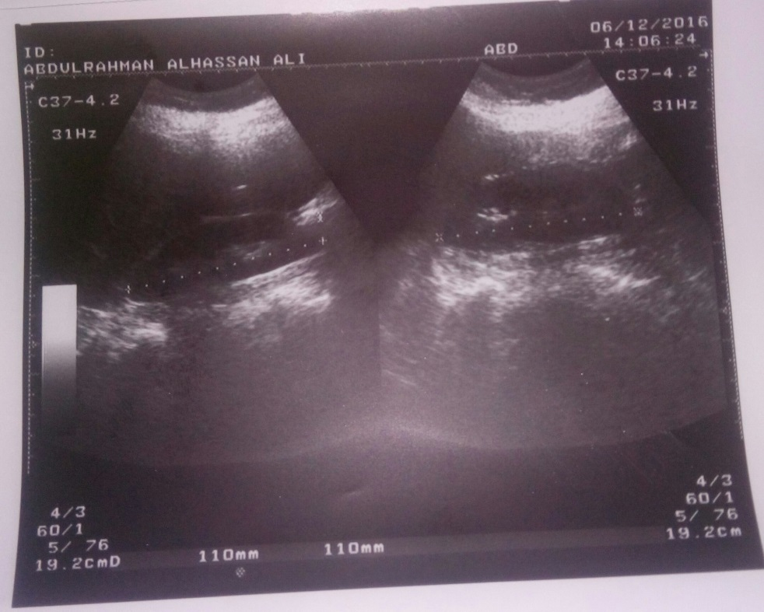

- Ultrasound image (1): 27 years old female shows Rt an Lt kidney length 110 and 110 mm

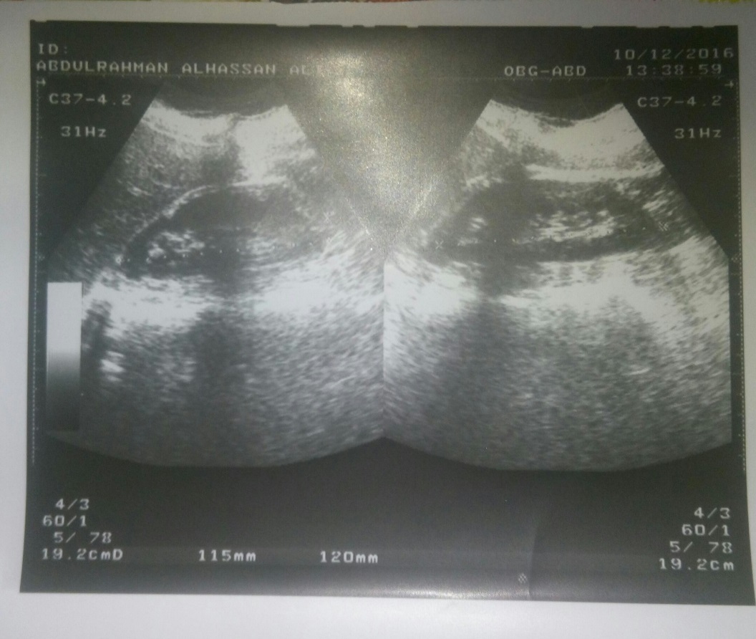

Ultrasound image (2): 30 years female shows Rt and Lt kidney length 115mm and 120 mm respectively.

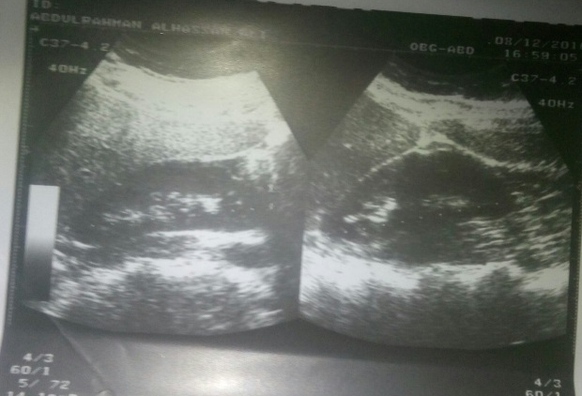

Ultrasound image (3): 35 years female shows Rt and Lt kidney length 102mm and 103 mm respectively.

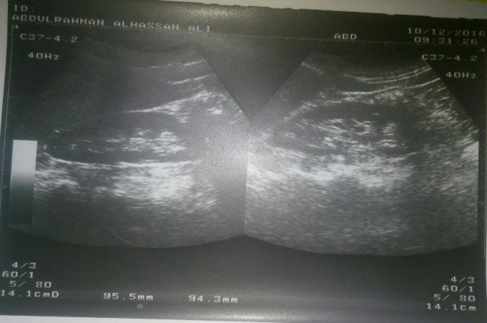

Ultrasound image (4): 41 years female shows Rt and Lt kidney length 94 mm and 95 mm respectively.

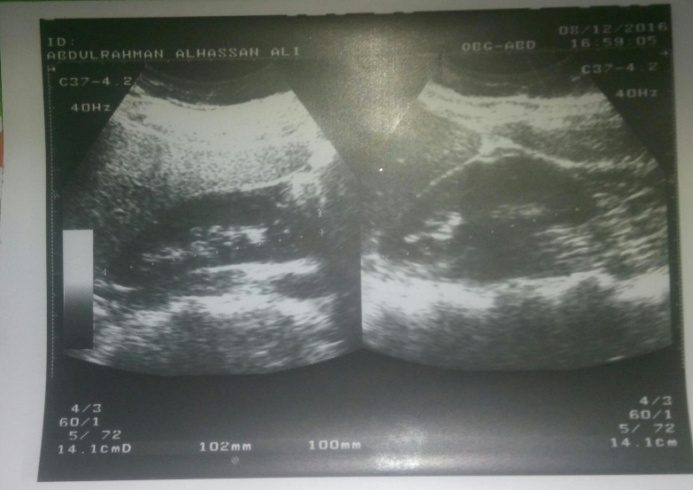

- ه

Ultrasound image (5): 14 years female shows Rt and Lt kidney length 100 mm and 102 mm respectively.

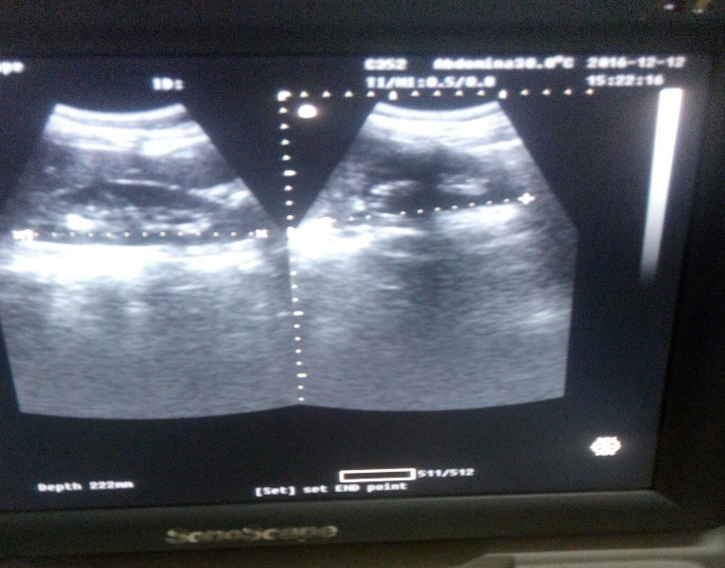

Ultrasound image (6): 38 years female shows Rt and Lt kidney length 87 mm and 90 mm respectively.

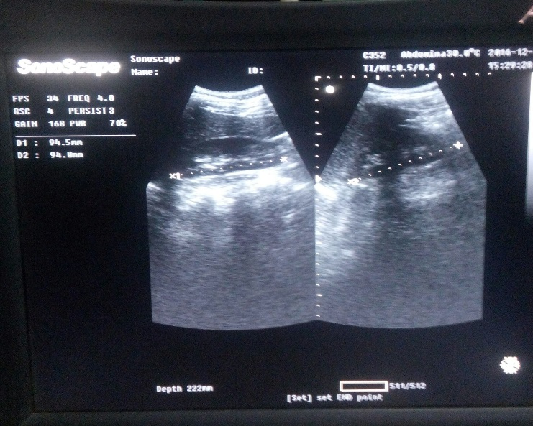

Ultrasound image (7): 27 years female shows Rt and Lt kidney length 94 mm and 94 mm respectively
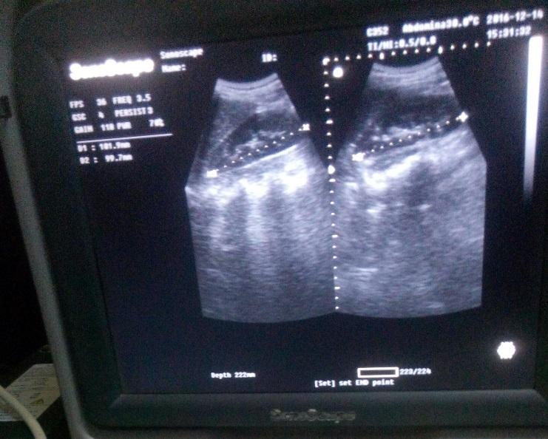

Ultrasound image (8): 30 years female shows Rt and Lt kidney length 99 mm and 100 mm respectively.

Ultrasound image (9): 29 years female shows Rt and Lt kidney length 94 mm and 98 mm respectively.

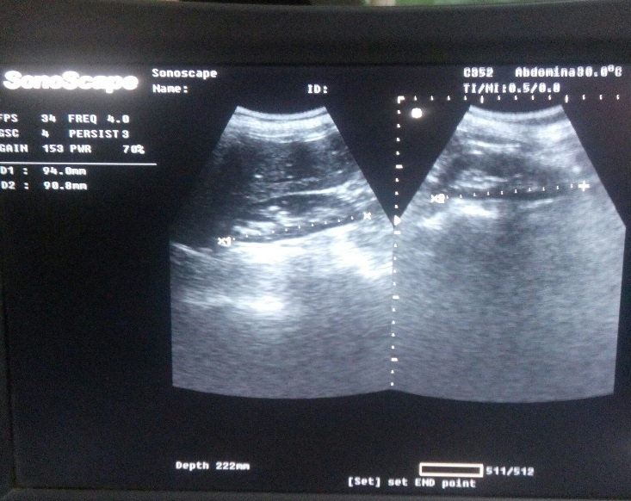

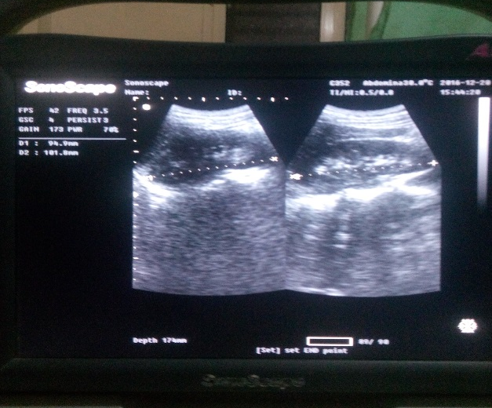

Ultrasound image (10): 32 years female shows Rt and Lt kidney length 99 mm and 101 mm respectively.

Data collection sheet

No | Age | Height | Rt kidney | Lt kidney

