## **شعار جامعة السودان صورة.jpgشعار جامعة السودان صورة.jpg**

بسم الله الرحمن الرحيم

**Sudan University of Science and Technology**

**College of Education**

**Department of science – Chemistry**

**Photochemical Searching of Alkaloid from Neem**

**دراسة فيتوكيميائية للقلويدات في نبات النيم**

BSc in Education-Chemistry

By:

1- Solafa Alsadig Mohamed

2- Fatima Al Fadel Mohamed Ahmed

3- Hager Abd Alwahab Ibrahim

4- Nada Hassan Dafalla

Supervised by:

Uz/ Amin Aldin Issa

**November 2015**

## 

## **قال تعالى:**

**(وقل رب ادخلنى مدخل صدق واخرجنى مخرج صدق واجعل لى من لدنك سلطانا نصيرا)**

## **الإسراء:80**

**صدق الله العظيم**

**Dedifiction**

**We dedified to......**

**Our parents, brothers and sisters.**

**Thank to Allah for giving us strength and health to complete this work. We deeply grateful to supervisor Amineldin Issa for his fruitful guidance**

**Thanks to the department of chemistry, Sudan University of science and Technology for all facilities.**

**Our thanks are extended to all those who assisted us to accomplish this work.**

**We would also like to thank our families for their patience and support.**

**Phytochemical screening of the alcoholic extract of the leaves of Naeem indicated the presence of alkaloids and absence of flavonoids, glicosides and steroids.**

**The alkaloids of Naeem were investigated due to their medicinal value and relative abundance in this plant species.**

**The crude product obtained from the alcoholic extract was fractionated by thin layer chromatograbhy where one alkaloid is obtained in pure state the behavior of this isolated under the UV light as well as its colour reactions indicated that is alkaloid.**

**The alkaloid was subjected to spectral studies, namely IR and UV states which confirmed that these phytochemicals were alkaloids indicated by colour reactions and behavior under UV light.**

**الخلاصة**

**اجريت اختبارات فيتوكيميائيه للمستخلص الكحولي لاوراق نبات النيم حيث اتضح انه يحتوي على قلويدات وعدم احتوائه على فلافونويدات , جلايكوسيدات واسترويدات .**

**بدأت دراسة تفصيلية للقلويدات التى يحتويها النبات لوفرتها ولاهميتها الطبية حيث استخلصت من الاوراق بالكحول ثم استخدمت كروموتوغرافيا الطبقة الرقيقة لفصل القلويدات الموجودة في النبات في الصورة النقية واوضح طبقة الاشعه فوق البنفسجية والاختبارات اللونيه انها قلويدات بعد اجراء دراسة طيفية باستخدام طيف الاشعة فوق البنفسجية وطيف الاشعه تحت الحمراء واكدت كلا منها ان المركبات هي قلويدات .**

**Table of contents:**

|  |  |  |
| --- | --- | --- |
|  | | **Page number** |
| **الايــــة** | | **I** |
| **Dedification** | | **II** |
| **Acknowledgment** | | **III** |
| **Abstract** | | **IV** |
| **الخلاصة** | | **V** |
| **Table of contents** | | **VI** |
| **Chapter one**  **Interoduction** | | |
| **1.1** | **General approach** | |  |
| **1.2** | **Classification of alkaloids** | |  |
| **1.2.1** | **Phenyl ethyl amine group** | |  |
| **1.2.2** | **Pyrolidine group** | |  |
| **1.2.3** | **Pyridine group** | |  |
| **1.2.4** | **Pyrolidine-Pyridine group** | |  |
| **1.2.5** | **Quinoline group** | |  |
| **1.2.6** | **Isoquinoline group** | |  |
| **1.2.7** | **Phenanthrene group** | |  |
| **1.2.8** | **Alkaloids of the indol group** | |  |
| **1.2.9** | **Alkaloids of the imidazole group** | |  |
| **1.2.10** | **Alkaloids of the purne group** | |  |
| **1.2.11** | **Steroidal alkaloids group** | |  |
| **1.2.12** | **Alkaloids of the caroline group** | |  |
| **1.2.13** | **Alkaloids of the tropolone group** | |  |
| **1.2.14** | **The furoquinoline group** | |  |
| **1.3** | **Alkaloids biosynthesis** | |  |
| **1.3.1** | **Biosynthesis of tropane alkaloids** | |  |
| **1.3.2** | **Biosynthesis of pyrrolidine pyridine alkaloids** | |  |
| **1.3.3** | **Biosynthesis of quinoline alkaloids** | |  |
| **1.3.4** | **Biosynthesis of iso quinoline alkaloids** | |  |
| **1.3.5** | **Biosynthesis of indole alkaloids** | |  |
| **1.3.6** | **Biosynthesis of steroidal alkaloids** | |  |
|  |
| **2.1** | **Chemicals used** | |  |
| **2.2** | **Solvent used** | |  |
| **2.3** | **Instruments and apparatus used** | |  |
| **2.4** | **Other apparatus used including the following** | |  |

|  |  |  |
| --- | --- | --- |
| **2.5** | **Chromatographic materials** |  |
| **2.6** | **Spray reagents** |  |
| **2.7** | **Collection of plant materials** |  |
| **2.8** | **Documentation of the samples** |  |
| **2.9** | **Preparation of the plant materials** |  |
| **2.10** | **Preparation of test reagents for phytochemical investigation** |  |
| **2.10.1** | **Alkaloids test reagent** |  |
| **2.10.2** | **Flvonoids test reagent** |  |
| **2.11** | **Preparation of plant extract for phydocmical investigation** |  |
| **2.12** | **Phytochemical vestigation** |  |
| **2.13** | **Test for alkaloids** |  |
| **2.14** | **Test for flavonoids** |  |
| **2.15** | **Test for tannins** |  |
| **2.16** | **Test for glycosides** |  |
| **2.17** | **Method of extraction of the material** |  |
| **2.18** | **Method of the thinlayer chromatography TLC** |  |
| **2.19** | **Melting point determination** |  |
| **2.20** | **Physic –chemical methods** |  |
|  |  |  |
| **3.1** | **Results** |  |

|  |  |  |
| --- | --- | --- |
| **3.1.1** | **Preliminary phytochemical screening** |  |
| **3.1.2** | **Further investigation** |  |
| **3.1.3** | **Mayeris reagent test** |  |
| **3.1.4** | **Dragenetorffs reagent test** |  |
| **3.1.5** | **Thinlayer chromatoy raply(TLC) for the coneentrated chloroform extract** |  |
| **3.1.6** | **Result of spraying with dragendorffs reagent** |  |
| **3.1.7** | **Melting point result** |  |
| **3.1.8** | **Spectroscopic result** |  |
| **3.1.8.1** | **The UV result of compound** |  |
| **3.1.8.2** | **The infrared result of compound** |  |

**1. Introduction**

**1.1 General approach:**

**The photochemical investigation of a plant may involve the following:**

**Extraction of the plant materials; separation and isolation of the constituent of interest; characterization of the isolated compounds; investigation of the biosynthetic path ways to particular compounds; and qualitative evaluation.**

**(Trease et al, 1965)**

**Alkaloids: alkaloids are basic nitrogenous compounds usually of complex activities. Whilst tiny amount of some can immobilize an elephant or a rhinoceroothers have important clinical use such as analgesics, ant malarial, antispasmodics, for pupil dilation, and treatment of hypertension, mental disorder and tumors. they are all nitrogen heterocyclic which occur mainly in plants as their salts of common carboxylic acids such as citric, lactic, oxalic ,acetic, malefic and tartaric acids as well as numeric , benzoic, aconitic and veratric acids. Their amine characteristic produces an alkaline solution in water and hence the origin of their name –alkaloids. (Hazim, 1995)**

**I. Historical Background:**

**The name of alkaloids was first introduced by Meissner in 1818 to indicate alkali-like substances, in other words like alkali {from the Arabic (alkali), and from the Greek (eiods), appearance}.**

**The number of products, their structural diversity and their important physiological activity make alkaloids among the most important group of naturally occurring substances of therapeutically interest. (Boulton, 1967).**

**A precise definition of the alkaloid (alkali-like) is somewhat difficult because there is no clear cut boundary between alkaloids and naturally occurring complex amines. (Daniel.et al, 1969)**

**Typical alkaloids are derived from plant sources. They are basic, containing one or more nitrogen atoms (usually in hetrocyclic ring) and usually have marked physiological action no man or other animals. The name proto-alkaloids or amino alkaloids are applied to compounds such as horde nine, ephedrine and colchicines which lack one or more of the properties of typical alkaloids. Other alkaloids not conforming to the general definition are those derived from bacterial and animal sources together with synthetic compounds not found on plant, but very closely related to the natural alkaloids (eg.homatropine) (Brunton,1995).**

**The first isolation of alkaloids, in the last century, followed the reintroducation into medicine of a number of alkaloid-containing drugs and was coincidental with the advent of the percolation process**

**The chemist who plant to work on the constitution of alkaloids is generally confronted with three main problems; first the location of a suitable plant source, second the isolation of the plant bases from this source, and third the resolution pf his mixtures of alkaloids into its pure components.**

**Alkaloids bearing plants have been found in virtually every habitat in**

**He French apothecary Derosne isolated the alkaloid afterwards known as narcotine in 1803 and the Hanovian apothecary Serturner further investigated opium and isolated morphine (1806, 1816). Isolation of other alkaloids particularly by Pelletier and Caventu rabidly followed. Strchnine (1817) and coniine (1826). Coniine was the first to have its structure established and to be synthesized, but for others, such as colchicines, it was well over a centaury before the structure was finally elucidated. (Brunton, 1995).**

**II. General properties of alkaloids:**

**Alkaloids are usually colorles, crystalline, non volatile solids which are insoluble in water, but are soluble in ethanol, ether, chloroform, etc.**

**Some alkaloids are liquids which are soluble in water e.g. coniine and nicotine, and a few are optically active. They are generally tertiary nitrogen compounds. Most of the alkaloids also contain oxygen. The optically active alkaloids are very useful for resolving racemic acids. the alkaloids form insoluble precipitate with solutions of phosphotungestic acid, phosphomplybdic acid, picric acid, potassium mercuric iodide, etc.Many of these precipitates have definite crystalline shapes and so may used to help in the identification of an alkaloid (Finar, 1964)**

**III. Natural Occurrences: which vascular plants grow? There are however, no taxonomic characteristics by which a plant may arbitrarily be assigned to a group suitable for alkaloid study. Well authenticated bases have been found to occur in some thirty eight plant families and it may safely be said that the remaining families will provide only an occasional alkaloids bearing plant (Manskee and Holmes, 1969).**

**The orders which contain alkaloid bearing plants and the families in which these plants occur are listed below in table 1.**

**Table 1: (Manskee and Holmes, 1969)**

|  |  |
| --- | --- |
| **Orders** | **Families** |
| **Magnliales** | **Magnoliaceae** |
| **Anonales** | **Anonaceae** |
| **Laurales** | **Lauraceae** |
| **Ranales** | **Ranunculeae** |
| **Berberidales** | **Berbberdidaceae** |
| **Aritsolochinales** | **Aristolochiaceae** |
| **Piperales** | **Piperaceae** |
| **Rhoeadales** | **Papaveraceae** |
| **Chinopodiales** | **Chinopodiaceae** |
| **Lythrales** | **Punicaceae** |
| **Cucurbitales** | **Carieaceae** |
| **Catales** | **Cataceae** |
| **Malipghiales** | **Cactaceae** |
| **Rosales** | **Erythroxylaceae** |
| **Leguminosae** | **Papilionaceae** |
| **Hamamelidales** | **Buxaceae** |
| **Rhamnales** | **Rahmnaceae** |
| **Rutales** | **Rutaceae** |
| **Umbelliflorea** | **Umbelliferae** |
| **Lognaniales** | **Loganiaceae** |
| **Rubiales** | **Rubiaceae** |
| **Asterales** | **Compositae** |
| **Campanales** | **Lobliaaceae** |
| **Borginiales** | **Borginiaceae** |
| **Sonlanales** | **Solanaceae/Convolvulaceae** |
| **Liliales** | **Liliaceae** |
| **Amaryllidales** | **Amaryllidaceae** |
| **Dioscoreales** | **Dioscoreaceae** |
| **Graminales** | **Graminaceae** |
| **Orchidiles** | **Orchidaceae** |
| **Coniferae** | **Taxaceae** |
| **Gentales** | **Gentaceae** |
| **Equisetales** | **Equisetaceae** |

**IV. The nitrogen of alkaloids:**

**Alkaloids, taken in their broadest sense, many have a nitrogen atom which is primary (mescaline), secondary (ephedrine),tertiary (atropine)or quaternary (one of the atoms of tubocuranine) and this factor affects the derivatives of the alkaloid which can be prepared and isolation procedures. In the plant, alkaloid may existin the free state, as salts or as amine or alkaloid N-oxide, Nitrogen oxidation products of alkaloids particularly the N-oxides, tertiary alkaloids are well known laboratory products. as early as the 1920s quite extensive pharmacological and toxilogical comparison had been made of common alkaloids such as morphine , strychnine and hyoscyamine and their corresponding N-oxides was engendered by their purported delayed release properties , low toxicities and low addictive properties compared with the corresponding tertiary alkaloids.(Glaston,1969).**

**V. Site of formation of alkaloids:**

**When alkaloids are found to be present in particular organs or parts of plants, it does not necessarily mean that alkaloid are found or synthesized in that particular organ , for example , the alkaloids in several datura species and nicotina species , are mostly formed in the roots , but are rapidly translocated to leaves . This has been well demonstrated by various investigators using, grafting experiments and other techniques. The leaves, where the alkaloids accumulate, are the part to be used for the extracation and isolation of any appreciable quantities of the alkaloids. (Saxon, 1986)**

**a) Function of the alkaloids in the plants:**

**Maby articles were written about the possible function of alkaloids in plants or the reasons why they occur there. Some of the possibilities which have been discussed include their function as:**

* **Poisonous agents protecting the plant against insects and animals.**
* **End products of detoxification reactions, representing a metabolic locking-up of compound, otherwise harmful to the plant.**
* **Regularity growth factors.**
* **Reserve substances capable of supplying nitrogen or other necessary elements to the plant economy. (Shafigg, 1996)**

**b) Distribution of alkaloids in the plant:**

**Elaboration of alkaloids is not localized in certain specific organs but appears to characteristic of all organs (inculuding the seeds) although it must be emphasized that not all organs of any one species posses such functions. noteworthy amongst organs which are devoid of alkaloids are the seedes of the dodacco plant and of the opium poppy although the seeds of this plants do not store detectable quantities of alkaloids yet on germination , alkaloids are to be found in the very young seedling . (Manskee and Holmes, 1963)**

**In the first year of growth alkaloids seem to be quite evenly distributed amongst the various organs, but with increased age there appears to be localization of this base in a few organs. The bark of the arbor sent plants is generally richer in alkaloids than are the leaves or shoots (cinchona) and this may be attributed to their accumulation in the bark, year after year.**

**The bark of old berberry roots may contain as much as 10% of brberine whereas that of very young plants contain little more than found in the leaves.**

**As in all generalizations there are exceptions to the statement that in biennials and perennials there is a preponderance of these nitrogenous products in the roots .Notable among these exceptions are the arial part of dicentra, Aconitum and Delphin which in some instances prove to be a rich source of alkaloids (Manskee and Holmes, 1963) while the localization of the alkaloids in various does not appear to occur in the annuals yet there is a marked fluctuation of alkaloid content r in all the organs throughout the growing season. The period of maximum output of these bases in papaver , senecio ,corydalis, est. Appears to be coincident with the early flowering stage .it is obvious that the alkaloids are intemedent in plant metabolism though it is not possible to state the fate of nitrogen .(Manskee and Holmes,1963)**

**When plants elaborate more than one alkaloids, their ratio in the plant need necessarily be the same at all stages of growth.isotheabine, for example is virtually abescent in the young oriental poppy but increase in isolable amount when the plant approaches maturity.This observation may explain why different investigators report the isolation of different alkaloids for the same species. (Manskee and Holmes, 1963)**

**Cultural and climatic conditions have only a moderate effect on the alkaloid content of a plant .It is known that amount of alkaloids in opium varies with the source, but some of these variations are undoubtedly due to the varietal differences in the poppies in question. There are ample a priori reasons to suspect that different plants of a single species may elaborate different amount of alkaloids. (Manskee and Holmes, 1963)**

**It is well known that strains of tobacco and of lupines can be selected to yield greater or lesser amount of alkaloids.**

**Never morphine nor codeine have been found in any other species of papaver and the basic ring system in these alkaloids have been found in part only in alkaloids derived from plants of a family (Menispermaaca) whose affinities with papaveraceae can only be remote .(Manskee and Holmes,1963)**

**VI. Nomenclature of alkaloids:**

**The chief characteristic of the nomenclature of alkaloids is the lack of a system which prevails. By agreement, chemical rules designate that names of alkaloids should end with the suffix (-ine.) Latin names end in (-Ina).the name of alkaloids are obtained in various ways:**

* **From the generic name of the plant yielding them (atropine, hydrazine).**
* **From the specific name of the plant yielding them (cocaine, belladonine)**
* **From their physiological activity(emetine, narcotine, morphine)**
* **From their physiological property e.g. (hygrine-hydro=moist).**
* **Occasionally discoverer e.g. (pelletierine after Pelletier).**
* **From the common name of the drug yielding them e.g. ergotamine.**
* **Sometimes ,a suffix is added to the name of a principal alkaloids to designate another alkaloids from the same source (quinine ,quinidine, hydroquinine) .some of the prefixes in common use are iso-,pseudo-, neo- and epi-. Occasionally the prefix has a particular significance attached to it, as in the case in the prefixed nor-. Originally, nor- was prefixed to the existing name of alkaloids toindicate that nor- compounds was N demethylated, as compared to the original compound which carried a methyl group on the nitrogen. This meaning has been extended to include also those alkaloids in which a methoxyl group is dimethylated, resulting in a nor compound.**

**1.2 Classification of alkaloids:**

**Long before the constitution of the alkaloids were known the source of alkaloids was considered the most important characteristic of the compounds. Thus there could not be a rational classification. Even today with the structure of some many known, the classification of the alkaloids is still somewhat arbitrary owing to the difficult of classifying into distinct groups .Even so, it is probably most satisfactory (chemically) to classify the alkaloids according to the nature of the nucleus present in the molecule.**

**Members of the following groups are described:**

* **Phenyl ethyl amine group**
* **Pyrrolydine group**
* **Pyridine group**
* **Pyrrolidine –pyridine group**
* **Quinoline group**
* **Isoquinoline group**
* **Phenantharene group**
* **In dole group**
* **Alkaloids of the imidazole group**
* **Alkaloids of the purine group**
* **Steridal alkaloids group**
* **Alkaloids of the garbling group**
* **Alkaloids of the tropolone group**

**It should be noted that in many case different alkaloids obtained from the same plant often have similar chemical structures, and so sometimes the source of the alkaloids may indicate chemical similarity.**

**1-2-1 phenyl ethyl amine group:**

**Many compound of this group are known, some natural and others are synthetic. Their outstanding physiological action is to increase the blood pressure; hence they are often refered to as the pressure drugs. Examples of this group are phenyl ethylamine, (-)-ephedrine, Benzedrine, B-p-hydroxy phenyl ethyl amine, hordenine, mescaline, adrenaline, (epinephrine) noradrenaline (norepinephrine)**

**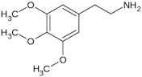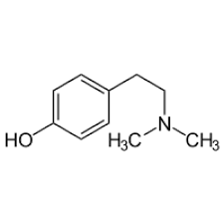**

**Hordenine Mescaline**

**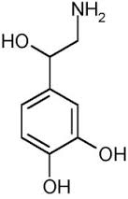C:\Users\toshiba\AppData\Local\Microsoft\Windows\Temporary Internet Files\Content.Word\٢٠١٥-٠٩-٠٧-١٥-١٦-١٢-1193937916.png**

**tryamine**

**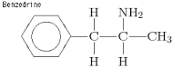**

**Adrenaline**

**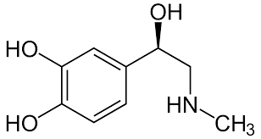**

**Noradenaline**

**1.2.2 Pyrolidine group:**

**Example of this group is hygrine and cuscohygrine.**

**Hygrine: is a derivative of pyrolidine and is a colourless strongly alkaline liquid which absorbs carbon dioxide from the air and decomposes on exposure to light. It is soluble in water and organic solvents. `**

**Cuscohygrine: cuscohygrine occurs in the oily bases of Peruvian coca leaves and is miscible with water forming a crystalline hydrate. It contains two tertiary nitrogen atoms. 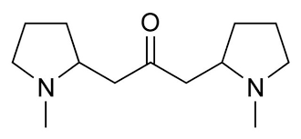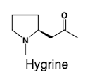**

**Cuscohydrine**

**1-2-3 pyridine group:**

**This pyridine group of alkaloids could be divided into five sub group and the nucleus of the molecule is one of the following nuclei:**

* **Pyridine alone, e.g.trigonelline**
* **Pyridine with other nitrogenous ring, e.g. tobacco, alkaloids**
* **Terahydropyridine, e.g., areca alkaloids**
* **Piperidine, e.g. (1) peppers alkaloids, (2) conium alkaloids, (3) lobelia alkaloids and (4) pomegranate alkaloids.**
* **Pyridine and piperidine alkaloids: e.g.ricinine**

**I. Alkaloids having pyridine group only:**

**Trigonelline: it is the betaine of 1\_Methylnicotinic acid .it occurs in fenugreek seeds (Trigonella foenum \_graecum), coffee beans and other plants.**

**Trigonelline is a crystalline compound which dissolves in water giving a neutral solution.**

**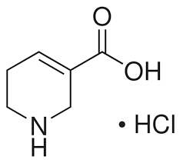**

**Trigonelline**

**II.Alkalaoids having pyridine with other nitrogenous ring:**

**Tobacco alkaloids: the leaves of tobcco plant (Nicotiana tabactum l., family Solanaceae) constitute about three \_quarters of total alkaloids contents. The leaves contain about 4\_6% of nicotine .Among other volatile liquids present ,are nor\_nicotine and anabasine as well as the non\_volatile liquid alkaloids nicotine and nicotyrine and the only solid tobacco alkaloid, nicotelline**

**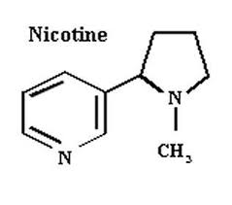**

**III. Tetrahydropyridine alkaloids:**

**Belonging to this group are the areca nut alkaloids as well as 8\_coniceine which are hydrogenated derivatives of nicotinic acid e.g. guvacine.**

**Guvacine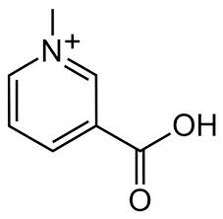**

**IV. Piperidine alkaloids:**

**Piperidine can be prepared from pyridine by bydrogenation using nickel as catalyst. Belonging to the piperidine group of alkaloids could be mentioned the alkaloids of pepper, conium, lobelia and pomegranate.**

**Pepper alkaloids: of several species of pepper (of which tiper, nigrun is the most important, yielding black pepper) cootain a comparatively large proportion of alkaloids. The chief alkaloid constituents of pepper rpiperine and chevicine.**

**Conium alkaloids: the hemlock plant (conium mama macaltum, family umbelliferae) owes its proper it to the presence of several alkaloids namely, coniine, $γ$-coniceine, conhydrine, pesudoconhydrine, and N- methyl coniine of which coniine is the most important. (Finar, 1964).**

**Lobelia alkaloids: the crude drug lobelia herb commonly known as Indian tobacco (lobelia inflate, am. Capanulaceae) .chief among these alkaloids is lode line, lobe nine, nor-lobelanine, lobelanidine, nor-iobelanidine, lobenine and isolobenine. Of these the most important is lobe line.**

**Pomegranate alkaloids: the fruit rind and bark of root and stem of Punic grantum (family punicaceae) contain several alkaloids, a many these alkaloids four are liquids, pelletierine, isopelletierire, methylpelletierine, and methylisopelletierine. (Faine, 1964)**

**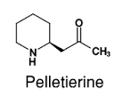**

**V. Pyridine and piperidine alkaloids:**

**The important member of this group is reclining which was isolated by tuson in 1864 from castor oil seeds.**

**Ricinine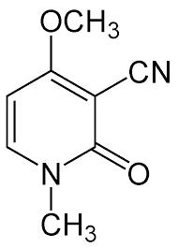**

**1-2-4 pyrolidine –pyridine group:**

**This group contains the following:**

1. **Solanacous alkaloid : this group includes atropine, hyoscyamine and scopolamine (hyoscine)**

**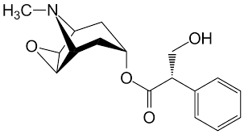Scopolamine**

**`**

1. **Coca alkaloids: in this group occur cocaine which occurs in coca leaves and it is used as local anaesthetic. The other members of the coca alkaloids are benzoylecgonine and tropacocaine.**

**1-2-5Quinoline group:**

**This group consists of the following:**

1. **Angostura alkaloids :a number of alkaloids have been isolated from angostura bark , e.g. cusparine, galloping and galipoline.(Finar,1964)**

**Galipine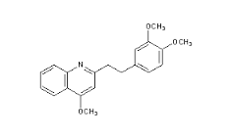**

**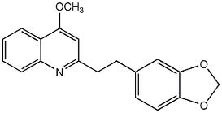**

**Galipoline**

1. **Cinchona alkaloids: cinch nine and quinine together with many other alkaloids occur in the bark of various species of cinchonas. Cinchonine may be regarded as the parent substance of cinchona alkaloids, but quinine is the most important member of this group, its main use being in the treatment of malaria. (Finar, 1964).**

**Cinchonine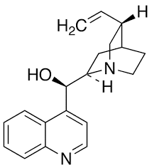**

1. **Opium alkaloids: many alkaloids have been isolated from opium and they are divided into two groups according to the nature of their structure and these two groups are isoquinoline group and phenanthrene group.**

**1-2-6 Isoquinoline group:**

**This group contain the alkaloids palavering C20H21O4N m.p177C and it is one of the optically inactive alkaloids, it does not contain any symmetric carbon atom .the structure of papverine was established by gold Schmidt and his co-workers (1883-1888).also isoquinoline group contain the alkaloids laudanosine.**

**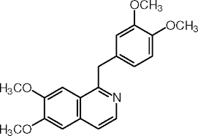Papaverine**

**1-2-7phenanthrene group:**

**This group contains morphine, codeine and thebaine. These are three important opium alkaloids which contain the phenantherne nucleus .morphine C17H19O3N.M.P254C is the chief alkaloids in opium and was the first alkaloids to be isolated. (Finar, 1964)**

**(-) codeine, C18H21O3Nmp.155Cwas isolated by Grimaaux in the year1881.**

**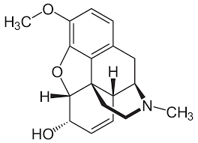**

**codein**

**1.2.8 Alkaloids of the indole group:**

**A number of important alkaloids posses an in dole ring as part of their structure, among these ,are alkaloids of Ergot ,physotigma, Nix comical rauwolfia and vinca.The seeds of physotigma(family ligumenosae)known as calabar been,contain several alkaloids which are indole derivatives.phsostigmine which is also known as serine,is the principal one among them .(Henry,1949)**

**1.2.9 Alkaloids of the imidazole group:**

**Pilocarpus and pilocarpin are the drugs of this group.A\_number of pilocarpus species (family Rutaceae) contain several alkaloids having an imdazole ring in the molecule. The major alkaloids of this family are pilocarpine and its stereoisomer isopilocarpine (Henry, 1949).**

**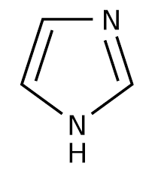Imidiazole or glycoxaline**

**1.2.10 Alkaloids of the Purne group:**

**The prunes are derives of a heterocyclic nucleus consisting of the six- mamboed pyramiding ring fused to the five –mamboed imidazole ring Purina itself does not occur in nature but numerous derivatives are biologically significant the pharmaceutically important bases of this group are all ethylated derives of oxidized form of porcine 2,6 dioxypurine (xthanthene ) caffeine is 1,3,7 trimethylxanthine theophylline is 1,3 dimrthylxanthylxanthine,and the bromine is 3,7 dimethylxanthine.**

**1.2.11 Steroidal alkaloids group:**

**Steroidal alkaloid represents a group of alkaloids, which have a close structural relationship to sterols, i.e. contain a prehydro\_1\_2\_cyclopentanon phenanthrene skeleton characteristic of sterols. These alkaloids may occur in the plant in glucosidal combination with sugar. This group of alkaloids is represented by variorum alkaloids and selenium alkaloid.**

**1.2.12 Alkaloids of the Caroline group:**

**A number of alkaloids posse a Caroline nucleus as a part of their structure Among these are alkaloids of Harmala (seeds of pegantum harmala , family zygophyllaceae ) which comprises Harmala and hurine the alkaloids of yohimba (bark of corynanthe yohimba ,rubiacae)which comprise yohimbine ,yohimbine and $γ$ yohimbine.(shafigg.1996)**

**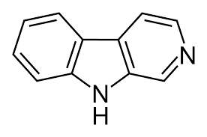Carboline**

**1-2-13 Alkaloids of the tropolone group:**

**Tropolone is a pscudo-aromatic seven membered unsaturated ring.**

**The corm seed and flower of the autumn crocus, colchicum autaamnale family liliaceae contain a number of neutral phenolic and basic alkaloids well as fat –like substances .**

**The best known of the alkaloids ofcolchicum is cholchicine, cholchicine possesses a tropolone structure and being non-basic incharacter, it cannor strictly be considered as an alkaloids .however following convention, it is referred to as alkaloids .(Henry, 1949)**

**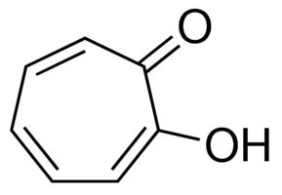Troplone**

**1.2.14 The furoquinoline group:**

**The furoquionoline group consists of the following subgroups.certaine alkaloids, the grouping is changed to reflect the new knowledge ,usually taking the name of a biologieally –important amine that santds out in the symthesis process .(Harbome, 1969)**

**1.3Alkaloid biosynthesis:**

**With regard to the biosynthesis of alkaloids ,they are very heterogeneous class of natural products some are formed from –amino acids e.g. orinthine .lysine, phenylalanine, tyrosine and tryphan ,\*others are derived from acetic acid ,whereas others are related to the terpenes or steroids it is now known that alkaloids are not formed in the leaves as direct or indirect products prouducts of photosynthesis,but they are mainly formed in the roots and then translocated to the leaves where they are stored e.g. strmonium ,(shafi gg,1996)**

**Sterile cultivation of excised roots .have proved that alkaloids are biosynthesized in these isolated roots .there are also indications of the role biosynthesised in these isolated roots. There are also indications of the role of the root in alkaloid synthesis. Scions of alkaloid plants grown on alkaloid free stems produce leaves virtually free of alkaloid. If such leaves are isolated in water, alkaloids do not appear. When, however, the development of adventitious root is promoted, alkaloids appear, it was reported that the development of embryonic roots at the grafting site of a scion , suffices to provide the scion with alkaloids.**

**Wagener found that morphine first appear in the root Papaver sominferum, but that, in the course of development, the centere of morphine distribution rises continuously until, at the time of repining, the capsules contain most of the morphine. In the lower organs, moreover, morphine decreases. (Shafigg, 1996)**

**1.3.1 Biosynthesis of tropane alkaloids:**

**Feeding experiment with labeled orinthine has revealed that this amino acid is incorporated steriospecifically to form the pyroliding ring of tropane.**

**The remaining three carbon atoms derived from acetate, thus completing the piperidine moiety. Methylation results via transmehylation from a suitable donor,e.g methionine, to complete the tropine nucleus.(finar,1964)**

**1.3.2Biosynthesis of pyrrolidine\_pyridine alkaloids:**

**The pyridine ring has been shown, by means of labeled precursors, to be formed in plant by several routes.Nicotinc acid is the precursor of pyridine ring of nicotine, and there is a great deal of evidence to show that this acid is producedvia quinolinic acid, e.g., nicotinic acid and quinolinic acid has been the subject of much debate, but it now appears that glycerol and aspartic acid are involved. One possible biosynthetic pathway is:**

**C:\Users\toshiba\AppData\Local\Microsoft\Windows\Temporary Internet Files\Content.Word\images_13.png 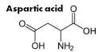**

**Glycerol**

**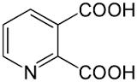 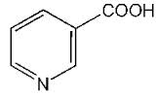**

**Quinolinic acid Nicotinic acid**

**Tracer experiments have shown that the pymolidine ring may from ornithine, putrescine(and its N\_metyl derivative), and $γ_$ methlaminobutyraladhyde. These are very efficient precursors;**

**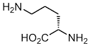C:\Users\toshiba\AppData\Local\Microsoft\Windows\Temporary Internet Files\Content.Word\images_2.png**

**Ornithine**

**1.3.3 Biosynthesis of quinoline alkaloids:**

**The biosyntheses of the cinchona alkaloid has been shown to be produced from tryptophan as the precursor. Another precursor is believed to be secolognin, which is derived from mevalonic acid (G=glucose) (finar, 1964)**

**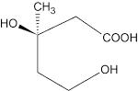 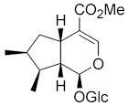**

**Mevalonic acid Loganin**

**We may now give some of the steps involved in the biosynthesis of quinine.(Finar,1964)**

1. **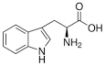Tryptophan**

**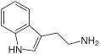**

**Tryptamaine**

1. ** + 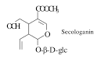**

**Tryptamine 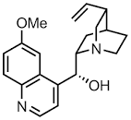Quinine**

**1.3.4 Biosynthesis of isoquinoline alkaloids:**

**Tracer experiments have shown that papaverine is derived from tyrosine. This produces dopamine and 3, 4\_dihydroxyphenylacetaldehyde (or the pyruvic acid) and thase undergo condensation.**

**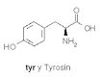 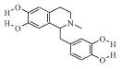**

**Norlaudanosoline**

**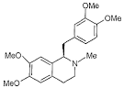Laudanosoline 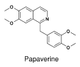**

**1.3.5Biosynthesis of indole alkaloids:**

**Rauwolfia alkaloids: The biosynthesis of Ajamine, Serpentine and Proserpine in Rauwolifia serpentine utilizes tryptophan as a precursor of rings A and B of these alkaloids. Experimental evidence that the remainder of these molecules, derives principally from acetyl CoA.three molecules of acetyl Coal apparently combine with one of Maloney Coal plus a Clun it(form ate) to produce a poly\_B\_Keto ester intermediate. This react with tryptophan moiety to produce serpentine or, after loss of an N\_methyl group, from frmate, .Reserpine and other related Rauwolifa alkaloids, no doubt result from similar reactions. (Finar, 1964)**

**1.3.6 Biosynthesis of steroidal alkaloids:**

**The eglycone moieties of selenium alkaloids found in potato and tomato plant have the same carbon skeleton as cholesterol, and it is presumed that they may formed from cholesterol, or that and cholesterol have common precursors.(Final, 1964)**

**2 Experimental**

**2.1 Chemicals used:**

**-Alumminium chloride (AR.)**

**-Bismuth nitrate (AR.)**

**-Ferric chloride (AR.)**

**-Hydochloric acid (AR.)**

**-Mercuric chloride (AR.)**

**-Potassium hydroxide (AR.)**

**-Potassium iodide (AR.)**

**2.2 Solvent used:**

**-chloroform (Loba chemie, India)**

**-Ethanol (Loba chemie, India)**

**-Ethyl acetate (Riedel-De-Haen,Genmany)**

**-Petroleum ether (40-60) (Loba Chemie,India)**

**2.3 Instruments and apparatus used:**

**UV:UItra violet spectra were recorded on A Jenway 6505 UV/Vis spectrometer inspectroscopic grade methanol.**

**IR: Infra red spectrum was recorded in Thermonicolet IR -300 in NaCl disc.**

**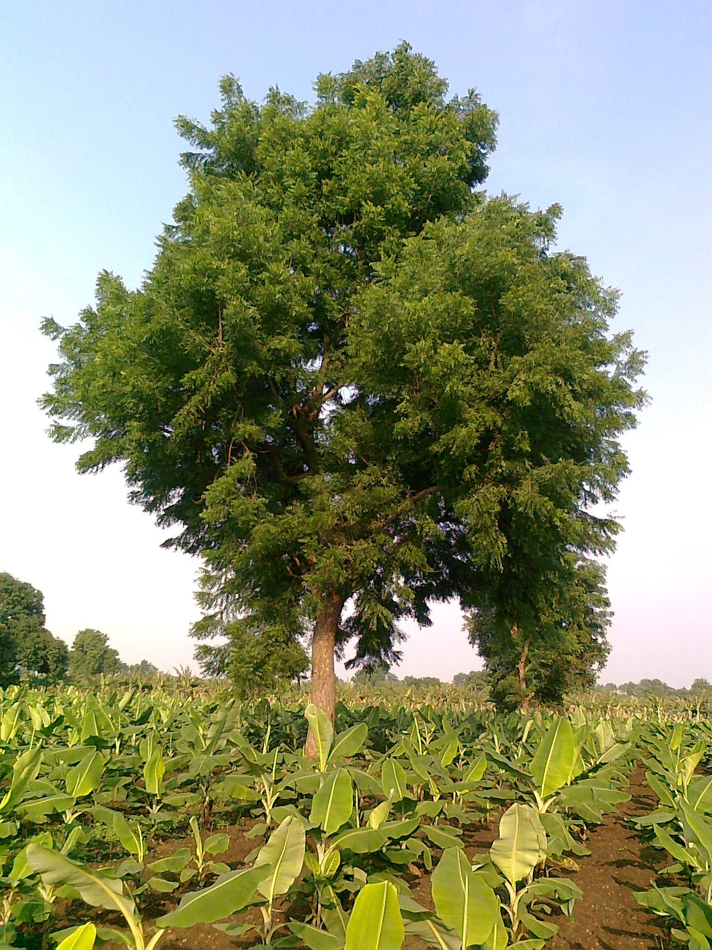**

**2.4 other apparatus used including the following:**

**-Balance, analytical metler H35 (Galenkamp, U.K)**

**-Drying oven (Galenkamp, U.K)**

**-Electric grinder (Moulinex, France)**

**-Rotary vacuum evaporator (Buchi, Switzerland)**

**-soxhlet extractor (Karl kolb, Germany)**

**-TLC spreading device (Desega Heideiberg, Germany)**

**-UV Lamp (Galenkamp, UK)**

**-Melting point apparatus (Thermochemical, England)**

**2.5 Chromatographic materials:**

**-silica gel type G for thin layer chromatography (loba chemie India)**

**-10 TLC glass preparative plates**

**2.6 spray reagents:**

**-Dragendorfs reagent**

**-Mayer reagent**

**2.7 collection of plant materials:**

**Leaves and stems of (Alnee) haplophyllum tuberculatum (forsk) a guss. Were collected in the flowering stage during March from algazeera slang twenty five kilometers north of Khartoum.**

**2.8 Documentation of the samples:**

**Herbarium materials were retained in the department of botany university of Khartoum and the samples were authenticated by the staff of the herbaeium.**

**2.9 preparation of the plant material:**

**The arial parts of hplophyllum tuberculatum (leaves and stems) were collected in the flowering stage during April from Aljazeera slang. The leaves were isolated from the stems using hands.The stems were cut into small pieces. The isolated leaves and stems were dried in arid atmosphere in closed room using fans (not introduced to sun heat).After complete drying the crushed stems were ground with mortar to minimize the volume and then they were powdered using the electric grinder (Moulinex, France) and these grinding increased the surface area so as to maintain good extraction. The leaves also were ground with mortar and were powdered using electric grinder (Moulinex, France).**

**2.10 preparation of test reagents for phytochemical investigation:**

**2.10.1 Alkaloid test reagent**

**Modified dragendorff s reagent :**

**Stock solution A:**

**(0.85g) of bismuth nitrate was dissolved in (10) acetic and 40 ml**

**Of water was added .**

**Stock solution (B):**

**(8g) of potassium iodide was dissolved in (20ml) water when testing for**

**Alkaloid 5ml of stock saluting A is mixed with (5ml) of stock solution B**

**(20ml) of acetic acid (100ml) were added**

**Mayer reagent :**

**Potassium mercuric acid test solution (1.5g) of mercuric chloride added to**

**(Sg) potassium iodide and (100ml) water**

**2.10.2 Flavonoids test reagent:**

**Aluminium chloride solution :**

**(1g) of Aluminium chloride was dissolved in (100ml) methanol**

**Potassium hydroxide solution :**

**(1g) of potassium hydroxide was dissolved (100ml) water**

**2.11 preparation of plant extract for phytoemical investigation:**

**(100 g) of powdered air – dried leaves and stems of hplophyllum tuberculatum were extracted with (200ml) 95% ethanol using soxhlet exractor for 5 hours .the cool solution was filtered and the volume was adjusted to (200ml) by addition of enough 95% ethanol. This prepared extract was used for the following tests .**

**2.12 Phytochemical investigation :**

**The leaves and stems of hplophyllum to tuberculatum was screened for alkaloids ,flavonoids, glycosids, lignans and tannin .**

**2.13 Test for alkaloids:**

**Method:**

**(30ml) of the prepared extract was evaporated to drynees on a water bath. (5ml) of 2N hydrochloric acid was added and the solution was heated with stirring in a water bath for 10 minutes .the cooled solution was filtered .to a portion (5ml) of this solution ,few drops of dragendorffs reagent were added . brown red precipitate was formed indicating the presence of alkaloids .**

**2.14 Test for flavonoids:**

**Method:**

**(75ml) aliquot of the prepared extract was evaporated todryness on a water bath; the cooled residue was defatted by extraction with hexane.**

**The defatted residue was dissolved in (30ml) 95% ethanol and filtered.**

**The filtrate was used for the following tests:**

1. **To (3ml) of the filtrate few drops of methanolic aluminum chloride were added. Formation of a dark yellow colour was taken as a positive test for flavonoids.**
2. **To (3ml) of the filtrate few drops of potassium hydroxide solution were added. A dark yellow colour indicated the presence of flavonids.**
3. **To (3ml) of the filtrate few drops of chloride solution were added. Development of a blue coloration was taken as a positive test for flavonoids.**

**2.15 Test for tannins:**

**Method:**

**(25ml) aliquot solution of the prepared extract was evaporated to dryness on a water bath and the residue was n-hexane and filtered.**

**The hexane – insoluble portion was stirred with (10ml) of hot saline solution (0, 9%w\v of sodium chloride and freshly prepared distilled**

**Water)**

**The mixture was cooled and filtered and the volume adjusted to (100ml) with more saline solution. (5 ml) of this solution was treated with few drops of ferric chloride solution, a blue colour was formed indicating the presence of tannins.**

**2.16 Test for glycosides:**

**Method:**

**(20ml) of the prepared extract was vigoursly shaken in a test tube. The presence of a froth that could persist for one hour indicated the presencre of glycosides.**

**2.17 Method of extraction of the plant material:**

**1kg of the stem were extracted with 70% hot mcthanol using soxhlet**

**ertactor the extraction was carried out for 72 complete ertractorr the**

**Methanol extract which contain the plant constituents was bkatceted**

**to rotatory evaporator to minimize the volume under reduced………..**

**The reduced methanol extract with hexane to remove fats waxes gums and the pigment of chlorophyll using separttory funnel 500 ml. The defatted methanol extract was trated with chloroform to extract alkaloids and other constituents. Extraction was done several times and every 20ml of the methanol extract was extracted with 60ml of chloroform. The combined chloroform extracted was concentrated to low volume under reduced pressure. The concentrated chloroform extract was shaken with 5%hydrochlooric acid until no further alkaloids could be extracted (checked by Mayer`s and Dragendorrfs reagents). The combined acid extracted were made alkaline with concentrated ammonium hydroxide then extracted repeatedly with chloroform. The concentrated chloroform extract was kept for thin layer chromatography.**

**The residue of the reduced methanol extract was further extracted with ethyl acetate and the extraction was checked for the presence of the alkaloids by Mayer and Dragndorffs reagents.**

**The same procedure was carried out for the leaves. The concentrated chloroform extracts (leaves and stems) was kept for thin layer chromatography.**

**2.18 Method of thin layer chromatography TLC:**

**Thin layer chromatography was carried to the chloroform extract for both (leaves and stems) using solvent systems petroleum ether: ethyl acetate 2:3**

**Ten preparative TLC plates were coated with silica gel G sing the spreader device (Desega Heidelberg, Germany). With thickness 1mm and the plates were activated using drying oven (Galen Kamp, UK) at 150C. The concentrated chloroform extracts were introduced by capillary tube 2cm above the bottom of the preparative coated TLC plates and after drying they were put into the TLC jar which contained the solvent system petroleum ether : ethyl acetate 2:3**

**After developing the TLC plates were set for drying and examined under UV light.**

**2.19 Melting point determination:**

**10 mg of each of the components which exhibited alkaloidal characteristic and which were labeled as sample2 and the ones which exhibited non alkaloidal characteristic and which were labeled as sample3 and sample4, each were introduced into the capillary tube, the capillary tube was introduced into the melting point apparatus and the apparatus was set on.**

**2.20 Physico-chemical methods:**

**UV spectra were recorded using methanol on Ajanawy 6505UV/VIS spectrometer.**

**IR spectra were recorded as thin film on Nacl disc on Thermonicolet-300**

**IR spectrophotometer.**

**HNMR spectra were recorded on Gemini 300 (330MHz) in the appropriate deuterated solvent, using tetra methyl silane (TMS) as internal standard.**

**3 Result & Discussion**

**3.1 Results:**

**3.1.1 Preliminary phytochemical screening:**

**The preliminary phytochemical screening of Haplophyllum tuberculatum were indicated the presence of secondary metabolites: alkaloids, flavonoids, glycosides and tannins.**

**3.1.2 Further investigation:**

**The aerial parts (leaves and stems) of Haplophyllum tuberculatum were extracted separately with 70% methanol using sohxlet extractor and were concentrated under reduced pressure using rotatory evaporator, the concentrated methanol extracts were defatted with hexane to remove waxes, gums and chlorophyll so as to be ready for the following extractions which were carried with chloroform using separotary funnel 500ml, another extraction was carried to the reduced methanol extracts with ethyl acetate. The chloroform and ethyl acetate extract were concentrated for the following analysis.**

**The concentrated chloroform and ethyl acetate extracts were checked for alkaloids by mayeris and Dragendoreffs reagents**

**3.1.3 Mayeris reagent test :**

**when 3.0 ml of the acidic chloroform extract (leaves and stems) were treated whit 1.oml of the reagent in a test tube it gave positive result; creamy color precipitate for both leaves and stems and this indicated the positive result for the alkaloids in the chloroform extract .**

**When 3.0ml of the ethyl acetate extract (leaves and stems) was treated with 1.0ml of Mayer`s reagent no precipitate occurred that means negative result; no alkaloids present in theethyl acetate extract.**

**.**

|  |  |
| --- | --- |
| **Component No.** | **Rf Value** |
| **1** | **0.1** |
| **2** | **0.2** |
| **3** | **0.32** |
| **4** | **0.45** |
| **5** | **0.52** |
| **6** | **0.6** |
| **7** | **0.75** |

**3.1.4 Dragendorff`s reagent test: When 3.0ml of the acidic chloroform extract (leaves and stems) were treated with 1.0 ml of the reagent in a test tube, gave positive result; brown red precipitate for both leaves and stems, and this indicated the presence of alkaloids.**

**When 3.0 ml of the ethyl acetate extract ( leaves and stems ) was treated whit 1.0 ml of the reagent in a test tube no precipitate occurred and that means the ethyl acetate extract was devoid of any detectable alkaloids.**

**3.1.5 Thin layer chromatograply (TLC) for the concentrated chloroform extract :**

**The concentrated chloroform extract (leaves and stems) which exhibited positive results for alkaloids were screened on TLC using petroleum ether and ethyl acetate as solvent system with the ratio 2:3 when examining the developed plates chloroform extract under the UV light both (leaves and stems ) showed a bulk of 7 flulorescent components (see table3).when one developed plate was sprayed whit dragendorff`s reagent to detect alkaloidsit gave positive result whit two of the seven fluorescent components (yellow red ) colour and they were alkaloidal constituents.**

**The seven fluorescent components obtained whit their Rf values after examining the developed plates under UV light are illustrated in table 3.**

**Both leaves and stems gave same component with their Rf values when the developed plates were examined under the UV light .**

**Rf value =Distance traveled by center of zone/ Distance simultaneously traveled by developer front (Erich Heftmann ,1966)**

**3.1.6 Result of spraying with Dragendorff`s reagent:**

**After spraying the developed TLC plate both leaves and stems with dragendorff`s reagent, the comppnents which gave positive result are illustrated bellow in table 2.**

**Table 2:**

|  |  |  |
| --- | --- | --- |
| **Component no.** | **Rf Value** | **Description** |
| **6** | **0.6** | **Yellow red color** |
| **7** | **0.75** | **Yellow red color** |

**Compoundl and compound2 were concentrated using TLC until we get a**

**quantity enough for the tests of melting point and spectroscopic analysis.**

**Also the two non alkaloidal constituents with the Rf value 0.52 named as cmpoound 3 and Rf0.32 named as compound 4 exhibited a bulk of white**

**blue florescence and they were concentrated by means of TLC for simple**

**analysis and UV ,IR spectral analysis.**

**3.1.7 Melting point result :**

**The result of the melting point of compound1 was 167C0.**

**The result of the melting point of copound2 was 177C0 .**

**The melting point of the non alkaloidal constituent compound3 was 191C**

**The melting point of the non alkaloidal constituent compound4 was 195C**

**3.1.8 spectroscopic result :**

**Because the leaves and stems showed identical results in the preliminary**

**analysis and in the TLC; the spectroscopic analysis was done only for the**

**components of the stems . the alkaloidal compound1 and compound2 were in vestigated by UV,IR 1HNMR and Ms spectroscopy and the non alkaloidal constituents compound3 and compound4 were investigated by IR and UV spectroscopy only.**

**3.1.8.1 The UV result of compound :**

**The data of the spectrum obtained is illustrated bellow in table 3:**

**Table 3:**

$γ$**Max. 210nm**

|  |  |  |  |
| --- | --- | --- | --- |
| **Wave length**  **Nm** | **Absorbance** | **Wave length**  **nm** | **Absorbance** |
| **210nm** | **0.134** | **550nm** | **--------------** |
| **220nm** | **0.766** | **650nm** | **--------------** |
| **240nm** | **0.508** | **900** | **--------------** |
| **260nm** | **0.333** |  |  |
| **356nm** | **0.48** |  |  |
| **488nm** | **0.098** |  |  |

**The spectrum obtained is illustrated as figure2**

**3.1.8.2 The infra red result of compound :**

**the data of the spectrum obtained:**

**IR cm-1 :3425.34 cm-1 ,2923.88cm-1 (s), ,2854.45cm-1 (s) ,1741.60cm-1(s) ,1631.67-1568.02cm-1, 1415.65 cm-1,1107.06cm-1and 794.62cm-1..**

**The spectrum obtained is illustrated as figure2**

****

**Discussion of the result:**

**The alkaloids comprise a body of organic substance of extra ordinary wariety and interest. Among plant secondary metabolite alkaloids occupy pmminent position.**

**Many alkaloids exert biological activity and the anti-microbial , anti malarial ,anti-tumor activity of some alkaloids is well established. Also alkaloids are economically important.It is this interesting property that promoted the present investigation and it was decited to investigate the alkaloids of medicinally important species of hplophyllum tuberculatum which is used in the folkloric medicine in sudan .**

**The Sudanese species of Hplophyllum tuberculatum has been stuied for alkaloids before ,(Khalid et al ,1881). The study concluded that the Sudanese Haplophyllum tuberculatum species contain the furoquinoline alkaloid skimmianine which have the following chemical structure**

**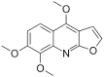**

**Skimmianine**

**Hence compound exhibited alkaloidal behavior and with regard to IR ,UV spectrum result the following characterization of compound was suggested.**

**Conclusion &Recommendation**

**Naeem(Haplophyllum tuberculatum) is used in folkloric-medicine in the treatment of nausea, malaria, and gastric pain, intestinal worms, as spasmolytic and in childbirth and it grows in northern and central sudan.**

**In this study we concluded that Naeem (Haplophyllum tuberculatum) is rich of some secondary metabolites especially alkaloids. Tow alkalodis were isolated form Naeem and we suggest their structure by of IR,UV, techniques. Also the isolation of another tow non alkaloids constituents and their identification by simple analysis,IR and UV techniques was done.**

**We recommend that afuture 13C NMR will provide additional evidence in favour of the proposed structures of the isolated alkaloids compound.**

**References:**

* **Ahmed ,s. 1,potential of using neem tree(Azadirachta Indica) for pest control and reral development. Neem news 1.5:49-55,(1988).**
* **Ahmed,s., in Pharmacognosy, Introduction of plant Constituents and their tests, New Delhi.(2007).**
* **Atl,c, k and kapur , B.N, cultiration and utilization of medicinal plants. CSIR, RRL,Jamme-Tawi,India.727,(1982)**
* **Biswas,K, Chattopadhyay,l., Banerjee R.K. and Bandyopadhyay, U., Biological Activities and Medicinal Properties of Neem (Azadirachta indica) Curr.Sci., 82 (11):1336-1344.(2002)**
* **Biu, A. A. Dyusufu, S and Rabo, J. S. Phytochemical screening of Acadirachta indica (Neem)(Meliaceae) in Maiduguri Nigeria,Biosciena research communications. 2, 281-282,(2009).**
* **Conrick, J. the Mira culous healing herb. Beverly neem hills , America. Inc. USA.(2007)**
* **Dixit, V. P. Effect of neem seed oil on on the blood glucose of normal and alloxan diabetic rats. J. of Elhano pharmacol. 17:95-98.(1986).**
* **Ebong, P. E, et. Al, the Antidiabetic effciancy of combined extract from twe conyinental plant, A. indigo(Ajuss) (Neem) and vernonia anygdalina (Del) (Africa bitter leaf ).University of caliber P.M B 1115, calabar , Nigeria .P. p 239, 243. (2008).**