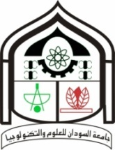
بسم الله الرحمن الرحيم
Sudan University of Science and Technology
College of engineering
School of Mechanical engineering

Cost and waste reduction in PASGIANOS Company
A thesis submitted in partial fulfillment of the requirements for the degree of B.SC. In Mechanical Engineering

Prepared by:
Ahmed Kamal Salih
Mohammed Awad Mahmood

Supervisor: Dr. Widatalla Elamein

