Review on Image Guided Surgery Systems

Akram Omara¹, Omer M. Gaddoura², Megdy B. Eltayb¹

¹Sudan University of Science and Technology, Biomedical Engineering Dept.
²Bayan College for Science and Technology, Biomedical Engineering Dept.
akram_amara@yahoo.co.uk

Received: 08/10/2019
Accepted: 18/11/2019

ABSTRACT- Nowadays modern imaging techniques can grant an excellent quality 3D images that clearly show the anatomy, vascularity, pathology and active functions of the tissues. The ability to register these preoperative images to each other, to offer a comprehensive information, and later the ability to register the image space to the patient space intraoperatively is the core for the image guided surgery systems (IGS). Other main elements of the system include the process of tracking the surgical tools intraoperatively by reflecting their positions within the 3D image model. In some occasions an intraoperative image may be acquired and registered to the preoperative images to make sure the 3D model used to guide the operation describes the actual situation at surgery time. This survey overviews the history of IGS and discusses the modern system components for a reliable application and gives information about the different applications in medical specialties that benefited from the use of IGS.

Keywords: Image-guided surgery; Anatomical landmarks; Skin markers; bone mounted markers, Point matching registration; Space registration; tracking system.

المستخلص- في الوقت الحاضر، يمكن لتقنيات التصوير الحديثة أن تضمن انتاج صور ثلاثية الأبعاد ذات جودة ممتازة, تُظهر هذة الصور بوضوح التشريح والأوعية الدموية والأمراض والوظائف النشطة للأنسجة. القدرة على تسجيل هذه الصور قبل الجراحة مع بعضها البعض ،لتعطى معلومات شاملةعن الانسجة، و من ثم القدرة على تسجيل فضاء هذة الصور مع فضاء المريض لاحقا أثناء العملية الجراحية هي اساس عمل أنظمة الجراحة الموجهة بالصور (IGS). العناصر الرئيسية الأخرى لهذا النظام تشمل عملية تتبع الأدوات الجراحية أثناء العملية الجراحية عن طريق عكس مواقعها داخل نموذج الصورة ثلاثية الأبعاد. في بعض الحالات ، يمكن الحصول على صورة اضافية داخل العملية وتسجيلها مع الصور السابقة للتأكد من أن النموذج الثلاثي الأبعاد الذى يستخدم لتوجيه العملية يصف بدقة الوضع الفعلي في وقت الجراحة. نستعرض هذاالبحث تاريخ نشؤ النظام و تطوره و المكونات الحديثة بالاضافة لمعلومات حول التطبيقات المختلفة له فى التخصصات الطبية.

INTRODUCTION
A common situation in traditional surgical methods is that the actual planned therapy is very basic and straight forward but the procedure implemented to reach the actual region of interest is harmful or threatening to patients lives. A large opening is often essential to provide surgeon with the required visual guidance. In such situations, surgeons have to rely on their knowledge and experience to avoid functionally important tissues in the path to the targeted region. These two main shortcomings; the complete reliance on surgeon skills and the lack of real time information on surgical site for a safe path, have derived and paved the way toward minimal invasive procedures and hence promoted the maturity of IGS techniques to enhance them. In IGS techniques the surgical tool can navigate and approach the region of interest precisely and without the traditional direct visualization. Information about the anatomy and function of the trajectory tissues are available on surgical site to provide the necessary guidance. The routine uses of IGS by a well-trained surgeon brings treatment outcomes to a new level by reducing procedure time, lowering the total costs, improving the surgical safety, and lessening patient distress and healing time ^{[1,2].}
Technical Background
The successive improvement in minimal invasive techniques for the same procedure, modified from is shown in Figure 1. Wilhelm Roentgen shown in Figure 2 discovered the X-rays in 8 November 1895 and as early as December 1895 the first radiograph (the hand of his wife) was produced.
One month later on January 13, 1896 the first use of X-ray image in surgery was reported in Birmingham (UK) ^{[5].} An X-ray radiograph was used to localize a needle in a woman hand and guide a surgery to remove it.
This immediate implementation of image information in surgery reflects the eager need of such methodology. However, because the X-ray radiograph characteristics does not allow precise geometric measurements due to the distortion arises from both the reduction of the 3D physical space into the 2D image space and the differential magnification caused by the divergence of the X-rays beams from the source to the film, a certain degree of uncertainty about the position of the target remains in the projective images.
Therefore, the surgeon, JH Clayton, still had to rely on his anatomical knowledge to relate the needle position to the surrounding boney structures visible in the X-ray image and to avoid vessels and tendons which are not visible in the radiograph. This process of defining the exact spatial location of a target and a safe trajectory that avoid vital structures is the essential idea behind the IGS.
Thus, the successful outcome of each IGS requires correct image geometry and soft tissue visibility which are both unavailable in X-ray radiograph. The technique used by Clayton may be referred to as low level IGS as the surgeon still has to rely on his own knowledge to localize and approach the target. While geometrical information distortion might not affect the diagnostic value of the image, it has equal if not more value than grey level information in IGS.

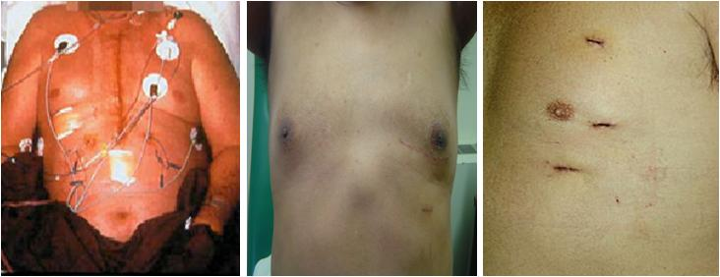

Figure 1: the successive improvement in minimal invasive techniques for the same procedure, modified from ^{[3,4].}

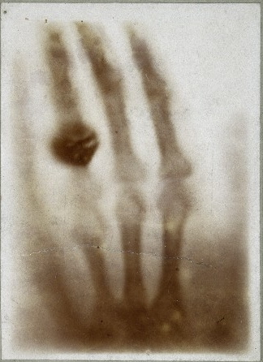
Figure 2: Wilhelm Conrad Roentgen and the first X-ray radiograph (the hand of Rontgen wife), ^{[6].}

Solutions to improve images quality have been sought by researchers to allow a direct measure of target position and trajectory within image data. The uses of a very long focal length > 9m to produce a parallel ray through the imaged body minimize the differential magnification to some extent. The soft tissue contrast problem was handled by injections of contrast solutions and later by the introduction of new imaging systems and means of multimodality image registration.
Almost 10 years after Clayton surgery, Horsley and Clarke designed an apparatus to be attached to the head ^{[7]}. They used the Cartesian coordinate’s calculations to establish a relation between the targeted positions in a monkey brain and predetermined landmarks on its skull.
Even though Horsley & Clarke’s intention was not to establish a transformation between two spaces nor based on patient specific data, their device inherently holds an essential concept to IGS, giving the patient’s body a coordinate system. A similar apparatus was conceived for the human skull by the engineer Aubrey Mussen, who had worked with Horsley and Clarke system ^{[8]}. This devise was found after 30 years of his death covered with a newspaper dated 1918.
However, the existence of a fixed relation between certain internal and external landmarks has proved not to be valid or similar across human beings. Therefore, the new methods have moved to employ patient specific information instead of generalized atlases and charts.
Spiegel et al ^{[9]} developed a device that consisted of lead markers mounted to a plastic frame. The radiographic images could be acquired while the frame attached to the patient head. The presence of the markers in the image space allowed the correlation of the images and the establishment of a 3D Cartesian coordinate system with respect to both the brain and the images.
More than 40 stereotactic devices were developed using the same concept of Spiegel device during the next 10 years, Figure 3(A). Although varying in the design and shape, they all provide a coordinate system to the patient space by means of a rigid frame that could easily be distinguished in image data. The rigidly fixed frame also used to hold the probe and guide it to the target which allows the tracking of the probe position with a marked scale within the frame coordinate system.
With the advent of both the 3D geometrically correct imaging systems (computed tomography) and the cost effective yet powerful computers, the field has experienced a revolutionary progress. The X-ray films were digitized and the marker positions were used by the algorithms to fix any presented distortion in the data due to misalignment.
Brown ^{[10]} introduced a frame with a certain configuration of fiducial markers which is capable of correctly register the 2D slices together by producing unique shapes at each image slice. Based on the positions of the markers in the image, Brown also explained the method used to establish the frame coordinates of any pixel in the image. This configuration was formed of parallel and tilted bars around the frame and they represent the past versions of today's markers, Figure 3 (B, C).

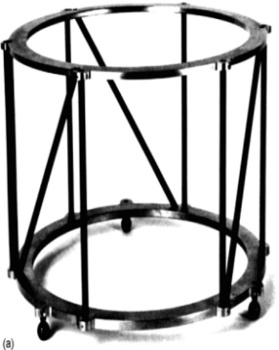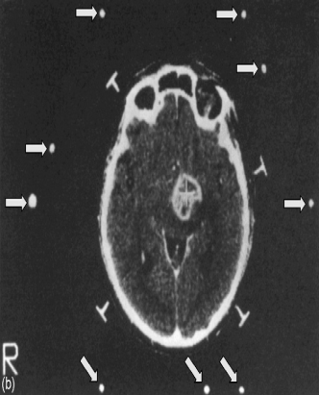
Figure 3: (A) examples of stereotactic frames, upper left: Translational system, upper right: arc centered system; lower left: burr-hole mounted system and lower right: interlocking arc system, from^{[11]}. (B) Brown frame for CT-to-patient registration. (C) Example of axial image slice of the head obtained with CT. the positions of the 9 bars appear in image data can be used to calculate the position of the image slice, from ^{[12]}.
B
C
A

Although stereotactic frames provide a standard accuracy of 1 mm, there was a general trend to abandon or replace the cumbersome frame completely. The frame causes patient discomfort since it has to be fixed rigidly to the head before imaging and should not be removed before the surgery. The application of the frame is invasive and requires a minor surgery, either by drilling 3 to 4 holes in the skull, 1 to 2 mm deep, necessary to install the screws or by applying pressure to secure sharp pins on the skull. In addition, the presence of the frame itself is considered intrusive to the surgical field and could impede the surgeon access.
Alternative framework capable of providing means of registration between the image and the imaged body was necessary to discard the frame-based technique. Starting from mid 1980s researchers began to introduce devices that implement the computer to track the surgical instrument within the patient space and transforming their positions into the 3D image space. This concept is the contrary of what was used before in the frame theory, where the image was used to locate a position in the patient space. The first image guided system was presented by Roberts et al. ^{[13]} in 1986. Such devices have become a routine and indispensable instrument in intracranial procedures.

Today’s IGS Components, Phases and Technologies
There are several essential steps and techniques for the successful implementation of image guided surgery systems including: Preoperative image acquisition, Preoperative planning, display and 3D visualization, Intraoperative patient to image registration and the 3D real time tracking. The following subsections provide a comprehensive review of these steps.
Pre-operative Imaging:
The progress in both surgery and imaging techniques led to the improvement of IGS ^{[14].} Preoperative imaging is the basic stage that provides the system with the patient specific guidance information. Medical imaging equipments have been designed and mainly used for diagnostic purposes, the use of their geometric data to guide the surgery is fairly recent. Initially in the 1970s, CTs were dominating the stereotactic surgeries for planning and guidance. Other modalities (MR, SPECT, PET and DSA), which were introduced later, have then participated to this field by complementing the CT’s information each with its unique provided information.
The main attraction of using CTs in IGS comes from their ability to provide surgeons with a 3D image as well as being considered geometrically accurate devices. However, their acquisition is usually made slice by slice in most scanners which may tamper the image geometry in case of patient movement during scanning. The other unfortunate shortcoming of CTs, especially in brain, is the low contrast of soft tissues, making this type of imaging better for bony structures. MRI is today’s de-facto standard in most IGS systems in neurosurgery.
This preference is due to its ability to vividly distinguish small differences between the soft tissues and the better definition of lesions margins. However, MRI images are liable to both geometric and intensity distortions ^{[15]}. Recent systems incorporate schemes to reduce the problem to a sufficient level ^{[16]}.
The limited quality and availability of intra-operative imaging devices furthered the dependence of the IGS systems on preoperative images to guide the surgery. While preoperative images accurately represent the patient anatomy, some changes might occur during surgery (ex. brain shift) and then real time intra-operative images such as interventional MRI ^{[17,18]}, C-arm CT^{[19,20]}, ultrasound^{[21,22]}, video^{[23]} and electrophysiological recordings might be used to update the preoperative information. A non rigid registration is usually required to align the intra-operative with preoperative data ^{[24, 25]}.
Pre-operative Planning:
The second phase of IGS system is usually dedicated to the surgery plan and to enhance the guidance data. Image processing techniques are used when necessary to correct the geometric and intensity distortions. For example, while CT images are geometrically correct it might exhibit distortions due to the alignment of patient or gantry and the variability of slice thickness and positioning. New CT scanners overcome most of these problems by the concurrent acquisition of a large number of slices. Segmentation may be used as well to define and highlight the target, the trajectory and the important anatomical structures in the site of the surgery.
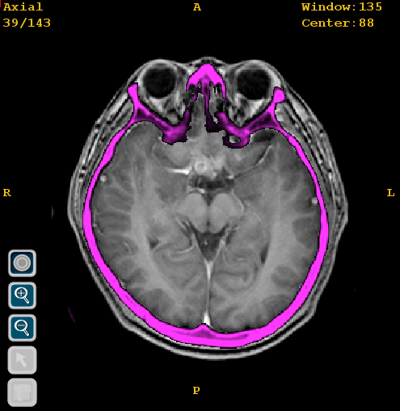
Figure 4: multimodality registration, MRI data with CT data.
Multimodalities image registration might also be necessary since each modality offers exclusive information about the site of interest. For instance, registering the CT images with the MRI would add the missing soft tissue information on the visible bony structures of the CT, Figure 4. The vascular information can also be added with MR angiography or CT angiography. Defining anatomical locations for the brain functions or placing electrodes on functionally active region is also made possible by registrations with PET, SPECT, and fMRI.
Preoperative multimodality registration makes the surgical planning and execution more effective by allowing a simultaneous use of the distinct information of each modality. Such technique is essential to plan a safe trajectory from the opening to the target, avoiding vital anatomy, functionally active regions and intervening through vascular free zones.
Display and 3D Visualization:
Image visualization and display techniques are important to both briefly and efficiently view the necessary information for the successful intervention as well as to ease the perception of the underlying 3D anatomical structures. Image visualization methods include: volume-reslicing, surface rendering and direct volume rendering. Volume-reslicing displays the 3D image as three orthogonal 2D image sections (axial, sagittal and coronal). The display of the 3D image as a volume or as a single entity is feasible, either via surface rendering ^{[26]} by projecting the surfaces within the volume, or via direct volume rendering ^{[27]} by projecting the entire volume. In surface rendering, which is more popular than volume rendering in clinical practice, an accurate automated or manual prerequisite segmentation is necessary to identify the surfaces of interest in the volume.
Most IGS systems employ standard computer screens to display the guidance information in four views. These views present dynamic location update for the axial, coronal and sagittal sections according to the position of the tracked instrument as well as a 3D volume in the fourth window simultaneously, Figure 5 (A). This way of display is widely used due to the surgeon’s preference, since their habitual practice in school training and work experience is mostly based on mentally reconstructing the anatomical structure from these 3 standard cross-sectional views. Melanie Tory et al ^{[28]} recommended a hybrid method, instead of the pure 2D slices or pure 3D volume, which displays the 3 cross sections in their actual locations within the volume, Figure 5 (B). Their technique was based on a behavioral preference of human perception and is expected to be more efficient
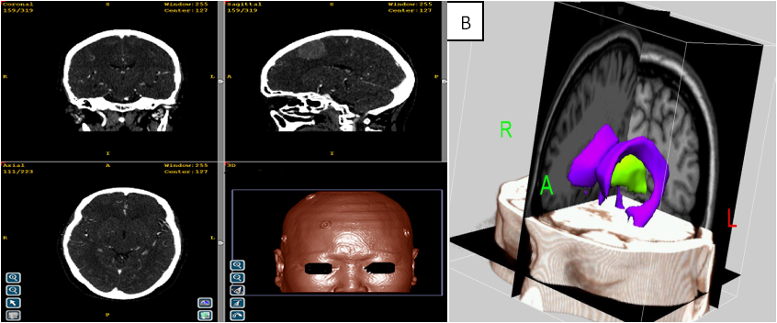
A
Figure 5: the display techniques (A) The standard 4 windows views of the IGS systems display showing axial, coronal and sagittal sections in addition to the 3D visualization, (B) The hybrid displaying technique where the three 2D slices are displayed in their actual positions within the 3D volume, figure (B) from ^{[29]}.

Two disadvantages associated with the use of the standard computer; the long distance between the surgical site and the monitor and the cumbersome interaction. The adoption of interactive screens (touch screen), virtual keyboards, speech recognition systems ^{[30, 31]}, computer vision-based gesture recognition techniques ^{[32]} or even simple on/off foot pedals might be useful to minimize surgeon’s interruption. On the other hand, the distant placement of the monitors, which meant to avoid their obtrusiveness with the surgical field, distracts the surgeon between patient and image space or causes him to center his attention only in image space, Figure 6. Many attempts have been made to bring the display system closer to the surgical site including miniature LCD screens ^{[33]}, head mounted displays (HMD)^{[34]}, stereo operating microscopes and binoculars^{[35,36]}, projection of the image on the surgical site and augmented reality^{[37].}

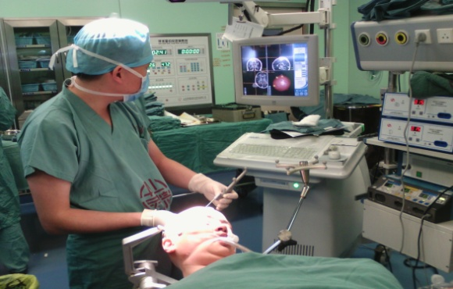
Figure 6: The display monitor placement in the operation room ^{[38].}

Intra-operative Patient to Image Registration
Registration can be defined as the determination of a spatial transformation between two spaces. The ability to register patient space to image space accurately is the key that enabling the use of images to guide the operation ^{[39 - 46]} and it can be classified into two subtypes: point-matching registration and surface-matching registration
Point Matching Registration:
Point-matching registration is the most common method in IGS practice. In this technique a group of at least three linearly independent points have to be identified in both the image space and the patient space ^{[38,47]}. It is crucial that the matching positions are accurately identified. Then a spatial transformation is performed using one of several available algorithms to achieve the rigid alignment between the corresponding points from one space to another. The point-matching registration can be accomplished based on either bone mounted markers, skin adhesive markers or anatomical landmarks.
Skin Adhesive Markers:
Skin adhesive markers (SMs), shown in Figure 7(A), are the most common clinical routine practice in point matching registration. SMs are usually easier to place in patient space and to identify in image space. Depending on the used imaging technique (CT, MRI, PET, etc.), these markers can be designed of several materials and shapes to guarantee their evident presence in the image space. For example, markers made of metallic component are suitable for use with CT but can cause undesirable distortions on the magnetic field of the MRI.
On the other hand, markers filled with sulfate solution are not visible in CT scans but are clearly visible in MRI images. Certain types of markers packed with a soluble x-ray contrast material (iodine and gadolinium) can be visible with both MRI and CT images. SMs can be attached to patient’s skin separately as single markers or as a whole configuration of markers together.
SMs have some limitations. A preoperative preparation stage has to be considered, including fiducial planning and image scanning. The fiducial planning must be conducted by trained staffs, who attach the SMs to the patient’s head with a proper distribution ^{[38,48,49]} before the image scanning. Usually every patient already has diagnostic images when the use of IGS is determined. An additional image scanning after placing markers on patient head, which is necessary for the IGS implementation, is a redundant procedure. The new scanning means additional cost and radiation exposure in the case of CT.
In addition, it is very important when using markers to keep their positions unchanged between preoperative imaging and the surgical procedure. Skin motion with respect to underline boney structures can occur due to tissue swelling, drying or even the tractions while placing patient head in the head clamp directly before the surgery ^{[50]}. This motion could present a potential source of error to SMs registration.
Therefore, care must be taken to place these markers carefully in selected locations of the skin and the time between introducing the markers on patients and imaging to the actual surgical procedure must be reasonably short to avoid markers movements and dislocations on patient skin. Moreover, the SMs may require to be reattached again if they are accidently detached and hence the image scans have to be then retaken once more. The accuracy reported by several studies using this technique where in the range of 1.5 -4 mm.

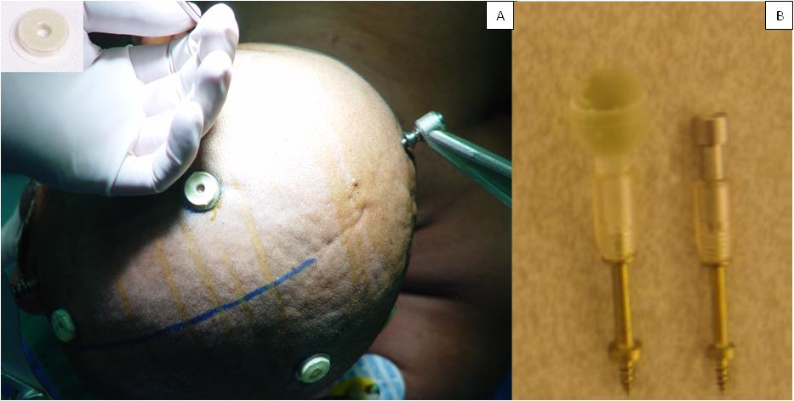
Figure 7: extrinsic markers (A) skin adhesive marker (B) bone mounted markers, modified from ^{[51].}

Bone Mounted Markers:
Bone-mounted markers, shown in Figure 7 (B), usually consist of 2 parts, a titanium bottom that is fastened into the patient skull and a replaceable top part that is filled according to the used imaging modality. As a result of their firm and strict fastening, bone-mounted markers solved the problem of errors caused due to SMs dislocation. When appropriately planned, the highest targeting accuracy reported in point-matching registration were associated with the use of bone-mounted markers as shown in several studies ^{[48-53]} and ranged between 0.5 to 1.5 mm.
The inconvenience of this technique is the invasiveness of their application. A minor additional procedure under local anesthesia is necessary to install the markers to the skull before the imaging. A comprehensive review of markers is provided by Fitzpatrick ^{[54]}.
Anatomical Landmarks
It is also possible to complete the registration without the use of the extrinsic markers, by selecting the corresponding Anatomical Landmarks (ALs) in image and patient spaces. The benefit of using this method is its simplicity. No preoperative preparation is needed, no dedicated image acquisition is necessary because the diagnostic scans can be implemented straightforwardly in IGS. Moreover, no markers need to be attached to patient's skin before imaging, and of course there is no fear of registration errors due to markers mobility or accidental removal between imaging and surgery. ALs registration is considered the easiest and fastest point matching registration technique and provides the simplest planning procedure for the surgical navigation ^{[55]}.
The disadvantages of using this method are the few numbers of anatomical landmarks that can be recognized in both image and patient spaces, distinct landmarks not always available at the site of surgery. In addition, the error associated with localizing some of these landmarks is large.
While some previous studies have shown that ALs method give accuracy ranges that is equivalent to that of SMs technique and is adequate to guide the surgical intervention ^{[38,55-58]}, others argued that ALs produce poorer accuracy compared to SMs ^{[59]}. The issue of applicability and accuracy of ALs-based registration continues to be a controversial subject in IGS
Surface Matching:
The technique was introduced in 1989 when Pelizzari and Chen extracted the surfaces from 3D images of different modalities and then used these surfaces to align the images within a single coordinate system ^{[60]}. The same concept used later to register the surface extracted from a 3D image with the similar surface in patient space. The method uses a cloud of sampled points from the patient space that describes the same surface extracted from the 3D image.
A transformation that register the two surfaces perfectly can then be calculated using a surface-matching technique, Fig. 8. The transformation matrix can then be used for the tracking of surgical tools in a similar way to those obtained with point-matching registration.

Figure 8: Surface matching technique, left: the two unregistered corresponding surfaces extracted from image and patient spaces, right: the registered surface, from ^{[61]}.
Since surface data might be collected point by point, this method is time consuming, user dependant and the number of the points are usually small (40 to 200) to optimally describe the surface. Laser devices were introduced to improve and speed the point’s collection. However, surfaces that usually used for the intraoperative registration are forehead, nose and area around the orbits where there is less hair growth and skin deformation.
Therefore, the registration errors in the posterior part of the head tend to be bigger. Surface matching are more complex than point matching methods, the registration accuracy depends on the image quality and the different facial expressions between image scanning and registration. A combined method of point and surface matching was introduced by Maurer et al ^{[62]}, the new method was reported to be more accurate than surface matching or point matching alone.
Evaluation of Registration Quality
The patient to image registration is often a main cause of error in the clinical application of IGS ^{[63]} and this error is mainly attributed to either the expected inaccuracy in identifying the exact locations of the corresponding fiducial points essential for point matching registration or to the different facial expressions in surface matching registration. Hofer et al. ^{[64]} recommended a standard way to effectively describe and compare the accuracy of image guided systems by counting the mathematical mean, the standard deviation, and the maximum deviation of the targeted point localization for the accuracy evaluation. The standardization of the imaging and registration methods will also allow the improvement and the development of new systems.
Three parameters are usually considered when the task is to assess the suitability of a registration in IGS. The accuracy: represent estimation for the distance between the actual and the predicted location of the certain target. The speed: with which the algorithm can calculate the transformation accurately, usually several seconds to 2 minutes are accepted intra-operatively. The robustness: the ability of the algorithm to perform correctly under different situations associated with the quality of the data, like the presence of noise and outliers.
Maurer et al. ^{[65]} gave definitions of three errors in point-matching registration: Fiducial Localization Error (FLE): the average error in locating the position of the fiducial points. Fiducial Registration Error (FRE): The Root Mean Square (RMS) distance between corresponding fiducial points after registration. Target Registration Error (TRE): the distance between corresponding points other than the fiducial points after registration ^{[38],} Figure 9.
Tracking Systems:
Once the registration transformation between the patient and the image is computed, the next step is to use it to precisely project the surgical instrument location with respect to the target. The position and orientation of the surgical instrument must be continuously tracked within the patient space and displayed accordingly in each one of the three image sections or within the 3D visualization.
It is necessary to track the position of the head as well if the patient is not immobilized to compensate for it is movements. In fact, tracking is a six-dimensional problem. The tracking of the instrument positions in patient space which defined by X Y and Z axes is not enough. The Yaw, Pitch, and Roll of the instrument spatial orientation must also be tracked.

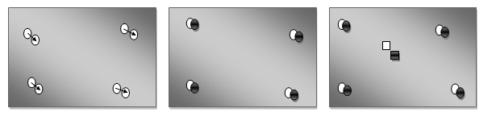
A
B
c
Figure 9: Registration errors (A) FLE is indicated by the arrows, the distance between the selected and the actual position of the fiducial markers. (B) FRE, the distance between the positions of the fiducial markers in one space (white) and the positions of the transformed corresponding fiducial markers of the other space (black). (C) TRE, the distance between the actual target position (white rectangle) and the predicted position after the registration (black rectangle), modified from ^{[66].}

There are various tracking techniques have been introduced such as mechanical, ultrasonic, magnetic and optical. Each technique has its advantages and weaknesses.
Mechanical Tracking:
In this method ^{[67]} the surgical instrument is physically attached to an articulated mechanical arm equipped with angular sensors in the joints. Optical sensors and potentiometers are the most common ^{[68]}. The position of the surgical instrument tip is calculated by the computer on the basis of the sensed angles at each joint and the known arm geometry. The tracking accuracy is usually sufficient and adequate update rates of positions are attainable. Moreover, their performance remains stable with environmental changes. However, the main drawbacks are that it can only track one object at a time, which necessitates the immobilization of the patient head. These systems are also large, heavy and tend to be intrusive with the surgical field. Those drawbacks are similar to those motivated the move away from frame stereotactic techniques.
Ultrasound Tracking
In this method, an emitter should be attached to the instrument to be tracked while the receivers installed at known locations in the operation room ^{[69]}. From the time needed by the emitted signal to reach the receivers, time-of-flight (TOF), the location of the emitter and thus the tracked instrument could be calculated. If more than two emitters are attached to a stiff instrument, the orientation can be determined as well from the angular position of the emitters. This approach offers a compact wireless setup and provides the possibility of multiple object tracking. Nevertheless, it has some major limitations as well. One emitter has to spark at time which introduces a time delay for all the emitters to spark before the instrument location can be determined. The instrument must also remain stationary during the delay time N (TOF+TD) to avoid error occurrence. N is the number of emitters and TD is the delay time between spark events necessary to deal with reverberations. This problem introduces restrictions on the system update rates and on the numbers of emitters to be used especially when multiple objects have to be tracked. Changes in room temperature will also results in changes in the sound speed affecting the localization accuracy of the system. A recalibration method, pilot sparking ^{[70]}, is proposed to solve this problem. In this method the differences in the transit time for a standard spark were used to correct for the changes in the sound speed. In addition, ultrasound methods require continues uninterrupted line of sight between emitters and receivers.
Electromagnetic Tracking:
In this method a transmitter source is used to create a magnetic field in the operation room and miniature coiled sensors (diameters of 1mm) are placed within the instrument to be tracked ^{[71, 72]}. The sensors interact and distort the magnetic field according to their position and orientations. By measuring these changes, the position and orientation of the sensors and hence the instrument can be determined. In this method there is no time delay required and since no line of sight is required as well, magnetic systems can track flexible instruments within the body cavities without the rigid instrument constraint. Moreover, this method allows multiple objects tracking and the update rate and the system accuracy (1mm to 0.50 mm) are both acceptable for surgeries. In addition, a Wireless system was introduced recently from Calypso Medical Technologies Inc. (Seattle WA, USA) ^{[73, 74]}. This approach solves many other techniques limitations and has the potential to dominate the tracking approaches. The unfortunate shortcoming of this technique, which prevent it is wide use, is the performance deterioration in the presence of metallic object. Recent active research area is the trials to make magnetic tracking systems getting more "metal immune". A combined approach using optical and magnetic methods is also introduced, where the magnetic device corrected periodically with optical system and take over when sight of light is broken ^{[75, 76].}
Optical Tracking:
In today’s IGS optical methods based on infra red (IR) dominate the field of tracking ^{[77, 78]}. There are two subtypes: active ^{[79]} and passive ^{[80]} tracking. In the first subtype, markers made of IR light emitting diodes (LEDs) are linked to the tracked instrument while several cameras installed around the operation room. The cameras’ views are then utilized to stereo photogrammetrically find out the exact location and orientation of these diodes (e.g. Flashpoint 5000).
Passive works inversely, where the cameras emit an IR light that reflect back to it again from a retro-reflecting spheres and/or geometric patterns on the tracked instrument (e.g. Polaris). Three or more fiducial markers are necessary to determine the instrument orientation and the accuracy at its tip depends on their configuration ^{[81]}. Both subtypes allow multiple object tracking and are robust to environmental changes.
The localization accuracy of both techniques is usually better than 0.5 mm ^{[82]}. The update rates are also sufficient for medical applications. Passive method is usually preferred since it doesn’t require batteries or wires in the tracked instrument. The shortcoming of optical method is the necessary uninterrupted sight line. This problem is solved for rigid instruments to some extend by placing several cameras in different positions to limit the possibility of obstructing the sight line.
But there is no satisfactory solution yet for a flexible instrument in body cavities since the markers have to be visible to the cameras. Consequently, another concept ^{[83, 84]} makes use of glass fibers characteristics may solve the line of sight and flexible instrument tracking problems. The fiber optics materials change their optical transmission properties with the changes in their shape (ex. Bent), which could be deployed to determining their ends positions inside patient’s bodies.
Greg Welch et al ^{[85]} have provided the following description of the ideal tracking system to be effective: Small: unobtrusive to the surgical settings. Precise: resolution less than 1mm. Comprehensive: calculates all six degrees of freedom. Synchronized: tracks up to 100 objects concurrently. Rapid: refresh rate of 1,000 Hz with a delay of less than 1ms, in spite of the number of used sensors.
Line of sight: line of sight is not required. Robust: does not change with the environment factors such as light, temperature, sound, magnetic fields, etc. Working volume: can cover a work volume of 53m (room sized). Wireless and Inexpensive: allows wireless communication for a long enough time to perform a procedure.

Application Examples
IGSs started, developed and matured in the field of neurosurgery. One of their first practices outside the brain is their use in spinal surgeries due to the fact that both fields shared the benefit of the available rigid anatomy.
In addition, both fields require accurate guidance to ensure less harm to their content of functionally important tissues. The rigid body assumption is not hundred percent true in both cases due to the phenomena of soft tissue motion inside the skull known as brain shift and due to the spinal cord motion. While spinal cord vertebras are actually rigid if considered individually, but as whole cord still can exhibit changes in length, movements and shifts due to the presence of the deformable disks between the vertebras.
Nevertheless, these motions are limited to some situations like craniotomies and constrained in it is magnitude by the presence of the rigid skull and vertebras, which allows the application of IGS with a proper compensation for these shifts. Preoperative tomograms and intra-operative dual fluoroscopy guided systems have been developed for spinal cord surgeries ^{[86, 87].}
With its appealing accuracy in localizing the targeted region of interest with the slight possible damage to the nearby healthy tissues, other fields started to take on IGS methods in their procedures such as: maxillofacial ^{[94]} and orthopedics ^{[88 - 93]}. In abdominal, the situation is much different due to the unconstraint motion of the organs which make the realization of an accurate registration a very hard task.
Moreover, the ongoing movements of organs like liver, heart and prostate due to both breathing and heart beats complicated the problem. Many attempted have been made to solve these problems in liver ^{[95 - 97]} Heart and pulmonary surgeries ^{[98]}. In addition, the echoendoscope which is the application of both ultrasound and endoscopy is being used also as a guidance method recently ^{[99]}.

Conclusions
One of the most impressive developments in the last few years is the use of robotic systems; some medical enterprises start developing a surgical robot that are capable of pursuing different surgical interventions based on IGS principles [100]. In spite of these advancements, there are still remaining many challenges and directions for future research. For example, further and deeper investigations are required to unveil the nature of correlation between the registration accuracy and the accuracy at the targets within the brain as well as the nature of the FLE distribution.
A proper combination of ALs and surface matching registration might also be considered to further improve the registration accuracy. Nevertheless, solving surface matching registration problems could result in a complete deviation from point matching registration methods since it solves many of the limitations associated with other methods.
It has the potential to overtake SMs and ALs since it does not require marker tagging or additional scan and could be automated. Another related issue is that Image guided surgery systems also still depends on preoperative data for intraoperative guidance. A cost effective, better quality, unobtrusive, safe and easy to operate Intraoperative imaging systems are required to effectively update or replace the preoperative information.

REFERENCES
- Linte CA, Yaniv ZR (2016) Image-guided interventions: we’ve come a long way, but are we there? IEEE Pulse 7(6): pp. 46-50
- Paleologos TS, Wadley JP, Kitchen ND, Thomas DG. (2000). Clinical utility and cost-effectiveness of interactive image-guided craniotomy: clinical comparison between conventional and image- guided meningioma surgery. Neurosurgery 47: pp. 40–47.
- http://www.smart-heart-living.com. Accessed on: 13/12/2019.
- http://www.bigappleheartsurgery.com. Accessed on: 13/12/2019.
- Dam H J W. (1896). The new marvel in photography McLure’s Mag. 6 403.
- http://commons.wikimedia.org/wiki/File:First_medical_Xray_by_Wilhelm_R%C3%B6ntgen_of_his_wife_Anna_Bertha_Ludwig%27s_hand_18951222.jpg. Accessed on: 13/12/2019.
- Horsley V and Clarke R H. (1908). The structure and function of the cerebellum examined by a new method Brain 31: pp. 45–124.
- Olivier A, Bertrand G and Picard C. (1983). Discovery of the first human stereotaxic instrument Appl. Neurophysiol. 4(6): pp. 84–91.
- Spiegel E A, Wycis H T, Marks M and Lee A S. (1947). Stereotaxic apparatus for operation of the human brain Science 106 (3): pp. 49–50.
- Brown R A. (1979). A computerized tomography-computer graphics approach to stereotaxic localization J. Neurosurg. 50(7): pp.15–20.
- Gildenberg P L. (1998). The history of stereotactic and functional neurosurgery Textbook of Functional and Stereotactic Neurosurgery ed P L Gildenberg and R Tasker (New York: McGraw-Hill).
- Malcolm F PELL, Thomas D, Cosman E. (1994). Development and technical features of the Cosman-Roberts-Wells (CRW) stereotactic system. In: Pell MF, Thomas DGT, eds: Handbook of Stereotaxy using the CRW Apparatus. Baltimore: Williams & Wilkins 1994: pp.1–52.
- Roberts DW, Strohbehn JW, Hatch JF, Murray W, Kettenberger H. (1986). A frameless stereotaxic integration of computerized tomographic imaging and the operating microscope. J Neurosurg 6(5): pp. 545–549.
- Carlos F D, Josefina C, (2019). Image-Guided Surgery: A Combined Evolution of Surgery and Imaging Methods. Nov Res Sci.1(2). NRS.000506.
- Waheeda Sureshbabu and Osama Mawlawi. (2005). PET/CT imaging artifacts. J. Nucl. Med. Technol., 33(3): pp.156-161.
- Deming Wang, Wendy Strugnell, Gary Cowin, David M. Doddrell, and Richard Slaughter. (2004). Geometric distortion in clinical MRI systems part I: evaluation using a 3D phantom. Magn. Reson. Imaging, 22(9): pp.1211- 1221.
- Ferenc A. Jolesz. (2005). Future perspectives for intraoperative MRI. Neurosurgical Clinics of North America, 16(1): pp. 201-213.
- Schulder M, Sernas T J and Carmel P W. (2003). Cranial surgery and navigation with a compact intraoperative MRI system Acta Neurochirurg. Suppl. 8 (5): pp. 79–86.
- S. Wirth et al. (2001). C-arm based computed tomography - a comparative study. In Computer Assisted Radiology and Surgery, pp. 408-413.
- M. Grass, R. Koppe, E. Klotz, R. Proksa, M. H. Kuhn, H. Aerts, J. Op de Beek, and R. Kemkers. (1999). Three-dimensional reconstruction of high contrast objects using C-arm image intensi¯er projection data. Comput. Med. Imaging Graph., 23(6): pp.311-321.
- Andrew H. Gee, Richard W. Prager, Graham M. Treece, and Laurence H. Berman. (2003). Engineering a freehand 3D ultrasound system. Pattern Recognition Letters, 24(4- 5): pp.757-777.
- Aaron Fenster and Donal B. Downey. (2000). Three dimensional ultrasound imaging. Annual Review of Biomedical Engineering, 2(1): pp.457-475.
- Gleason P L, Kikinis R, Altobelli D, Wells W, Alexander E, Black P M and Jolesz F. (1994). Video registration virtual reality for nonlinkage stereotactic surgery Stereotact. Funct. Neurosurg. 6(3): pp. 139–43.
- CrumWR, Griffin L D, Hill D L and Hawkes D J. (2003). Zen and the art of medical image registration: correspondence, homology, and quality Neuroimage 20(14): pp.25–37.
- Crum W R, Hartkens T and Hill D L. (2004). Non-rigid image registration: theory and practice Br. J. Radiol. Spec. 77 (S1): pp.40–53.
- James D. Foley, Andries van Dam, Steven K. Feiner, and John F. Hughes. (1996). Computer graphics (2nd ed. in C): principles and practice. Addison-Wesley Longman Publishing Co., Inc., Boston, MA, USA.
- Arie E. Kaufman. (2000). Volume visualization: Principles and advances. International Spring School on Visualization, Bonn, 2000.
- Melanie Tory, Arthur E. Kirkpatrick, M. Stella Atkins, and Torsten MÄoller. (2006). Visualization task performance with 2D, 3D, and combination displays. IEEE Trans. Visual. Comput. Graphics, 12(1): pp. 2-13.
- Peters TM. (2006). Image-guidance for surgical procedures. Phys Med Biol. 51(14): pp. R505- R540.
- H. Visarius, J. Gong, C. Scheer, S. Haralamb, and L. P. Nolte. (1997). Man-machine interfaces in computer assisted surgery. Computer Aided Surgery, 2(2): pp.102-107.
- Ibrahim A. Salama and Steven D. Schwaitzberg. (2005). Utility of a voice-activated system in minimally invasive surgery. Journal of Laparoendoscopic and advanced surgical techniques, 15(5): pp. 443-446.
- N. Ahuja and M. H. Yang. (2001). Face Detection and Gesture Recognition for Human- Computer Interaction. Kluwer, 2001.
- B. Mansoux, L. Nigay, and J. Troccaz. (2005). The mini-screen: an innovative device for computer assisted surgery systems. Studies in Health Technology and Informatics, 11(1): pp.314-320.
- Levy, M.L., Chen, J.C.T., Moffart, K., Corber, Z. and McComb, J.G. (1998). Stereoscopic head-mounted display incorporated into microsurgical procedures. Neurosurgery, 4(3): pp. 392-396.
- Wolfgang Birkfellner et al. (2003). Computer-enhanced stereoscopic vision in a head- mounted operating binocular. Phys. Med. Biol., 4(8): pp.49-57.
- Philip J. Edwards et al. (2000). Design and evaluation of a system for microscope-assisted guided interventions (MAGI). IEEE Trans. Med. Imag., 19(11): pp.1082-1093.
- Michael Rosenthal et al. (2002). Augmented reality guidance for needle biopsies: An initial randomized, controlled trial in phantoms. Medical Image Analysis, 6(3): pp. 313-320.
- Akram I. Omara, Manning Wang, YiFeng Fan, and Zhijian Song. (2013). "Anatomical landmarks for point-matching registration in image-guided neurosurgery", International Journal of Medical Robotics and Computer Assisted Surgery.
- A. Ardeshir Goshtasby. (2005). 2-D and 3-D Image Registration for Medical, Remote Sensing, and Industrial Applications. Wiley, 2005.
- Joseph. V. Hajnal, Derek L. G. Hill, and David J. Hawkes, editors. (2001). Medical Image Registration. CRC Press, 2001.
- Derek L. G. Hill, Philipp G. Batchelor, Mark Holden, and David J. Hawkes. (2001). Medical image registration. Phys. Med. Biol., 46(3): pp.R1-R45.
- S. Lavallee. (1996). Registration for computer-integrated surgery: Methodology, state of the art. In R. H. Taylor, S. Lavallee, G. C. Burdea, and R. MÄosges, editors, Computer-integrated surgery, Technology and clinical applications, chapter 5, pp. 77-97. MIT Press, Cambridge Ma, 1996.
- J. B. Antoine Maintz and Max A. Viergever. (1998). A survey of medical image registration. Medical Image Analysis, 2(1): pp.1-37.
- Barbara Zitova and Jan Flusser. (2003). Image registration methods: a survey. Image and Vision Computing, 21(11): pp.977-1000.
- Alam F, Rahman SU, Khalil A, Ullah S, Khusro S. (2017). Quantitative evaluation of intrinsic registration methods for medical images. Sindh Univ Res J – SURJ (Sci Ser) 2017; 49(1): pp. 43–8.
- Alam F, Rahman SU, Ullah S, Khalil A, Uddin A. (2016). A review on extrinsic registration methods for medical images. Tech J Univ Eng Technol Taxila 2016; 2(1):110–119.
- Eggert DW, Lorusso A, Fisher RB: (1997). Estimation 3D rigid body transformation: a comparison of four major algorithms. Machine Vision Applic 1997; 9: pp. 272–290.
- Wang Manning; Song Zhijian. (2010). Distribution Templates of the Fiducial Points in Image-Guided Neurosurgery. Neurosurgery 2010; 66(3): pp. 143-150.
- Wang Manning; Song Zhijian. (2010). Guidelines for the placement of fiducial points in image-guided neurosurgery. International Journal of Medical Robotics and Computer Assisted Surgery. 2010; 6(2): pp. 142-149.
- Barnett GH, Miller DW, Weisenberger J. (1999). Frameless stereotaxy with scalp applied fiducial markers for brain biopsy procedures: experience in 218 cases. J. Neurosurg. 91(5): pp. 69–76.
- Ziv yaniv, Kevin cleary. (2006). Image-guided procedures: a review. CAIMR TR-2006-3.
- Jay West et al. (1997). Comparison and evaluation of retrospective intermodality brain im-age registration techniques. Journal of Computer Assisted Tomography, 4(4): pp.554- 568.
- Maurer C R J, Fitzpatrick J M, Wang M Y, Galloway R L J, Maciunas R J and Allen G S (1997). Registration of head volume images using implantable fiducial markers IEEE Trans. Med. Imaging 16 (4): pp. 47–62.
- Fitzpatrick JM, Galloway RL. (2001). Fiducial-based 3D image- and patient space matching. Automedica, 20(1-2), pp. 36-47.
- Erasmo Barros da Silva Jr, André G. Leal, Jerônimo B. Milano, Luis F. Moura da Silva Jr, Rogério S. Clemente, Ricardo Ramina. (2010). Image-guided surgical planning using anatomical landmarks in the retrosigmoid approach. Acta Neurochir; Vol. 152: pp. 905–910.
- Vrionis FD, Foley KT, Robertson JH, Shea JJ III. (1997). Use of cranial surface anatomic fiducials for interactive imageguided navigation in the temporal bone: a cadaveric study. Neurosurgery 40: pp. 755–763.
- Wolfsberger S, Rössler K, Regatschnig R, Ungersböck K: (2002). Anatomical landmarks for image registration in frameless stereotactic neuronavigation. Neurosurg Rev 2002; 25:68–72.
- Pfisterer WK, Papadopoulos S, Drumm DA, Smith K, Preul MC. (2008). Fiducial versus nonfiducial neuronavigation registration assessment and considerations of accuracy. Neurosurgery 2008; 6(2): pp.201– 207.
- Peter A. Woerdeman, Peter W. A. Willems, Herke J. Noordmans, Cornelis A. F. Tulleken, Jan Willem Berkelbach Van Der Sprenkl .(2007). Application accuracy in frameless image-guided neurosurgery: a comparison study of three patient-to-image registration methods. J Neurosurg 2007; 10(6): pp. 1012–1016.
- Pelizzari C A, Chen G T Y, Spelbring D R, Weichselbaum R R and Chen C T. (1989). Accurate three-dimensional registration of PET, CT and MR images of the brain J. Comput. Assist. Tomogr. 13: pp. 20–6.
- Eggers G, Mühling J, Marmulla R. (2006). Image-to-patient registration techniques in head surgery. Int J Oral Maxillofac Surg. 35(12):1081-1095.
- Maurer C R J, Maciunas R J and Fitzpatrick J M. (1998). Registration of head CT images to physical space using a weighted combination of points and surfaces IEEE Trans. Med. Imaging 17: pp. 753–611.
- Man Ning Wang; Zhi Jian Song. (2011). Classification and Analysis of the Errors in Neuronavigation. Neurosurgery 68(4): pp. 1131-1143.
- Hofer M, Strauss G, Koulechov K, Dietz A. (2005). Definition of accuracy and precision—evaluating CAS-systems. Int Congress Series 1281, pp.548–552.
- Maurer CR, Fitzpatrick JM, Wang MY. (1997). Registration of head volume images using implantable fiducial markers. IEEE Trans Med Imaging 16(4): pp. 447–462.
- West JB, Fitzpatrick JM, Toms SA. (2001). Fiducial point placement and the accuracy of point-based, rigid body registration. Neurosurgery 48(4): pp. 810–816.
- Eric P. Sipos, Scot A. Tebo, S. James Zinreich, Donlin M. Long, and Henry Brem. (1996). In vivo accuracy testing and clinical experience with the ISG viewing wand. Neu- rosurgery, 39(1): pp.194-202.
- Golfinos J and Spetzler R F. (1996). The ISG system for 3-D craniotomy A Textbook of Stereotactic and Functional Neurosurgery ed P L Gildenberg and R N Tasker (Philadelphia: McGraw-Hill).
- Barnett G, Kormos D, Steiner C, Weisenberger J. (1993). Intraoperative localization using an armless, frameless stereotactic wand. Technical note. J. Neurosurg.78(5): pp. 10–14.
- Horstmann GA, Reinhardt HF. (1994). Ranging accuracy test of the sonic microstereometric system. Neurosurgery 3(4): pp. 51–57.
- Heinrich Becker, Felix Herth, Armin Ernst, and Yehuda Schwarz. (2005). Bronchoscopic biopsy of peripheral lung lesions under electromagnetic guidance: A pilot study. Journal of Bronchology, 12(1):9-13.
- Frantz D D, Wiles A D, Leis S E and Kirsch S R. (2003). Accuracy assessment protocols for electromagnetic tracking systems Phys. Med. Biol. 48(22) pp.41–51.
- P. Parikh et al. (2005). Dynamic accuracy of an implanted wireless AC electromagnetic sensor for guided radiation therapy; implications for real-time tumor position tracking. Med. Phys., 32(6): pp. 21-32.
- L. Zhang et al. (2005). Accuracy and precision of implantable radiofrequency transponder localization measurements conducted using multislice CT. Med. Phys., 32(6): pp. 21-36.
- Birkfellner W, Watzinger F, Wanschitz F, Ewers R and Bergmann H. (1998). Calibration of tracking systems in a surgical environment IEEE Trans. Med. Imaging 7: pp. 37–42.
- Hummel J B, Bax M R, Figl M L, Kang Y, Maurer C Jr, Birkfellner W W, Bergmann H and Shahdi R. (2005). Design and application of an assessment protocol for electromagnetic tracking systems Med. Phys. 32 2371–9.
- Scot A. Tebo, Donald A. Leopold, Donlin M. Long, S. James Zinreich, and David W. Kennedy. (1996). An optical 3D digitizer for frameless stereotactic surgery. IEEE Comput. Graph. Appl., 16(1): pp.55-64.
- L. J. Zamorano, L. P. Nolte, A. M. Kadi, and Z. Jiang. (1994). Interactive intraoperative localization using an infrared-based system. Stereotact Funct Neurosurg, 63(1- 4): pp.84-88.
- Galloway RL, Maciunas RJ, Bass WA, Carpini W. (1994). Optical localization for interactive, image-guided neurosurgery. Med. Imaging 2164: pp. 137–45.
- Khadem R, Yeh CC, Sadeghi-Tehrani M, Bax MR, Johnson JA, et al. (2000). Comparative tracking error analysis of five different optical tracking systems. Comput. Aided Surg. 5: pp. 98–107.
- Jay B. West and Calvin R. Maurer, Jr. (2004). Designing optically tracked instruments for image-guided surgery. IEEE Trans. Med. Imag., 23(5): pp.533-545.
- Wiles A D, Thompson D G and Frantz D D. (2004). Accuracy assessment and interpretation for optical tracking systems Proc. SPIE 5367(4) pp. 21–32.
- Danisch L A, EnglehartKand Trivett T. (1999). Spatially continuous six degree of freedom position and orientation sensor Proc. SPIE 3541: Fiber Optic and Laser Sensors and Applications SPIE (Bellingham, WA: The International Society for Optical Engineering) pp. 48–56
- N. Pagoulatos, R.N. Rohling, W.S. Edwards, and Y. Kim. (2000). A new spatial localizer based on ¯ber optics with applications in 3D ultrasound imaging. In SPIE Medical Imaging: Image Display and Visualization, pp. 595-602.
- Greg Welch and Eric Foxlin. (2002). Motion tracking: No silver bullet, but a respectable arsenal. IEEE Comput. Graph. Appl., 22(6):24-38.
- Kumar N, Wild A, Webb JK, Aebi M. (2000). Hybrid computer-guided and minimally open surgery: anterior lumbar interbody fusion and translaminar screw fixation. Eur. Spine J. 9(S): pp. 71–77.
- Ludwig SC, Kowalski JM, Edwards CC, Heller JG. (2000). Cervical pedicle screws: comparative accuracy of two insertion techniques. Spine 25(26): pp. 75–81.
- Anthony DiGioia, Branislav Jaramaz, Frederick Picard, and Lutz Peter Nolte, editors. (2004). Computer and Robotic Assisted Hip and Knee Surgery. Oxford university press.
- Lutz P. Nolte and Reinhold Ganz, editors. (1999). Computer Assisted Orthopaedic Surgery (CAOS). Hogrefe and Huber, 1999.
- Leo Joskowicz, Charles Milgrom, Ariel Simkin, Lana Tockus, and Ziv Yaniv. FRA- CAS. (1998). A system for computer-aided image-guided long bone fracture surgery. Com- puter Aided Surgery, 3(6): pp. 271-288.
- Sugano N (2003). Computer-assisted orthopedic surgery J. Orthop. Sci. 8 442–8.
- Brown GA, Willis MC, Firoozbakhsh K, Barmada A, Tessman CL, Montgomery A. (2000). Computed tomography image-guided surgery in complex acetabular fractures. Clin. Orthop. 370(2
- 0: pp. 19– 26.
- Ellis RE, Tso CY, Rudan JF, Harrison MM. (1999). A surgical planning and guidance system for high tibial osteotomy. Comput. Aided Surg. 4(2): pp. 64–74.
- Kris Verstreken et al. (1998). An image-guided planning system for endosseous oral im-plants. IEEE Trans. Med. Imag., 17(5): pp. 842-852.
- Appelbaum L, Lederman R, Agid R and Libson E. (2005). Hepatic lymphoma: an imaging approach with emphasis on image-guided needle biopsy Isr. Med. Assoc. J. 7: pp. 19–22.
- Mevis (2005). Mevis Hepatic Surgery Planning. Web Site 2005 http://www.mevis.de/projects/liver/page 5.html. Accessed on: 13/12/2019.
- Cash D M, Sinha T K, Chapman W C, Terawaki H, Dawant B M, Galloway R L and Miga M I. (2003). Incorporation of a laser range scanner into image-guided liver surgery: surface acquisition, registration, and tracking Med. Phys. 30 (16): pp. 71–82.
- Suntharos P, Setser RM, Bradley-Skelton S, Prieto LR. (2017). Realtime three dimensional CT and MRI to guide interventions for congenital heart disease and acquired pulmonary vein stenosis. Int J Cardiovasc Imaging; pp.1–8.
- Cazacu IM, Luzuriaga CAA, Saftoiu A, Vilmann P, Bhutani MS (2018). A quarter century of EUS-FNA: Progress, milestones, and future directions. Endosc Ultrasound 7(3): pp. 141-160
- Lane T. (2018). A short history of robotic surgery. Ann R Coll Surg Engl 100(6): pp. 5-7.

